

**MINISTRY OF EDUCATION AND TRAINING**

**FPT UNIVERSITY**

**Capstone Project Document**

**House Decor System**

|  |  |
| --- | --- |
| **Nhóm số** | |
| **Group members** | Cao Đức Sơn Ngọc (Team Leader)  Lê Đại An – SE61479 |
| **Supervisor** | Thân Thị Ngọc Vân |
| **Ext. Supervisor** | N/A |
| **Capstone Project code** |  |

**-Ho Chi Minh City, *12 August 2017*-**

***This page is intentionally left blank***

**ACKNOWLEDGEMENT**

We wish to thank various people for their contribution to this project: Our teachers for their advice and participation in the final review, our friends for their valuable technical support.

Special thanks should be given to Teacher Thân Thị Ngọc Vân, our supervisor for his professional guidance and the useful, constructive recommendations throughout the course of this project.

**Table of Contents**

**Table of Contents** 4

**List of Tables** 7

List of Figures 9

Definitions, Acronyms, and Abbreviations 10

A. Report No. 1 Introduction 11

1. Project Information 11

2. Introduction 11

3. Current Situation 11

4. Problem Definition 11

5. Proposed Solution 11

5.1 Technologies 11

5.2 Feature functions 12

5.3 Advantages and disadvantages 12

6. Functional Requirements 12

7. Role and Responsibility 13

B. Report No.2 Software Project Management Plan 14

1. Problem Definition 14

1.1 Name of this Capstone Project 14

1.2 Problem Abstract 14

1.3 Project Overview 14

1.4 Boundaries of the system 15

1.5 Future Plans 16

1.6 Development Environment 16

2. Project organization 17

2.1 Software Process Model 17

2.2 Roles and responsibilities 17

2.3 Tools and Technique 18

3. Project Management Plan 19

3.1 Software development life cycle 19

3.2 Phase Detail 22

3.3 All Meeting Minutes 24

4. Coding Convention 25

C. Report No. 3 Software Requirement Specification 26

1. User Requirement Specification 26

1.1 Guest Requirement 26

1.2 User Requirement 26

1.3 Professional Requirement 26

1.4 Admin Requirement 27

1.5 System Requirement 27

2. System Requirement Specification 28

2.1 External Interface Requirement 28

2.2 System Overview Use Case 28

2.3 List of Use Case 30

3. Software System Attribute 112

3.1 Usability 112

3.2 Reliability 112

3.3 Availability 112

3.4 Security 112

3.5 Maintainability 112

3.6 Portability 112

3.7 Performance 112

D. Report No. 4 Software Design Description 113

1. Design Overview 113

2. System Architectural Design 114

2.1 Web application architecture description 114

3. Component Diagram 115

4. Detailed Description 116

4.1 Class Diagram 116

4.2 Class Diagram Explanation 117

4.3 Interaction Diagram 124

5. Interface 130

5.1 Component interface 130

5.2 User Interface Design 131

6. Database Design 136

6.1 Entity relationship diagram (ERD) 136

6.2 Data Dictionary 136

7. Algorithms 137

E. System Implementation & Test 139

1. Introduction 139

1.1 Overview 139

1.2 Test Approach 139

2. Database Relationship Diagram 140

2.1 Physical Diagram 140

2.2 Data Dictionary 141

3. Performance Measures 146

3.1 Test environment 146

3.2 Test cases 146

3.3 Test result 146

4. Test Plan 147

4.1 Features to be tested 147

4.2 Features not to be tested 147

5. System Testing Test Case 148

5.1 Web application test case 148

F. Software User’s Manual 160

1. Installation Guide 160

1.1 Setting up environment at server side 160

1.2 Deploy at sever side 160

1.3 Setting up the environment at client side 163

2. User Guide 163

2.1 <Guest> Login 164

2.2 <User> View photo 164

2.3 <User> View product 165

2.4 <User> Find professional 165

2.5 <User> Create idea book 166

2.6 <Seller> Add product 166

2.7 <Admin> Accept idea book 167

G. Appendix

**List of Tables**

**Table 1: Definitions, Acronyms, and Abbreviations** 10

**Table 2: Roles and Responsibilities** 13

**Table 3: Hardware Requirement for server** 16

**Table 4: Software Requirement** 17

**Table 5: Roles and Responsibilities** 18

**Table 6: Tool List** 18

**Table 7: Technique List** 19

**Table 8: Software Development Life Cycle Detail** 21

**Table 9: Phase 1: Infrastructure** 22

**Table 10: Phase 2: System & Web admin** 23

**Table 11: Phase 3: Web service** 24

**Table 12: Component Dictionary** 115

**Table 13: Class Diagram Dictionary** 117

**Table 14: Admin class methods explanation** 117

**Table 15: Professional class attributes explanation** 118

**Table 16: Professional method methods explanation** 118

**Table 17: User class attributes explanation** 118

**Table 18: User class methods explanation** 118

**Table 19: Role class attributes explanation** 118

**Table 20: Role class methods explanation** 119

**Table 21: Order class attributes explanation** 119

**Table 22: Order class methods explanation** 119

**Table 23: Order Detail class attributes explanation** 119

**Table 24:** **Order Detail class methods explanation** 119

**Table 25:** **City class attributes explanation** 119

**Table 26: City class methods explanation** 120

**Table 27: Tracking class attributes explanation** 120

**Table 28: Tracking class methods explanation** 120

**Table 29: Category class attributes explanation** 120

**Table 30: Category class methods explanation** 120

**Table 31: Photo class attributes explanation** 120

**Table 32: Photo class methods explanation** 121

**Table 33: Project class attributes explanation** 121

**Table 34: Project class methods explanation** 121

**Table 35: Idea book class attributes explanation** 121

**Table 36: Idea book class methods explanation** 121

**Table 37: Product photo class attributes explanation** 122

**Table 38: Product photo class methods explanation** 122

**Table 39: Type of work class attributes explanation** 122

**Table 40: Type of work class methods explanation** 122

**Table 41: Seller class attributes explanation** 122

**Table 42: Seller class methods explanation** 122

**Table 43:** **Promotion class attributes explanation** 123

**Table 44: Promotion class methods explanation** 123

**Table 45:** **Product class attributes explanation** 123

**Table 46: Product class methods explanation** 123

**Table 47: Style class attributes explanation** 123

**Table 48: Style class methods explanation** 124

**Table 49: Promotion Detail class attributes explanation** 124

**Table 50: Promotion Detail class methods explanation** 124

**Table 51: Idea book photo ref class attributes explanation** 124

**Table 52: Idea book photo ref class methods explanation** 124

**Table 53: Data dictionary: Describe content of all tables** 146

**Table 54: <Guest> Login** 149

**Table 55: <Guest> Add product to shopping cart** 150

**Table 56: <Member> Check out order** 151

**Table 57: <Member> Create an idea book** 151

**Table 58: <Member> Add photo to idea book** 152

**Table 59: <Professional> Create a project** 154

**Table 60: <Professional> Add photo to project** 155

**Table 61: <Seller> Create product** 158

**Table 62: <Admin> Admin activate/ deactivate an account** 158

**Table 63: <Admin> Accept/ Block a photo in an idea book** 159

**Table 64: <Admin> Approve an idea book** 159

**Table 65: <Admin> Approve a product** 160

**Table 66: <System> Send notification to seller** 160

**Table 67: <System> Send promotion to customer** 160

**Table 68: Hardware requirements** 161

**Table 69: Software requirements** 161

**List of Figures**

Figure 1: Scrum model 17

Figure 2: System Overview Use Case 29

Figure 3: <Guest> Overview Use Case 30

Figure 4: <Guest> View Photo 30

Figure 5: <Guest> Search Product 32

Figure 6: <Guest> View Product 33

Figure 7: <Guest> Search Professional 35

Figure 8: <Guest> View Other Profile 36

Figure 9: <Guest> View Idea Book 38

Figure 10: <Guest> View Project 39

Figure 11: <Guest> Login 41

Figure 12: <Guest> Register 42

Figure 13: <Customer> Edit Request 44

Figure 14: <Member> Add Idea Book 45

Figure 15: <Member> Edit Idea Book 46

Figure 16: <Member> Delete Idea Book 48

Figure 17: <Member> Upload Idea Book Photo 49

Figure 18: <Member> Edit Idea Book Photo 51

Figure 19: <Member> Delete Idea Book Photo 52

Figure 20: <Member> Add Photo into Idea Book 54

Figure 21: <Member> Edit Idea Profile 55

Figure 22: <Member> Add Item to Cart 57

Figure 23: <Member> View Cart 58

Figure 24: <Member> Delete Item 60

Figure 25: <Member> Edit Item 61

Figure 26: <Member> Order 62

Figure 27: <Member> View Order 64

Figure 28: <Professional> Create project 65

Figure 29: <Professional> View project detail 67

Figure 30: <Professional> Edit project 69

Figure 31: <Professional> Delete project 71

Figure 32: <Professional> Add photo 72

Figure 33: <Professional> Delete photo 74

Figure 34: <Admin> Overview Use Case 75

Figure 35: <Admin> View accounts 76

Figure 36: <Admin> Search accounts 77

Figure 37: <Admin> View account’s detail 79

Figure 38: <Admin> Deactivate accounts 80

Figure 39: <Admin> Activate account 81

Figure 40: <Admin> View products 83

Figure 41: <Admin> Search products 84

Figure 42: <Admin> View product’s detail 86

Figure 43: <Admin> Accept product 87

Figure 44: <Admin> Block product 88

Figure 45: <Admin> View idea books 89

Figure 46: <Admin> Search idea books 91

Figure 47: <Admin> View idea book’s detail 92

Figure 48: <Admin> View project 93

Figure 49: <Admin> Search project 95

Figure 50: <Admin> View project 96

Figure 51: <Admin> View photo’s detail 97

Figure 52: <Admin> Accept photo 98

Figure 53: <Admin> Block photo 100

Figure 54: <Admin> Approve 101

Figure 55: <Admin> Logout 102

Figure 56: <System> Add tracking 104

Figure 57: <System> Remove tracking 105

Figure 58: <System> Send Ads to Customer 106

Figure 59: <System> Send notification to Admin 107

Figure 60: <System> Send notification of product approval 109

Figure 61: <System> Send notification of banned post 110

Figure 62: <System> Manage order 111

Figure 63: System Architectural Design 114

Figure 64: Web Service Architecture 115

Figure 65: Web Service Architecture 116

Figure 66: Entity Relationship Diagram (ERD) 135

Figure 67: <Database Relation Diagram> Physical Diagram 139

# Definitions, Acronyms, and Abbreviations

|  |  |
| --- | --- |
| Name | Definition |
|  |  |
|  |  |
| **GUI** | Graphic User Interface |

**Table 1: Definitions, Acronyms, and Abbreviation**

**Report 1 – Introduction**

1. **Project Information**

* Project name: **Online furniture retailer**
* Abbreviation: **HouseDecor**
* Product Type: **Web Application**
* Start Date: **May 10, 2017**
* End Date:

1. **Introduction**

House is very important to everyone. In order to have a house as your wish, you will search for home services. So far, people select home service providers often through referrals of friends or relatives. This leaves the user with limited choice and more difficult in finding reliable service providers. On the service provider side, they are also limited in introducing their package services or products.

As a result, we built a system that helps people find the home service provider easier and the service provider will have more customers.

1. **Current Situation**

* The supplier of interior and exterior products has many, but the introduction of online products is limited because it costs to build and maintain a website.
* The problems of housing and the way of thinking in Vietnam are always carefully selected and specific authentication (for example: ask people who have just built houses, neighbors or find relatives). Private websites are rarely found unless they are big, reputable companies.
* Customer services usually work in groups including contractors, builders, painters, electricians water. The customer only needs minor repairs, it is difficult to find the painters, electricians, service clean the house…

1. **Problem Definition**

* In Vietnam, there aren’t any home building services website.
* Cost to build and maintain a website is an issue that many suppliers can’t introduce their products and services online.

1. **Proposed Solution**

Our proposed solution is to build a website Online furniture retailer:

- Provide information and sell seller's products.

- Support to search for service providers: interior design, exterior, construction contractor, home repair services.

- It also supports users to upload designs, share ideas, stories related to the exterior and interior.

* 1. **Technologies**

3 tiers:

* Server side:
* Database Design, OOP, MVC, Java technology.
* Client side:
* CSS, JavaScript, jQuery.
* Communication:
* Exchange information and transfer data in effective in networks.
  1. **Feature Functions**

Web application:

* For customer:
* Browse and save beautiful home photos with others.
* Find the right design and construction professionals.
* For supplier:
* Show their services, projects, products and communicate with customers in their posts to find suitable orders.
* Advertise their products, services to customers.
  1. **Advantages and disadvantages**
* **Advantages:**
* Bring new experience about design and construction home.
* Help customer to save time and money.
* Help customer to find their own supplier.
* Help supplier to have more customers, orders.
* **Disadvantages:**
* B2B website is uncommon for customer.
* Supplier provides services or sell products at price equal or lower than market price.

1. **Functional Requirements**

**Admin component:**

* Admin can manage all accounts: activate/deactivate.
* Admin can manage all products, idea books, projects, photos: view/accept/block.
* Admin can search accounts, products, idea books, projects.

**Guest component:**

* Guest can view and share photos, idea books, projects, products and profile of others.
* Guest can manage their cart: add/edit/remove but can’t check out.
* Guest can search/filter products, projects, professionals.
  + - Guest can register account to be Member or Professional

**Member component:**

* Member can edit profile.
* Member can view and share photos, idea books, projects, products and profile of others.
* Member can manage their idea books, photos: add/edit/delete.
* Member can manage their cart: add/edit/delete and check out.

Member can search/filter products, projects, professionals

**Professional component:**

* Professional can edit profile.
* Member can view and share photos, idea books, projects, products and profile of others.
* Professional can manage their idea books, projects, photos: add/edit/delete.
* Professional can manage their cart: add/edit/delete and check out.
* Professional can search/filter products, projects, professionals.
* Professional can register to be Seller

**Seller component:**

* Seller can manage their products: add/edit/delete.
* Seller can update order’s status.
* Seller can view sale-report by day, month.

**System component:**

* System send SMS, email to Seller when Seller have an order.
* System tracking member, professional’s activities.
* System minus quantity of product when the product is ordered.
* System send Advertisement to member, professional.
* System hide/show account’s posts when the account is banned/unbanned.
* System send notification to Admin, Member, Professional, Seller (notify their activities).

1. **Role and Responsibility**

|  |  |  |  |  |
| --- | --- | --- | --- | --- |
| **No** | **Full Name** | **Role** | **Position** | **Contact** |
| 1 | Thân Thị Ngọc Vân | Project Librarian | Supervisor | [Vanttn2@fe.edu.vn](mailto:Vanttn2@fe.edu.vn) |
| 2 | Cao Đức Sơn Ngọc | Developer | Leader | [Ngoccdsse61116@fpt.edu.vn](mailto:Havhse61394@fpt.edu.vn) |
| 3 | Lê Đại An | Developer | Member | [Ledaian41@gmail.com](mailto:Ledaian41@gmail.com) |
| 4 | Võ Trần Hoàng Long | Developer | Member | [Longvth13@gmail.com](mailto:Longvth13@gmail.com) |
| 5 | Trịnh Duy Nhân | Developer | Member | Duynhan102209@gmail.com |

*Table 2: Roles and Responsibilities*

# Report 2 – Software Project Management Plan

## Problem Definition

### Name of this Capstone Project

* **Official name:** Online Furniture Retailer
* **Vietnamese name:** Website bán hàng trực tuyến đồ nội ngoại thất
* **Abbreviation:** HouseDecor

### Problem Abstract

We build the system to support customer to find home building services and home products with high quality and reasonable price. Our system also support supplier to sell more products and have more customer use services. For that reason, we create a website that achieve their requirements.

In order to satisfy customer’s demand, we help them create idea books, buy products. Customer can also make a review about the suppliers.

For supplier, the system helps suppliers manage their online shop, their projects had built and notify suppliers about orders.

### Project Overview

#### 1.3.1 Current Situation

Below are the problems encountered in this project:

* Customer’s habit: Customers are used to buy home products at shop, showroom or ask family, friends, neighbors about home services when looking forward to building a house. Or search on the search engines, customers will find many results and the results are not grouped.
* Suppliers: Spend much money to marketing. Old-customer's introductions is the only way that suppliers have more customers.

#### 1.3.2 The Proposed System

Website provides following features:

* + - **For Admin:**
* Admin can manage all accounts: activate/deactivate.
* Admin can manage all products, idea books, projects, photos: view/accept/block.
* Admin can search accounts, products, idea books, projects.
  + - **For Guest:**
* Guest can view and share photos, idea books, projects, products and profile of others.
* Guest can manage their cart: add/edit/remove but can’t check out.
* Guest can search/filter products, projects, professionals.
* Guest can register account to be Member or Professional.
  + - **For Member:**
* Member can edit profile.
* Member can view and share photos, idea books, projects, products and profile of others.
* Member can manage their idea books, photos: add/edit/delete.
* Member can manage their cart: add/edit/delete and check out.
* Member can search/filter products, projects, professionals.
  + - **For Professional:**
* Professional can edit profile.
* Member can view and share photos, idea books, projects, products and profile of others.
* Professional can manage their idea books, projects, photos: add/edit/delete.
* Professional can manage their cart: add/edit/delete and check out.
* Professional can search/filter products, projects, professionals.
* Professional can register to be Seller.
  + - **For Seller:**
* Seller can manage their products: add/edit/delete.
* Seller can update order’s status.
* Seller can view sale-report by day, month.
  + - **For System:**
* System send email to Seller when Seller have an order.
* System tracking member, professional’s activities.
* System minus quantity of product when the product is ordered.
* System send promotions to member, professional.
* System hide/show account’s posts when the account is banned/unbanned.
* System send notification to Admin, Member, Professional, Seller (notify their activities).

### Boundaries of the system

* The web application provides a place to browse and save beautiful home photos, projects. The website helps to connect people each other about home services. The website provides following services:
  + Browse and save to idea book beautiful home photos.
  + Find and view detail of photos, products, projects, full stories about designers, home builders, home services, …
  + Find, view, buy other kinds of products (shop by categories: living room, bed room…; Shop by style: Victoria, Chic, Modern…; Shop by indoor, outdoor…
  + Manager user accounts, this function includes:
* Edit profile.
* Idea books: A place to store all photo saved.
* Upload photos: You can share your photos.
* Activity: you can see your comments, shared photos and some discussions about it.
  + Tracking user’s activity to send relative products, relative topic from the website to user’s email. The webmaster hopes that some of the audience will visit the website.
  + Send new promotions to user’s email.
  + other functions: View order info, view buying guides, FAQs, …

### Future Plans

With further research and development, the system can apply the following features:

* Provide online payment feature.
* Upgrade admin component: admin component divides into different roles/levels to manage website.
* Provide a master account and master component for owner business to manages admin component.

### Development Environment

#### Hardware requirements

* **For web application server**

|  |  |  |
| --- | --- | --- |
| **Windows** | **Minimum Requirements** | **Recommended** |
| **Internet Connection** | Cable, Wi-Fi (4 Mbps) | Cable, Wi-Fi (8 Mbps) |
| **Operating System** | Window Server 2008 R2 | Window Server 2012 R2 |
| **Computer Processor** | Intel® Xeon ® 1.4GHz | Intel® Xeon ® Quad Core |
| **Computer Memory** | 2GB of RAM | 4GB of RAM or more |

Table 3: Hardware Requirement for Server

#### Software requirements

|  |  |  |
| --- | --- | --- |
| **Software** | **Name / Version** | **Description** |
| **Operating system** | Window 10 Professional | Operating system and platform for development |
| **Environment** | JDK version 1.8.0 update 101 | Specification for developing web application |
| **IDE** | NetBeans IDE 8.2 | Use to implement website. |
| **Design Model tool** | StartUML v2.5.1 | Use to create modal and diagrams. |
| **DBMS** | MySQL | Use to create & manage the database for system |
| **Document storage** | GitHub | Use to store document |
| **Store and manage source code** | GitHub | Use to store all source code |
| **Web browser** | Chrome 42 or above | Testing browser |

Table 4: Software requirements

## Project organization

### Software Process Model

This project is developed using Scrum Model. This model is appropriate under consideration of 2 following reasons:

* Prototypes are delivered frequently for evaluation.
* Team members can involve more in the development process.

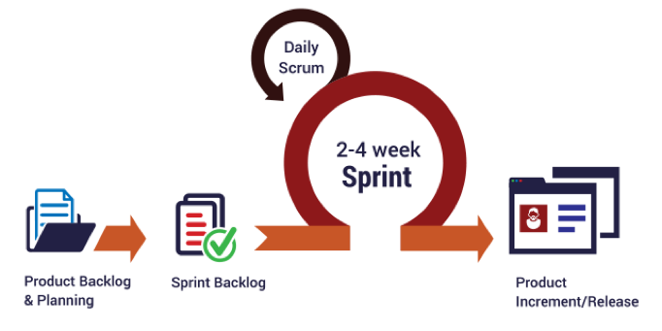  
Figure 1: Scrum model

Reference: <http://skytechnovation.com/scrum-development-model/>

### Roles and responsibilities

|  |  |  |  |
| --- | --- | --- | --- |
| **No** | **Full name** | **Role in Group** | **Responsibilities** |
| **1** | Thân Thị Ngọc Vân | Product owner, Project Manager | * Specify user requirements * Control the development process * Provide technical and business analysis support |
| **2** | Cao Đức Sơn Ngọc | Scrum leader, B.A, Developer, Tester | * Manage process * Design database * Clarify requirements * Prepare and combine documents * GUI design * Create test plan * Code * Test |
| **3** | Lê Đại An | Team member,  B.A, Developer,  Tester | * Design database * Clarify requirements * Prepare documents * GUI design * Create test plan * Code * Test |
| **4** | Võ Trần Hoàng Long | Team member,  B.A, Developer,  Tester | * Design database * Clarify requirements * Prepare documents * GUI design * Create test plan * Code * Test |

*Table 5: Roles and responsibilities*

### Tools and Techniques

|  |  |
| --- | --- |
| **Tool** | **Name / Version** |
| **Web server** | Tomcat |
| **Development tool** | NetBeans IDE 8.2 |
| **DBMS** | MySQL |
| **Source control** | GitHub |
| **Modeling tool** | StarUML v5.0.1 |
| **Document tool** | Microsoft Word 2016 |

*Table 6: Tools List*

|  |  |
| --- | --- |
| **Technique** | **Name / version** |
| **Frontend** | HTML, CSS, JavaScript, jQuery, Bootstrap |
| **Backend** | Java EE, Servlet, JSP, JPA, Hibernate |

*Table 7: Techniques List*

## Project Management Plan

### Software development life cycle

|  |  |  |  |  |  |
| --- | --- | --- | --- | --- | --- |
| **Phase** | **Description** | **Deliverables** | **Resource needed** | **Dependencies and Constrains** | **Risks** |
| **Infrastructure** | - Identify and clarify overall requirements.  - Determine the system architecture.  - Build infrastructure for the project.  - Prepare reports. | - System main structure. | 4 days |  | - Unclear project scope.  - Lack of member share of understand. |
| **Modeling UML** | - Define actors and role of each actor in system.  - Define types and features of each actor.  - Create system’s UML models.  - Prepare reports | - UML models. | 10 days | - Depends on “Infrastructure” | - Unclear project scope.  - Lack of experience. |
| **Database** | - Create ERD describe architecture, database.  - Generate Entity.  - Prepare reports. | - ERD, entity package. | 7 days | - Depends on “Modeling UML” | - Unclear project scope.  - Lack of experience. |
| **Web services** | - Add common library, JPA, JDBC.  - Prepare reports. | - Prototype, common project. | 1 days | - Depends on “Database” |  |
| **Implements** | - Members implement system’s features.  - Test modules.  - Combine modules into system. - Prepare reports. | - Completed system. | 56 days | - Depends on “Web services” | - Unclear system’s features.  - Lack of experience. |
| **Test System** | - Create use-cases and test system based on this.  - Prepare reports. | - Test reports and system with features are fixed bugs. | 5 days | - Depends on “Implements” | - Lack of experience. |
| **Package** | - Build setup-files.  - Deploy server.  - Burn CD.  - Complete reports. | - Reports, CD, setup-files. | 1 days | - Depends on “Test System” |  |

*Table 8: Software development life cycle*

### Phase Detail

* + 1. ***Phase 1: Infrastructure***

|  |  |  |
| --- | --- | --- |
| **Task** | **Description** | **Author** |
| **1. Assessment** | - Determine requirements.  - Create product backlog. | * NgocCDS * AnLD * LongVTH |
| **2. Selection** | - Determine system architecture: Spring Boot.  - Determine software design pattern: Repository & Service.  - Determine all core functions. | * NgocCDS * AnLD * LongVTH |
| **3. Development** | - Create the main structure of project. | * NgocCDS * AnLD * LongVTH |
| **4. Review** | - Review all completed works and presentation.  - Create sprint backlog. | * NgocCDS * AnLD * LongVTH |

*Table 9: Infrastructure*

* + 1. ***Phase 2: System & Web admin***

|  |  |  |
| --- | --- | --- |
| **Task** | **Description** | **Author** |
| **1. Assessment** | - Determine requirements for System and Web app.  - Update product backlog. | * NgocCDS * AnLD * LongVTH |
| **2. Selection** | - Determine all functions according to requirements of System and Web app. | * NgocCDS * AnLD * LongVTH |
| **3. Development** | - Design and build prototype for web UI  - Create conceptual diagram  - Design class diagram  - Design database  - Implement the entire web UI: layouts, detail pages, etc.  - Implement all the functions in controllers.  - Build needed utility classes | * NgocCDS * AnLD * LongVTH |
| **4. Review** | - Review all completed works and presentation.  - Create sprint backlog. | * NgocCDS * AnLD * LongVTH |

*Table 10: System and Web Admin*

* + 1. ***Phase 3: Web service***

|  |  |  |
| --- | --- | --- |
| **Task** | **Description** | **Author** |
| **1. Assessment** | - Determine requirements for Web service.  - Update product backlog. | * NgocCDS * AnLD * LongVTH |
| **2. Selection** | - Determine all functions according to requirements of Web service. | * NgocCDS * AnLD * LongVTH |
| **3. Development** | - Implement all the functions on the web app. | * NgocCDS * AnLD * LongVTH |
| **4. Review** | - Review all completed works and presentation.  - Create sprint backlog. | * NgocCDS * AnLD * LongVTH |

*Table 11: Web service*

### All Meeting Minutes

Meeting minutes are contained in folder “Meeting minutes” in the attached CD.

## Coding Convention

**Java:** Using to develop website and web service.

Summary:

* + Naming Convention:
* For variable’s name, use camel case. E.g.: minValue, maxValue…
* For function name, class name, use Pascal case. E.g.: AddIncome, AddExpense…
  + Layout Convention:
* Indent continuation one tab stop (four spaces).
* Add at least one blank line between method definitions and property definitions.
  + - Use parentheses to make clauses in an expression apparent.
* Using Java Code Convention from: <http://www.oracle.com/technetwork/java/codeconvtoc-136057.html>

# Report 3 - Software Requirement Specification

## User Requirement Specification

### Guest Requirement

Guest are those do not login to this system. They have some functions:

* View photo
* View product
* Search product
* Search professional
* View other Profile
* View Project
* View Idea Book
* Sign up
* Sign in
* Manage shopping cart

### Member Requirement

They can use some following functions:

* Sign out
* Edit Profile
* View photo
* View product
* Search product
* Search professional
* View other profile
* View project
* View idea book
* Send an order
* Create idea book
* Edit idea book
* Delete idea book
* Add photo to idea book
* Delete photo in idea book
* Order

### Professional Requirement

Professional, who is professional in house-building service. They provide house services or sell house products (like desk, chain, table, bed…). They can use some following functions:

* Manage projects:
  + - * Create new project.
      * View project detail.
      * Edit project.
      * Delete project.
      * Add photo to project.
      * Delete photo from project.
* Seller register.
* Manage store:

### Admin Requirement

Admin, who is responsible for managing accounts, products, projects, idea books, photos, sellers for the whole system, has the following function:

* Manage accounts:
  + - * View account list.
      * Search accounts.
      * View account’s detail.
      * Deactivate account.
      * Activate account.
* Manage products:
* View products.
* Search products.
* View product’s detail.
* Accept product.
* Block product.
* Manage idea books:
* View idea books.
* Search idea books.
* View idea book’s detail.
* Approve idea books.
* Accept photo in idea book.
* Block photo in idea book.
* Manage projects:
* View projects.
* Search projects.
* View project’s detail.
* Approve projects.
* Accept photo in project.
* Block photo in project.
* Manage sellers:
* View seller’s detail
* Update sale time

### System Requirement

System, which automatically runs some following functions:

* Send order to seller by email
* Add tracking
* Remove tracking
* Update quantity of product
* Send promotion to Customers
* Send notification to User:

• Admin: have new product, image need accept

* User and Professional: their product or image has been proceed.

## System Requirement Specification



### External Interface Requirement

#### User Interface

* The user interface uses Vietnamese language for web application.
* General requirement for graphics user interface is the GUI should be simple, clear, intuitive, and reminiscent.

#### Hardware Interface

#### Software Interface

* Web application work with Firefox (v30 or above), Chrome (v14 or above), Internet Explorer (v10 or above).

#### Communication Protocol

* Use HTTP to communicate between the web browser and the web server.

### System Overview Use Case

(Figure 1 : <Use case> System overview)

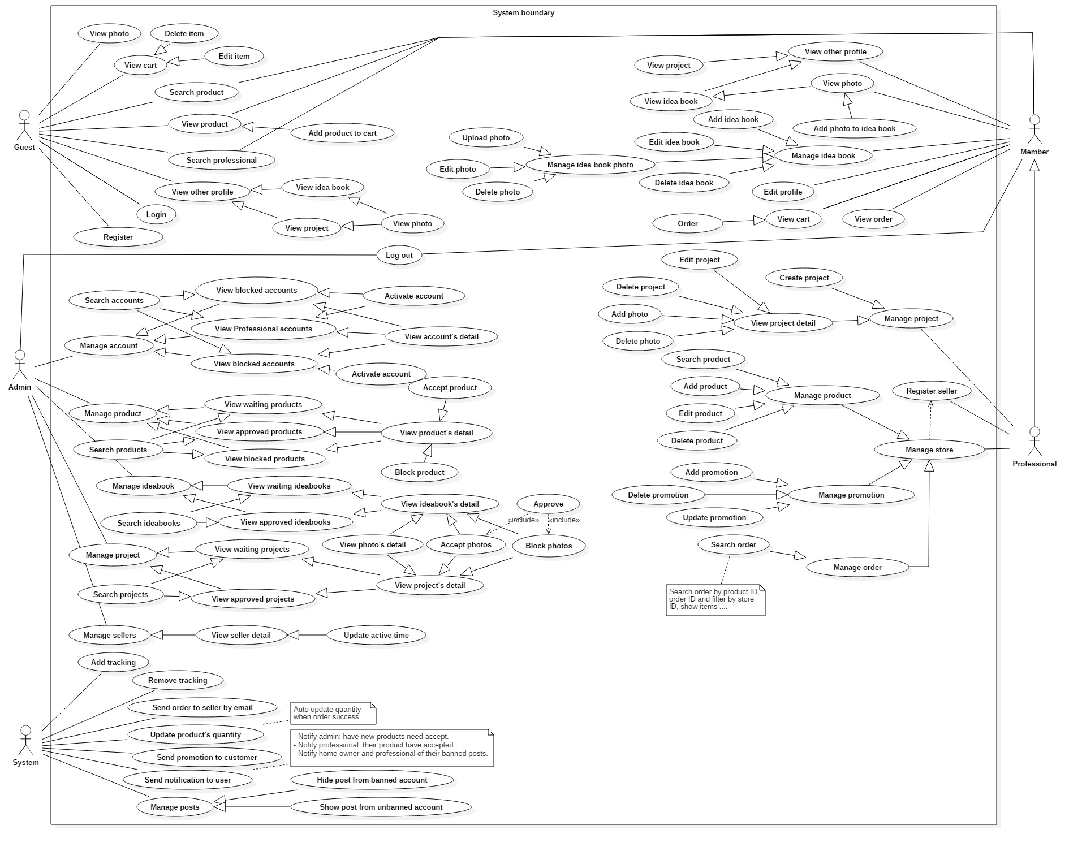



### List of Use Case

#### 2.3.1 Guest

##### < Guest > Overview use case

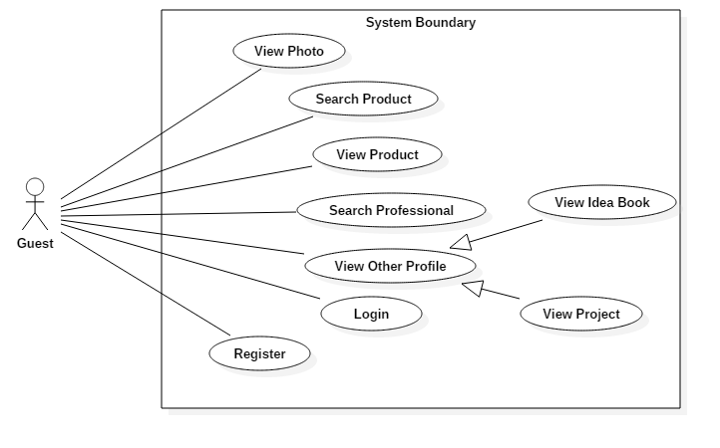

Figure 3: <Guest> Overview Use Case

##### < Guest > View Photo

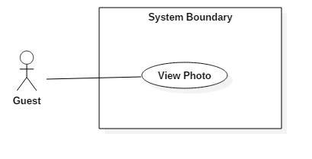

Figure 4: <Guest> View Photo

|  |  |  |  |
| --- | --- | --- | --- |
| **USE CASE – 1.1** | | | |
| **Use Case No.** | 1.1 | **Use Case Version** | 1.0 |
| **Use Case Name** | View Photo | | |
| **Author** | Cao Đức Sơn Ngọc | | |
| **Date** | May 20, 2017 | **Priority** | Normal |
| **Actor:**   * Guest   **Summary:**   * This use case allows a guest to view some photos in the project.   **Goal:**   * The lists of photos in the system are displayed -> **The lists of photos (images) is displayed in the system**   **Triggers:**  Guest clicks on “ảnh” tab.  **Preconditions:** N/A  **Post Conditions:**   * **Success:** Guest views photos in system -> Guest views images in system * **Fail:** N/A   **Main Success Scenario:**   |  |  |  | | --- | --- | --- | | Step | Actor Action | System Response | | 1 | Guest clicks on “ảnh” tab. | System loads the result. Information for each photo:   * Photo * Name Project has this photo * Professional post this photo -> **Professional posts this photo**   [Exception 1]: Internet connection is lost |   **Alternative Scenario:**   |  |  |  | | --- | --- | --- | | No. | Actor Action **(action actor)** | System Response (respond system) | | 1 | |  |  |   **Exception:** N/A  **Relationships:** N/A  **Business Rules: N/A** | | | |

##### < Guest > Search Product

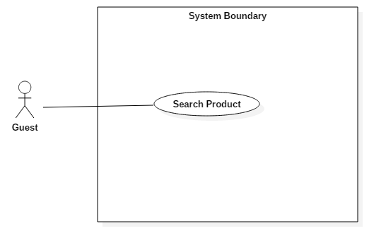

Figure 5: <Guest> Search Product

|  |  |  |  |
| --- | --- | --- | --- |
| **USE CASE – 1.2** | | | |
| **Use Case No.** | 1.2 | **Use Case Version** | 1.0 |
| **Use Case Name** | Search Product | | |
| **Author** | Cao Đức Sơn Ngọc | | |
| **Date** | May 20, 2017 | **Priority** | Normal |
| **Actor:**   * Guest   **Summary:**   * This use case allows a guest to search **for** products. **Bỏ For**   **Goal:**   * The list of products is displayed, with the search keyword. -> **displayed searches keyword**   **Triggers:**  **Guest inputs data into the search box to find the product and press “Enter”.**  **Preconditions:** N/A  **Post Conditions:**   * **Success:** Guest view**s** list product the same keyword. * **Fail:** N/A   **Main Success Scenario:**   |  |  |  | | --- | --- | --- | | Step | Actor Action **(action actor)** | System Response **(response system)** | | 1 | ~~Guest input information to search in search product input and “Enter”.~~ -> **Guest inputs data into the search box to find the product and press “Enter”.** | System loads the result. Information for each product:   * Product * Price * Seller post**s** product   [Exception 1]: Internet connection is lost |   **Alternative Scenario:**   |  |  |  | | --- | --- | --- | | No. | Actor Action | System Response | | 1 | |  |  |   **Exception:** N/A  **Relationships:** N/A  **Business Rules: N/A** | | | |

##### < Guest > View Product

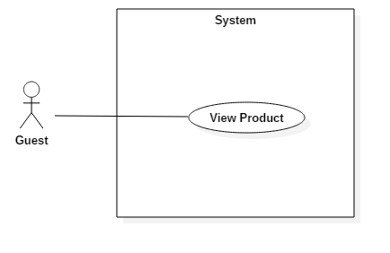

Figure 6: <Guest> View Product

|  |  |  |  |
| --- | --- | --- | --- |
| **USE CASE – 1.3** | | | |
| **Use Case No.** | 1.3 | **Use Case Version** | 1.0 |
| **Use Case Name** | View Product | | |
| **Author** | Cao Đức Sơn Ngọc | | |
| **Date** | May 20, 2017 | **Priority** | Normal |
| **Actor:**   * Guest   **Summary:**   * This use case allows guest to view product in project.   **Goal:**   * The list of product in the system is displayed -> The list of producing is displayed in the system   **Triggers:**  Guest clicks on “Sản phẩm” tab.  **Preconditions:** N/A  **Post Conditions:**   * **Success:** Guest view**s** product in system * **Fail:** N/A   **Main Success Scenario:**   |  |  |  | | --- | --- | --- | | Step | Actor Action | System Response | | 1 | Guest clicks on “Sản phẩm” tab. | System loads the result. Information for each product:   * Product * Price * Seller post**s** product   [Exception 1]: Internet connection is lost |   **Alternative Scenario:**   |  |  |  | | --- | --- | --- | | No. | Actor Action | System Response | | 1 | |  |  |   **Exception:** N/A  **Relationships:** N/A  **Business Rules: N/A** | | | |

##### < Guest > Search Professional

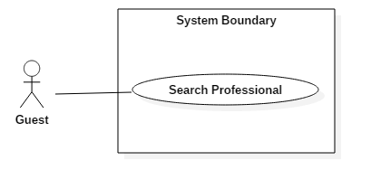

Figure 7: <Guest> Search Professional

|  |  |  |  |
| --- | --- | --- | --- |
| **USE CASE – 1.4** | | | |
| **Use Case No.** | 1.4 | **Use Case Version** | 1.0 |
| **Use Case Name** | Search Professional | | |
| **Author** | Cao Đức Sơn Ngọc | | |
| **Date** | May 20, 2017 | **Priority** | Normal |
| **Actor:**   * Guest   **Summary:**   * This use case allows guest to search for professional.   .  **Goal:**   * Guest search**es** Professional in the system.   **Triggers**  Guest clicks on “Sign in” tab.  **Preconditions:** N/A  **Post Conditions:**   * **Success:** Guest found professional. * **Fail:** N/A   **Main Success Scenario:**   |  |  |  | | --- | --- | --- | | Step | Actor Action | System Response | | 1 | Guest clicks on “Tìm Nhà Thiết Kế” tab. | System loads the page search professional.  . | | 2 | Guest input information to search and click button “ Tìm Kiếm” | System loads the result. Information for each professional:   * Name professional * About professional * ~~Number phone of~~ Phone number of professional * Address of professional -> **Professional Address** |   **Alternative Scenario:**   |  |  |  | | --- | --- | --- | | No. | Actor Action | System Response | | 1 | |  |  |   **Exception:** N/A  **Relationships:** N/A  **Business Rules: N/A** | | | |

##### < Guest > View Other Profile

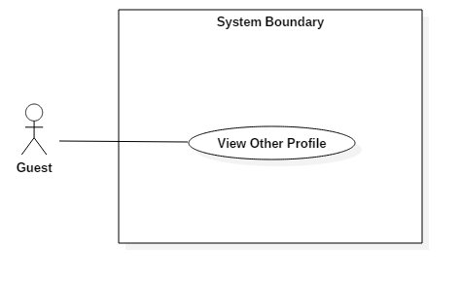

Figure 8: <Guest> View Other Profile

|  |  |  |  |
| --- | --- | --- | --- |
| **USE CASE – 1.5** | | | |
| **Use Case No.** | 1.5 | **Use Case Version** | 1.0 |
| **Use Case Name** | View Other Profile | | |
| **Author** | Cao Đức Sơn Ngọc | | |
| **Date** | May 20, 2017 | **Priority** | Normal |
| **Actor:**   * Guest   **Summary:**   * This use case allows guest to view other profile.   .  **Goal:**   * Guest views profile of member.   **Triggers**  Guest clicks on the member's name.  **Preconditions:** N/A  **Post Conditions:**   * **Success:** Guest views profile of member. * **Fail:** N/A   **Main Success Scenario:**   |  |  |  | | --- | --- | --- | | Step | Actor Action | System Response | | 1 | Guest clicks on the member's name. | System loads the page member’s profile.  . |   **Alternative Scenario:**   |  |  |  | | --- | --- | --- | | No. | Actor Action | System Response | | 1 | |  |  |   **Exception:** N/A  **Relationships:** N/A  **Business Rules: N/A** | | | |

##### < Guest > View Idea Book

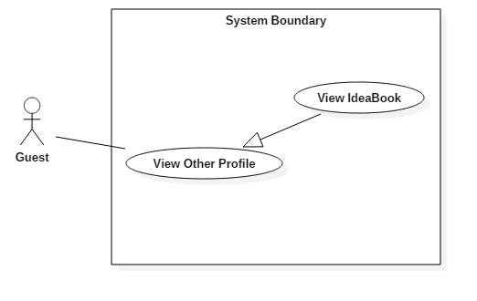 Figure 9: <Guest> View Idea Book

|  |  |  |  |
| --- | --- | --- | --- |
| **USE CASE – 1.6** | | | |
| **Use Case No.** | 1.6 | **Use Case Version** | 1.0 |
| **Use Case Name** | View Idea Book | | |
| **Author** | Cao Đức Sơn Ngọc | | |
| **Date** | May 20, 2017 | **Priority** | Normal |
| **Actor:**   * Guest   **Summary:**   * This use case allows guest to view member’s idea book.   .  **Goal:**   * Guest view idea book of member.   **Triggers**  Guest clicks on the member's name. Then click “Ý Tưởng” tab.  **Preconditions:** N/A  **Post Conditions:**   * **Success:** Guest views list of the idea book. * **Fail:** N/A   **Main Success Scenario:**   |  |  |  | | --- | --- | --- | | Step | Actor Action | System Response | | 1 | Guest clicks on the member's name. | System loads the page member’s profile.  . | | 2 | Guest clicks on “Ý Tưởng” tab. | System loads the result of the list idea book of member. |   **Alternative Scenario:**   |  |  |  | | --- | --- | --- | | No. | Actor Action | System Response | |  | |  |  |   **Exception:** N/A  **Relationships:** N/A  **Business Rules: N/A** | | | |

##### < Guest > View Project

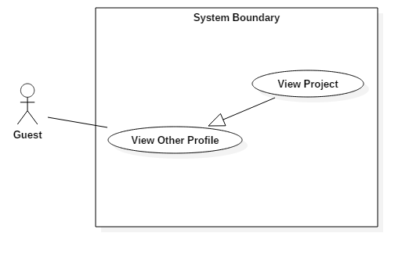 Figure 10: <Guest> View Project

|  |  |  |  |
| --- | --- | --- | --- |
| **USE CASE – 1.7** | | | |
| **Use Case No.** | 1.7 | **Use Case Version** | 1.0 |
| **Use Case Name** | View Project | | |
| **Author** | Cao Đức Sơn Ngọc | | |
| **Date** | May 20, 2017 | **Priority** | Normal |
| **Actor:**   * Guest   **Summary:**   * This use case allows guest to view member’s project.   .  **Goal:**   * Guest views project of member.   **Triggers**  Guest clicks on the member's name. Then click “Dự Án” tab.  **Preconditions:** That member must be a professional  **Post Conditions:**   * **Success:** Guest view list idea book. * **Fail:** N/A   **Main Success Scenario:**   |  |  |  | | --- | --- | --- | | Step | Actor Action | System Response | | 1 | Guest clicks on the member's name. | System loads the page member’s profile.  . | | 2 | Guest clicks on “Dự Án” tab. | System loads the result list project of member. |   **Alternative Scenario:**   |  |  |  | | --- | --- | --- | | No. | Actor Action | System Response | |  | |  |  |   **Exception:** N/A  **Relationships:** N/A  **Business Rules: N/A** | | | |

##### < Guest > Login

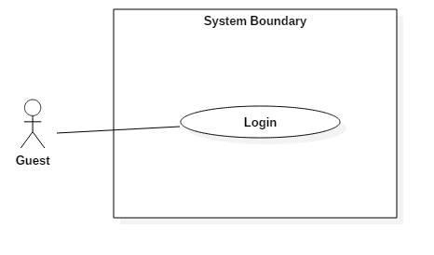

Figure 11: <Guest> Login

|  |  |  |  |
| --- | --- | --- | --- |
| **USE CASE – 1.8** | | | |
| **Use Case No.** | 1.8 | **Use Case Version** | 1.0 |
| **Use Case Name** | Login | | |
| **Author** | Cao Đức Sơn Ngọc | | |
| **Date** | May 20, 2017 | **Priority** | Normal |
| **Actor:**   * Guest   **Summary:**   * This use case allows guest login.   **Goal:**   * Guest logins account in the system.   **Triggers:**  Guest clicks on “Login” tab.  **Preconditions:** N/A  **Post Conditions:**   * **Success:** Guest logins success. * **Fail:** N/A   **Main Success Scenario:**   |  |  |  | | --- | --- | --- | | Step | Actor Action | System Response | | 1 | Guest inputs username and password then click button “Đăng nhập”. | Success login and system loads home page. |   **Alternative Scenario:**   |  |  |  | | --- | --- | --- | | No. | Actor Action | System Response | | 1 | |  |  |   **Exception:** N/A  **Relationships:** N/A  **Business Rules: N/A** | | | |

##### < Guest > Register

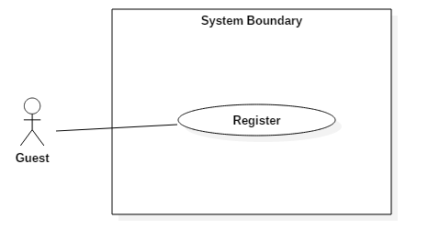

Figure 12: <Guest> Register

|  |  |  |  |
| --- | --- | --- | --- |
| **USE CASE – 1.9** | | | |
| **Use Case No.** | 1.9 | **Use Case Version** | 1.0 |
| **Use Case Name** | Register | | |
| **Author** | Cao Đức Sơn Ngọc | | |
| **Date** | May 20, 2017 | **Priority** | Normal |
| **Actor:**   * Guest   **Summary:**   * This use case allows guest register to member.   **Goal:**   * Guest registers account in the system.   **Triggers:**  Guest clicks on “Login” tab. Click on link “Don’t have account? Register.”  **Preconditions:** N/A  **Post Conditions:**   * **Success:** Guest registers successfully. * **Fail:** N/A   **Main Success Scenario:**   |  |  |  | | --- | --- | --- | | Step | Actor Action | System Response | | 1 | Guest clicks on “Don’t have account? Register.” link | System loads the page Register.  . | | 2 | Guest inputs information to register and click button Register | Success register and system loads home page. |   **Alternative Scenario:**   |  |  |  | | --- | --- | --- | | No. | Actor Action | System Response | | 1 | |  |  |   **Exception:** N/A  **Relationships:** N/A  **Business Rules: N/A** | | | |

#### Member

##### < Member > Overview Use Case

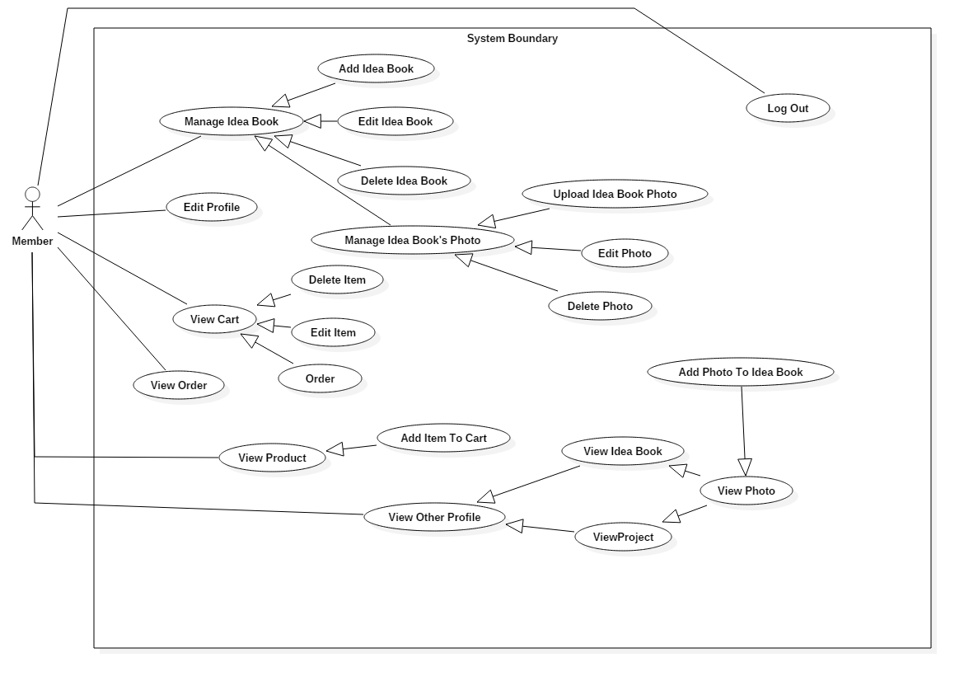

Figure 13: <Member> Overview Use Case

##### < Member > View Photo¸ Search Product, View Product, Search Professional, View Other Profile, View Idea Book, View Project the same use case of Guest.

##### < Member > Add Idea Book

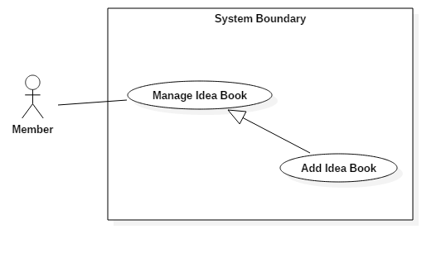

Figure 14: <Member> Add Idea Book

|  |  |  |  |
| --- | --- | --- | --- |
| **USE CASE – 2.1** | | | |
| **Use Case No.** | 2.2 | **Use Case Version** | 1.1 |
| **Use Case Name** | Add Idea Book | | |
| **Author** | Cao Đức Sơn Ngọc | | |
| **Date** | March 16, 2017 | **Priority** | Normal |
| **Actor:**   * Member   **Summary:**   * This use case allows Member to add an idea book.   **Goal:**   * Add new idea book in list idea book of member.   **Triggers:** Member clicks on “Icon Account”/”Ý Tưởng”/”Thêm Mới Ý Tưởng” .  **Preconditions:**   * Actor logged in system with role Member, Professional, Seller.   **Post Conditions:**   * **Success:** Add new idea book success. * **Fail:**   **Main Success Scenario:**   |  |  |  | | --- | --- | --- | | Step | Actor Action | System Response | | 1 | Member clicks on “Icon Account”.  Then clicks on “Ý Tưởng”/”Thêm Mới Ý Tưởng” button | System loads the modal to add new idea book. | | 2 | Member input idea book’s information. The click “Thêm Mới” button. | Add idea book success and result a list idea book. |   **Alternative Scenario:**   |  |  |  | | --- | --- | --- | | Step | Cause | System Response | | 1 |  |  |   **Exceptions: N/A**  **Relationships:** N/A  **Business Rules: N/A** | | | |

##### < Member > Edit Idea Book

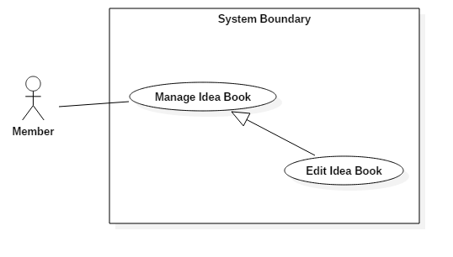

Figure 15: <Member> Edit Idea Book

|  |  |  |  |
| --- | --- | --- | --- |
| **USE CASE – 2.3** | | | |
| **Use Case No.** | 2.3 | **Use Case Version** | 1.1 |
| **Use Case Name** | Edit Idea Book | | |
| **Author** | Cao Đức Sơn Ngọc | | |
| **Date** | March 16, 2017 | **Priority** | Normal |
| **Actor:**   * Member   **Summary:**   * This use case allows Member to edit an idea book.   **Goal:**   * Edit description idea book.   **Triggers:** Member clicks on “Icon Account”/”Ý Tưởng” and click to idea book need edit.  **Preconditions:**   * Actor logged in system with role Member, Professional, Seller.   **Post Conditions:**   * **Success:** Edit description idea book success. * **Fail: N/A**   **Main Success Scenario:**   |  |  |  | | --- | --- | --- | | Step | Actor Action | System Response | | 1 | Member clicks on “Icon Account”.  Then clicks on “Ý Tưởng” click to idea book need edit. | System loads the page detail about idea book. | | 2 | Member input idea book’s description. The click “Lưu” button. | Update description success and result page detail idea book. |   **Alternative Scenario:**   |  |  |  | | --- | --- | --- | | Step | Cause | System Response | | 1 |  |  |   **Exceptions: N/A**  **Relationships:** N/A  **Business Rules: N/A** | | | |

##### < Member > Delete Idea Book

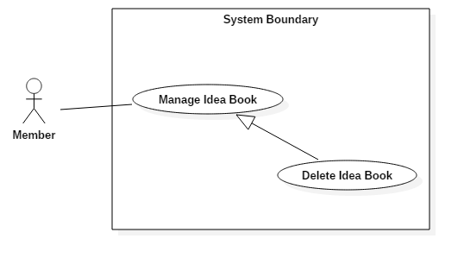

Figure 16: <Member> Delete Idea Book

|  |  |  |  |
| --- | --- | --- | --- |
| **USE CASE – 2.4** | | | |
| **Use Case No.** | 2.4 | **Use Case Version** | 1.1 |
| **Use Case Name** | Delete Idea Book | | |
| **Author** | Cao Đức Sơn Ngọc | | |
| **Date** | March 16, 2017 | **Priority** | Normal |
| **Actor:**   * Member   **Summary:**   * This use case allows Member to delete an idea book.   **Goal:**   * Delete an idea book.   **Triggers:** Member clicks on “Icon Account”/”Ý Tưởng” and click to idea book need delete.  **Preconditions:**   * Actor logged in system with role Member, Professional, Seller.   **Post Conditions:**   * **Success:** Delete description idea book success. * **Fail: N/A**   **Main Success Scenario:**   |  |  |  | | --- | --- | --- | | Step | Actor Action | System Response | | 1 | Member clicks on “Icon Account”.  Then clicks on “Ý Tưởng” click to idea book need delete. | System loads the page detail about idea book. | | 2 | Member input idea book’s description. The click “Xóa Ý Tưởng” button. | Delete idea book success and returns the idea list page. |   **Alternative Scenario:**   |  |  |  | | --- | --- | --- | | Step | Cause | System Response | | 1 |  |  |   **Exceptions: N/A**  **Relationships:** N/A  **Business Rules: N/A** | | | |

##### < Member > Upload Idea Book Photo

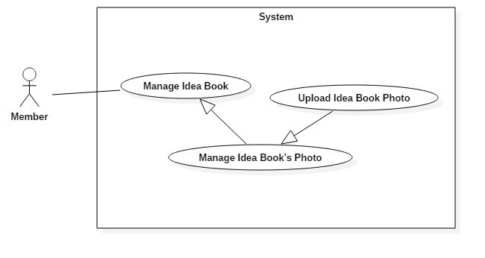

Figure 17: <Member> Upload Idea Book Photo

|  |  |  |  |
| --- | --- | --- | --- |
| **USE CASE – 2.5** | | | |
| **Use Case No.** | 2.5 | **Use Case Version** | 1.1 |
| **Use Case Name** | Upload Idea Book Photo | | |
| **Author** | Cao Đức Sơn Ngọc | | |
| **Date** | March 16, 2017 | **Priority** | Normal |
| **Actor:**   * Member   **Summary:**   * This use case allows Member to add a photo in idea book.   **Goal:**   * Add an idea book photo.   **Triggers:** Member clicks on “Icon Account”/”Ý Tưởng” and click to idea book for adding photos.  **Preconditions:**   * Actor logged in system with role Member, Professional, Seller.   **Post Conditions:**   * **Success:** Add photo to idea book success. * **Fail: N/A**   **Main Success Scenario:**   |  |  |  | | --- | --- | --- | | Step | Actor Action | System Response | | 1 | Member clicks on “Icon Account”.  Then clicks on “Ý Tưởng” click to idea book. | System loads the page detail about idea book. | | 2 | Member click “Thêm ảnh” button. | Add photo success and returns the idea book page. |   **Alternative Scenario:**   |  |  |  | | --- | --- | --- | | Step | Cause | System Response | | 1 |  |  |   **Exceptions: N/A**  **Relationships:** N/A  **Business Rules: N/A** | | | |

##### < Member > Edit Idea Book Photo

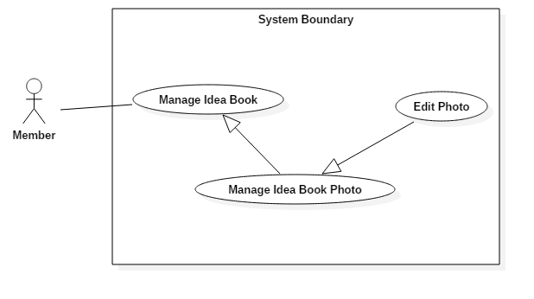

Figure 18: <Member> Edit Idea Book Photo

|  |  |  |  |
| --- | --- | --- | --- |
| **USE CASE – 2.6** | | | |
| **Use Case No.** | 2.6 | **Use Case Version** | 1.1 |
| **Use Case Name** | Edit Idea Book Photo | | |
| **Author** | Cao Đức Sơn Ngọc | | |
| **Date** | March 16, 2017 | **Priority** | Normal |
| **Actor:**   * Member   **Summary:**   * This use case allows Member to edit a photo in ideabook.   **Goal:**   * Edit a description idea book photo.   **Triggers:** Member clicks on “Icon Account”/”Ý Tưởng” and click to idea book for adding photos.  **Preconditions:**   * Actor logged in system with role Member, Professional, Seller.   **Post Conditions:**   * **Success:** Edit description photo to idea book success. * **Fail: N/A**   **Main Success Scenario:**   |  |  |  | | --- | --- | --- | | Step | Actor Action | System Response | | 1 | Member clicks on “Icon Account”.  Then clicks on “Ý Tưởng” click to idea book. | System loads the page detail about idea book. | | 2 | Member input description for photo. | Update photo success and returns the idea book page. |   **Alternative Scenario:**   |  |  |  | | --- | --- | --- | | Step | Cause | System Response | | 1 |  |  |   **Exceptions: N/A**  **Relationships:** N/A  **Business Rules: N/A** | | | |

##### < Member > Delete Idea Book Photo

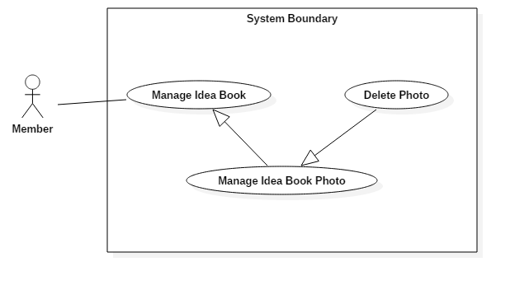

Figure 19: <Member> Delete Idea Book Photo

|  |  |  |  |
| --- | --- | --- | --- |
| **USE CASE – 2.7** | | | |
| **Use Case No.** | 2.7 | **Use Case Version** | 1.1 |
| **Use Case Name** | Delete Idea Book Photo | | |
| **Author** | Cao Đức Sơn Ngọc | | |
| **Date** | March 16, 2017 | **Priority** | Normal |
| **Actor:**   * Member   **Summary:**   * This use case allows Member to delete a photo in ideabook.   **Goal:**   * Delete a description idea book photo.   **Triggers:** Member clicks on “Icon Account”/”Ý Tưởng” and click to idea book for adding photos.  **Preconditions:**   * Actor logged in system with role Member, Professional, Seller.   **Post Conditions:**   * **Success:** Delete photo in idea book success. * **Fail: N/A**   **Main Success Scenario:**   |  |  |  | | --- | --- | --- | | Step | Actor Action | System Response | | 1 | Member clicks on “Icon Account”.  Then clicks on “Ý Tưởng” click to idea book. | System loads the page detail about idea book. | | 2 | Member click button “X” on the corner of the image. | Delete photo success and returns the idea book page. |   **Alternative Scenario:**   |  |  |  | | --- | --- | --- | | Step | Cause | System Response | | 1 |  |  |   **Exceptions: N/A**  **Relationships:** N/A  **Business Rules: N/A** | | | |

##### < Member > Add Photo into Idea Book

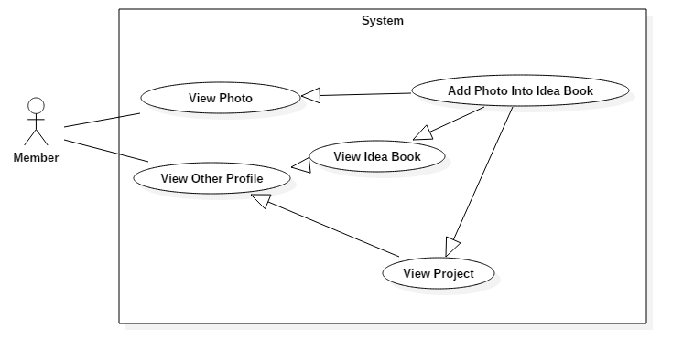

Figure 20: <Member> Add Photo into Idea Book

|  |  |  |  |
| --- | --- | --- | --- |
| **USE CASE – 2.8** | | | |
| **Use Case No.** | 2.8 | **Use Case Version** | 1.1 |
| **Use Case Name** | Add Photo Into Idea Book | | |
| **Author** | Cao Đức Sơn Ngọc | | |
| **Date** | March 16, 2017 | **Priority** | Normal |
| **Actor:**   * Member   **Summary:**   * This use case allows Member to add a photo into idea book.   **Goal:**   * Add a photo into idea book photo.   **Triggers:** Member views a photo and click “Lưu vào ý tưởng” button.  **Preconditions:**   * Actor logged in system with role Member, Professional, Seller.   **Post Conditions:**   * **Success:** Add the photo ino idea book successfull. * **Fail: N/A**   **Main Success Scenario:**   |  |  |  | | --- | --- | --- | | Step | Actor Action | System Response | | 1 | Member clicks on “Ảnh” tab.  Then clicks on a photo and click “Lưu vào ý tưởng” button. | Add the photo successfull.  System loads the page detail about idea book was just added photo. |   **Alternative Scenario 1:**   |  |  |  | | --- | --- | --- | | Step | Cause | System Response | | 1 | Member view any idea book.  Then clicks on a photo and click “Lưu vào ý tưởng” button. | Add the photo successfull.  System loads the page detail about idea book was just added photo. |   **Alternative Scenario 2:**   |  |  |  | | --- | --- | --- | | Step | Cause | System Response | | 1 | Member view any project.  Then clicks on a photo and click “Lưu vào ý tưởng” button. | Add the photo successfull.  System loads the page detail about idea book was just added photo. |   **Exceptions: N/A**  **Relationships:** N/A  **Business Rules: N/A** | | | |

##### < Member > Edit Idea Profile

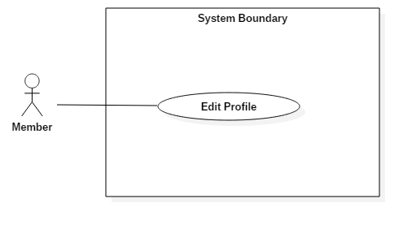

Figure 21: <Member> Edit Idea Profile

|  |  |  |  |
| --- | --- | --- | --- |
| **USE CASE – 2.9** | | | |
| **Use Case No.** | 2.9 | **Use Case Version** | 1.1 |
| **Use Case Name** | Edit Profile | | |
| **Author** | Cao Đức Sơn Ngọc | | |
| **Date** | March 16, 2017 | **Priority** | Normal |
| **Actor:**   * Member   **Summary:**   * This use case allows Member to edit profile.   **Goal:**   * Edit profile successfully.   **Triggers:** Member clicks on “Icon Account”/”Cập Nhật Hồ Sơ” .  **Preconditions:**   * Actor logged in system with role Member, Professional, Seller.   **Post Conditions:**   * **Success:** Update profile successfully. * **Fail: N/A**   **Main Success Scenario:**   |  |  |  | | --- | --- | --- | | Step | Actor Action | System Response | | 1 | Member clicks on “Icon Account”.  Then clicks on “Cập Nhật Hồ Sơ”. | System loads the page detail about member’s profile. | | 2 | Member input information to edit. Then click button “Cập Nhật” | update profile successfully and returns the profile page. |   **Alternative Scenario:**   |  |  |  | | --- | --- | --- | | Step | Cause | System Response | | 1 |  |  |   **Exceptions: N/A**  **Relationships:** N/A  **Business Rules: N/A** | | | |

##### < Member > Add Item to Cart

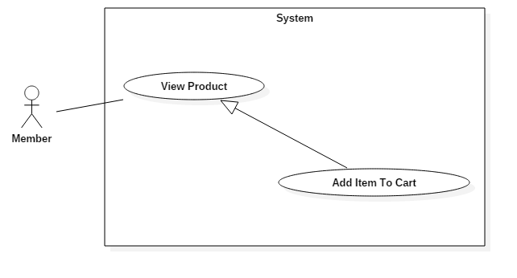

Figure 22: <Member> Add Item to Cart

|  |  |  |  |
| --- | --- | --- | --- |
| **USE CASE – 2.12** | | | |
| **Use Case No.** | 2.12 | **Use Case Version** | 1.1 |
| **Use Case Name** | Add Item To Cart | | |
| **Author** | Cao Đức Sơn Ngọc | | |
| **Date** | March 16, 2017 | **Priority** | Normal |
| **Actor:**   * Member   **Summary:**   * This use case allows Member to add a product to cart.   **Goal:**   * Add new product to cart of member.   **Triggers:** Member clicks on “Sản Phẩm” tab / Detail product.  **Preconditions:**   * Actor logged in system with role Member, Professional, Seller.   **Post Conditions:**   * **Success:** Add new product to cart successfull. * **Fail:**   **Main Success Scenario:**   |  |  |  | | --- | --- | --- | | Step | Actor Action | System Response | | 1 | Member clicks on “Sản Phẩm” tab. | System loads the list product. | | 2 | Member clicks on detail any product. Member chooses quantity of product then click “Thêm vào giỏ hang” button. | Add product to cart success and result modal to question to add cart or order. | | 3 | Member clicks on “Tiếp tục mua hang” button.  [Alternative 1] | System load page product. |   **Alternative Scenario:**   |  |  |  | | --- | --- | --- | | Step | Cause | System Response | | 1 | Member clicks on “Đặt hang” button. | System load page shopping cart for member order. |   **Exceptions: N/A**  **Relationships:** N/A  **Business Rules: N/A** | | | |

##### < Member > View Cart

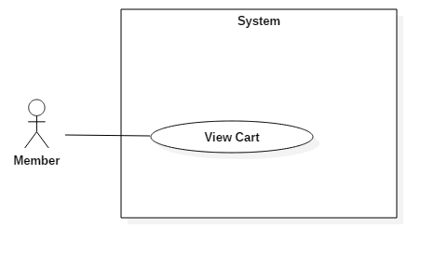

Figure 23: <Member> View Cart

|  |  |  |  |
| --- | --- | --- | --- |
| **USE CASE – 2.13** | | | |
| **Use Case No.** | 2.13 | **Use Case Version** | 1.1 |
| **Use Case Name** | View Cart | | |
| **Author** | Cao Đức Sơn Ngọc | | |
| **Date** | March 16, 2017 | **Priority** | Normal |
| **Actor:**   * Member   **Summary:**   * This use case allows Member to view member’s cart.   **Goal:**   * View cart of member.   **Triggers:** Member clicks on “Icon Cart”.  **Preconditions:**   * Actor logged in system with role Member, Professional, Seller.   **Post Conditions:**   * **Success:** View cart success. * **Fail:**   **Main Success Scenario:**   |  |  |  | | --- | --- | --- | | Step | Actor Action | System Response | | 1 | Member clicks on “Icon Cart”. | System loads the page member’s cart. |   **Alternative Scenario:**   |  |  |  | | --- | --- | --- | | Step | Cause | System Response | | 1 |  |  |   **Exceptions: N/A**  **Relationships:** N/A  **Business Rules: N/A** | | | |

##### < Member > Delete Item

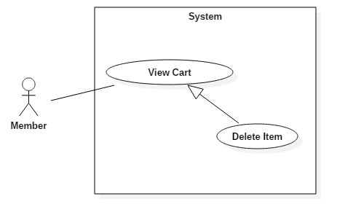

Figure 24: <Member> Delete Item

|  |  |  |  |
| --- | --- | --- | --- |
| **USE CASE – 2.14** | | | |
| **Use Case No.** | 2.14 | **Use Case Version** | 1.1 |
| **Use Case Name** | Delete Item | | |
| **Author** | Cao Đức Sơn Ngọc | | |
| **Date** | March 16, 2017 | **Priority** | Normal |
| **Actor:**   * Member   **Summary:**   * This use case allows Member to delete a product in cart.   **Goal:**   * Delete a product in cart of member.   **Triggers:** Member clicks on “Icon Cart”. Then click “Xóa sản phẩm” button.  **Preconditions:**   * Actor logged in system with role Member, Professional, Seller.   **Post Conditions:**   * **Success:** Delete product in cart successfully. * **Fail:**   **Main Success Scenario:**   |  |  |  | | --- | --- | --- | | Step | Actor Action | System Response | | 1 | Member clicks on “Icon Cart”. | System loads the page member’s cart. | | 2 | Member clicks “Xóa sản phẩm” button. | System deletes the product in member’s cart successfully. |   **Alternative Scenario:**   |  |  |  | | --- | --- | --- | | Step | Cause | System Response | | 1 |  |  |   **Exceptions: N/A**  **Relationships:** N/A  **Business Rules: N/A** | | | |

##### < Member > Edit Item

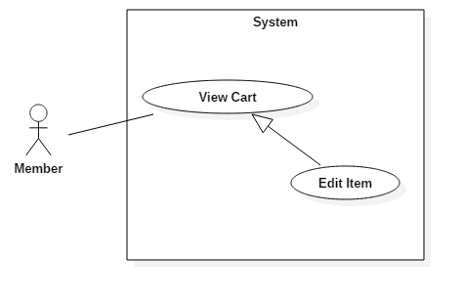

Figure 25: <Member> Edit Item

|  |  |  |  |
| --- | --- | --- | --- |
| **USE CASE – 2.15** | | | |
| **Use Case No.** | 2.15 | **Use Case Version** | 1.1 |
| **Use Case Name** | Edit Item | | |
| **Author** | Cao Đức Sơn Ngọc | | |
| **Date** | March 16, 2017 | **Priority** | Normal |
| **Actor:**   * Member   **Summary:**   * This use case allows Member to edit quantity of product in cart.   **Goal:**   * Edit quantity of product in cart of member.   **Triggers:** Member clicks on “Icon Cart”. Then click “Số lượng” dropdow.  **Preconditions:**   * Actor logged in system with role Member, Professional, Seller.   **Post Conditions:**   * **Success:** Update quantity of product in cart successfully. * **Fail:**   **Main Success Scenario:**   |  |  |  | | --- | --- | --- | | Step | Actor Action | System Response | | 1 | Member clicks on “Icon Cart”. | System loads the page member’s cart. | | 2 | Member clicks “Số lượng” dropdow. Then click “Ok” button. | System updates the quantity of product in member’s cart successfully. |   **Alternative Scenario:**   |  |  |  | | --- | --- | --- | | Step | Cause | System Response | | 1 |  |  |   **Exceptions: N/A**  **Relationships:** N/A  **Business Rules: N/A** | | | |

##### < Member > Order

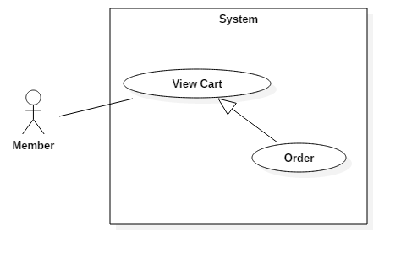

Figure 26: <Member> Order

|  |  |  |  |
| --- | --- | --- | --- |
| **USE CASE – 2.16** | | | |
| **Use Case No.** | 2.16 | **Use Case Version** | 1.1 |
| **Use Case Name** | Order | | |
| **Author** | Cao Đức Sơn Ngọc | | |
| **Date** | March 16, 2017 | **Priority** | Normal |
| **Actor:**   * Member   **Summary:**   * This use case allows Member to order all products in cart.   **Goal:**   * Order all products in cart of member.   **Triggers:** Member clicks on “Icon Cart”. Then click “Đặt hàng” button.  **Preconditions:**   * Actor logged in system with role Member, Professional, Seller.   **Post Conditions:**   * **Success:** Order all products in cart successfully. * **Fail:**   **Main Success Scenario:**   |  |  |  | | --- | --- | --- | | Step | Actor Action | System Response | | 1 | Member clicks on “Icon Cart”. | System loads the page member’s cart. | | 2 | Member clicks “Đặt hàng” button. | System sends order to seller successfully. Result view order page. |   **Alternative Scenario:**   |  |  |  | | --- | --- | --- | | Step | Cause | System Response | | 1 |  |  |   **Exceptions: N/A**  **Relationships:** N/A  **Business Rules: N/A** | | | |

##### < Member > View Order

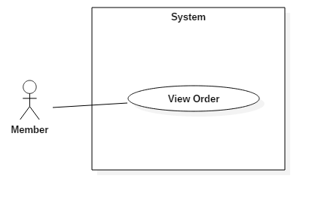

Figure 27: <Member> View Order

|  |  |  |  |
| --- | --- | --- | --- |
| **USE CASE – 2.17** | | | |
| **Use Case No.** | 2.17 | **Use Case Version** | 1.1 |
| **Use Case Name** | Order | | |
| **Author** | Cao Đức Sơn Ngọc | | |
| **Date** | March 16, 2017 | **Priority** | Normal |
| **Actor:**   * Member   **Summary:**   * This use case allows Member to view order.   **Goal:**   * View all order of member.   **Triggers:** Member clicks “Icon Account” / “Cập Nhật Hồ Sơ” or “Ý Tưởng”. Then click “Đơn hàng” tab.  **Preconditions:**   * Actor logged in system with role Member, Professional, Seller.   **Post Conditions:**   * **Success:** View all order successfully. * **Fail:**   **Main Success Scenario:**   |  |  |  | | --- | --- | --- | | Step | Actor Action | System Response | | 1 | Member clicks “Icon Account” / “Cập Nhật Hồ Sơ”.  [Alternative Scenario 1] | System loads the page member’s edit profile. | | 2 | Member clicks “Đơn hàng” tab. | System shows all order of member. |   **Alternative Scenario:**   |  |  |  | | --- | --- | --- | | Step | Cause | System Response | | 1 | Member clicks “Icon Account” / “Ý Tưởng”. | System loads the page member’s edit profile. | | 2 | Member clicks “Đơn hàng” tab. | System shows all order of member. |   **Exceptions: N/A**  **Relationships:** N/A  **Business Rules: N/A** | | | |

#### Professional

##### < Professional > Create project

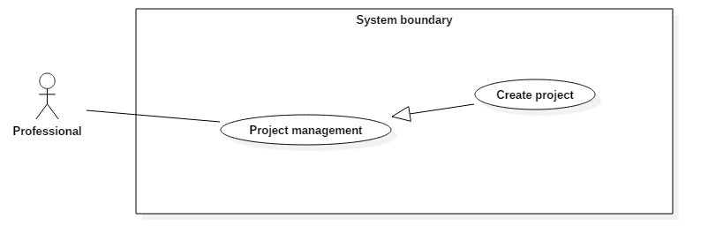

Figure 28: <Professional> Create project

|  |  |  |  |
| --- | --- | --- | --- |
| **USE CASE – 3.1** | | | |
| **Use Case No.** | 3.1 | **Use Case Version** | 1.1 |
| **Use Case Name** | Create project | | |
| **Author** | Le Dai An | | |
| **Date** | July 15, 2017 | **Priority** | Normal |
| **Actor:**   * Professional   **Summary:**   * This use case allows Professional create new project.   **Goal:**   * Create a new project.   **Triggers:** Professional clicks on “Tạo dự án” button.  **Preconditions:**   * Actor logged in system with role Professional.   **Post Conditions:**   * **Success:** New project occurs in their project list. * **Fail:**   **Main Success Scenario:**   |  |  |  | | --- | --- | --- | | Step | Actor Action | System Response | | 1 | - Clicks on create icon.  - Inputs information.  - Clicks on “Tạo dự án” button | System lists out the information of new project:   * Project’s name. * Address. * Cost. * Website. * Year.   When text change, system verifies input information.  System verifies input information. New Project with all copies of it are saved to database  [Alternative 1]: Project’s name is existed in system.  [Exception 1]: Internet connection is lost.  [Exception 2,3,4,5] |   **Alternative Scenario:**   |  |  |  | | --- | --- | --- | | Step | Cause | System Response | | 1 | The project’s name is existed in system. | Show error message “Tên dự án đã tồn tại”. |   **Exceptions:**   |  |  |  | | --- | --- | --- | | No | Cause | System Response | | 1 | Internet is disconnect. | Page with error code 404. | | 2 | Professional inputs Project’s name field with wrong format. | System displays error message: “Vui lòng điền vào trường này.” | | 3 | Professional inputs Cost field with wrong format. | System displays error message: “Giá trị phải lớn hơn hoặc bằng 0” | | 4 | Professional inputs Website field with wrong format. | System displays error message: “Vui lòng nhập URL” | | 5 | Professional inputs Year field with wrong format. | System displays error message: “Giá trị phải nhỏ hơn hoặc bằng 2017” |   **Relationships:** N/A  **Business Rules:**   * “Tên dự án”: free text input, length 1-71. * “Địa chỉ”: free text input, length 1-71. * “Giá”: float input, min 0. * “Website”: free text input, length 1-71. * “Năm”: integer input, max 2017, min 2000. | | | |

##### < Professional > View project detail

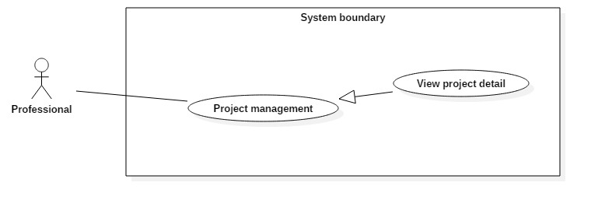

Figure 29: <Professional> View project detail

|  |  |  |  |
| --- | --- | --- | --- |
| **USE CASE – 3.2** | | | |
| **Use Case No.** | 3.2 | **Use Case Version** | 1.1 |
| **Use Case Name** | View project detail | | |
| **Author** | Le Dai An | | |
| **Date** | July 15, 2017 | **Priority** | Normal |
| **Actor:**   * Professional   **Summary:**   * This use case allows Professional to view detail of a project.   **Goal:**   * View project detail.   **Triggers:** Professional clicks on project’s name or project’s photo.  **Preconditions:**   * Actor logged in system with role Professional.   **Post Conditions:**   * **Success:** Project detail is showed. * **Fail:**   **Main Success Scenario:**   |  |  |  | | --- | --- | --- | | Step | Actor Action | System Response | | 1 | - Professional clicks on photo or name of project in list. | - System loads result and displays all information of account.  [Exception 1] Lost Internet Connection. |   **Alternative Scenario:** N/A  **Exceptions:**   |  |  |  | | --- | --- | --- | | No | Cause | System Response | | 1 | Internet is disconnect. | Page with error code 404. |   **Relationships:** N/A  **Business Rules:** N/A | | | |

##### < Professional > Edit project

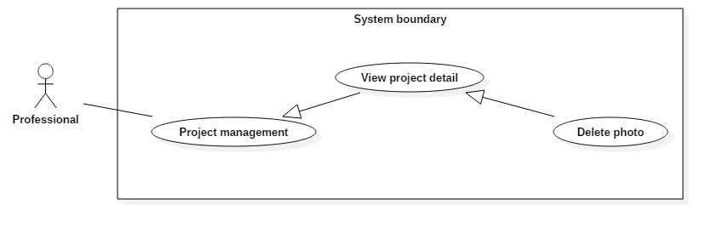

Figure 30: <Professional> Edit project

|  |  |  |  |
| --- | --- | --- | --- |
| **USE CASE – 3.3** | | | |
| **Use Case No.** | 3.3 | **Use Case Version** | 1.1 |
| **Use Case Name** | Edit project | | |
| **Author** | Le Dai An | | |
| **Date** | July 15, 2017 | **Priority** | Normal |
| **Actor:**   * Professional   **Summary:**   * This use case allows Professional to edit information of project.   **Goal:**   * Edit project’s information.   **Triggers:** Professional clicks on “Lưu” button.  **Preconditions:**   * Actor logged in system with role Professional.   **Post Conditions:**   * **Success:** Project’s information is changed. * **Fail:**   **Main Success Scenario:**   |  |  |  | | --- | --- | --- | | Step | Actor Action | System Response | | 1 | - Clicks on edit icon.  - Inputs information.  - Clicks on “Lưu” button | System lists out the information of new project:   * Project’s name. * Address. * Cost. * Website. * Year.   When text change, system verifies input information.  System verifies input information. New Project with all copies of it are saved to database  [Alternative 1]: Project’s name is existed in system.  [Exception 1]: Internet connection is lost.  [Exception 2,3,4,5] |   **Alternative Scenario:**   |  |  |  | | --- | --- | --- | | Step | Cause | System Response | | 1 | The project’s name is existed in system. | Show error message “Tên dự án đã tồn tại”. |   **Exceptions:**   |  |  |  | | --- | --- | --- | | No | Cause | System Response | | 1 | Internet is disconnect. | Page with error code 404. | | 2 | Professional inputs Project’s name field with wrong format. | System displays error message: “Vui lòng điền vào trường này.” | | 3 | Professional inputs Cost field with wrong format. | System displays error message: “Giá trị phải lớn hơn hoặc bằng 0” | | 4 | Professional inputs Website field with wrong format. | System displays error message: “Vui lòng nhập URL” | | 5 | Professional inputs Year field with wrong format. | System displays error message: “Giá trị phải nhỏ hơn hoặc bằng 2017” |   **Relationships:** N/A  **Business Rules:**   * “Tên dự án”: free text input, length 1-71. * “Địa chỉ”: free text input, length 1-71. * “Giá”: float input, min 0. * “Website”: free text input, length 1-71.   - “Năm”: integer input, max 2017, min 2000. | | | |

##### < Professional > Delete project

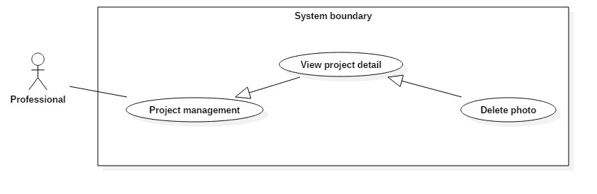

Figure 31: <Professional> Delete project

|  |  |  |  |
| --- | --- | --- | --- |
| **USE CASE – 3.4** | | | |
| **Use Case No.** | 3.4 | **Use Case Version** | 1.1 |
| **Use Case Name** | Delete project | | |
| **Author** | Le Dai An | | |
| **Date** | July 15, 2017 | **Priority** | Normal |
| **Actor:**   * Professional   **Summary:**   * This use case allows Professional to delete their project.   **Goal:**   * Delete project from system.   **Triggers:** Professional clicks on “Xóa” button.  **Preconditions:**   * Actor logged in system with role Professional.   **Post Conditions:**   * **Success:** The project is removed. * **Fail:**   **Main Success Scenario:**   |  |  |  | | --- | --- | --- | | Step | Actor Action | System Response | | 1 | - Professional clicks on “Xóa dự án” button. | System removes project. Update project’s status to “deleted” in database. And deletes all photo in project.  [Exception 1]: Internet connection is lost. |   **Alternative Scenario:** N/A  **Exceptions:**   |  |  |  | | --- | --- | --- | | No | Cause | System Response | | 1 | Internet is disconnect. | Page with error code 404. |   **Relationships:** N/A  **Business Rules:** N/A | | | |

##### < Professional > Add photo



Figure 32: <Professional> Add photo

|  |  |  |  |
| --- | --- | --- | --- |
| **USE CASE – 3.5** | | | |
| **Use Case No.** | 3.5 | **Use Case Version** | 1.1 |
| **Use Case Name** | Add photo | | |
| **Author** | Le Dai An | | |
| **Date** | July 15, 2017 | **Priority** | Normal |
| **Actor:**   * Professional   **Summary:**   * This use case allows Professional to add photo to a project.   **Goal:**   * Add photo to project.   **Triggers:** Professional clicks on “Thêm” button.  **Preconditions:**   * Actor logged in system with role Professional.   **Post Conditions:**   * **Success:** Photo is added to project. * **Fail:**   **Main Success Scenario:**   |  |  |  | | --- | --- | --- | | Step | Actor Action | System Response | | 1 | - Clicks on create icon.  - Inputs information.  - Clicks on “Thêm” button. | System lists out the information of new photo:   * Title. * Description * Category * Style * Upload file.   When text change, system verifies input information.  System verifies input information. New Photo with all copies of it are saved to database.  [Exception 1]: Internet connection is lost.  [Exception 2,3,4,5] |   **Alternative Scenario:** N/A  **Exceptions:**   |  |  |  | | --- | --- | --- | | No | Cause | System Response | | 1 | Internet is disconnect. | Page with error code 404. |   **Relationships:** N/A  **Business Rules:**   * “Tiêu đề”: free text input, length 1-71. * “Mô tả”: free text input, length 1-71. * “Phong cách”: choose 1 in 5 categories. * “Thể loại:: choose 1 in 5 styles. | | | |

##### < Professional > Delete photo



Figure 33: <Professional> Delete photo

|  |  |  |  |
| --- | --- | --- | --- |
| **USE CASE – 3.6** | | | |
| **Use Case No.** | 3.6 | **Use Case Version** | 1.1 |
| **Use Case Name** | Delete photo | | |
| **Author** | Le Dai An | | |
| **Date** | July 15, 2017 | **Priority** | Normal |
| **Actor:**   * Professional   **Summary:**   * This use case allows Professional to delete photo from a project.   **Goal:**   * Delete photo from project.   **Triggers:** Professional clicks on “Xóa” button.  **Preconditions:**   * Actor logged in system with role Professional.   **Post Conditions:**   * **Success:** Photo is removed from project. * **Fail:**   **Main Success Scenario:**   |  |  |  | | --- | --- | --- | | Step | Actor Action | System Response | | 1 | - Professional clicks on X button at top-right of photo. | System removes photo. Update photo’s status to “deleted” in database.  [Exception 1]: Internet connection is lost. |   **Alternative Scenario:** N/A  **Exceptions:**   |  |  |  | | --- | --- | --- | | No | Cause | System Response | | 1 | Internet is disconnect. | Page with error code 404. |   **Relationships:** N/A  **Business Rules:** N/A | | | |

#### Admin

##### < Admin > Overview Use Case

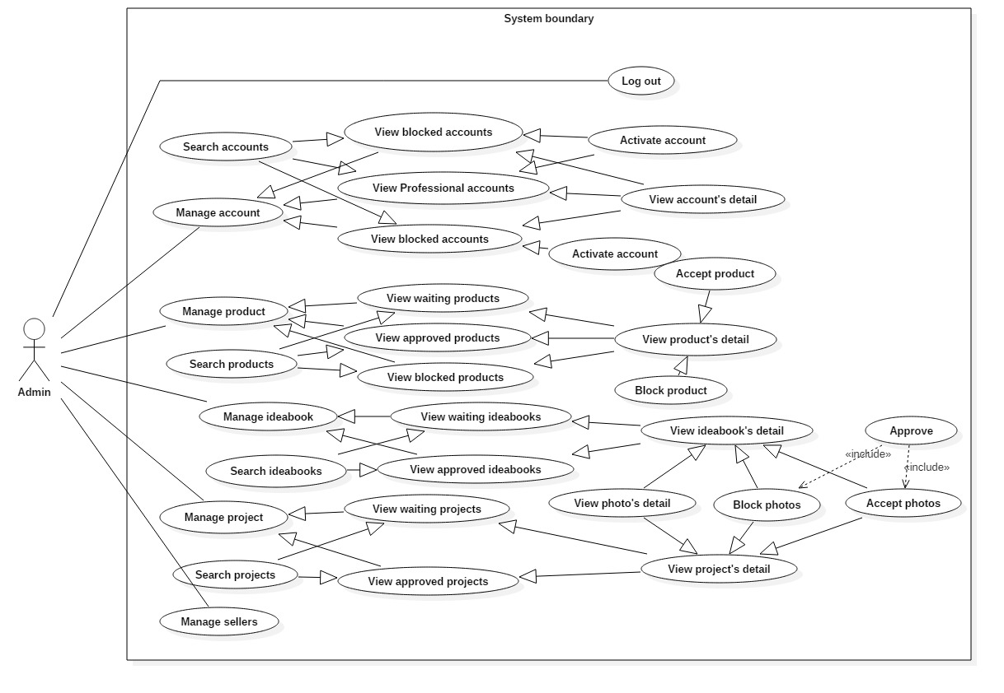

Figure 34: <Admin> Overview Use Case

##### < Admin > View accounts

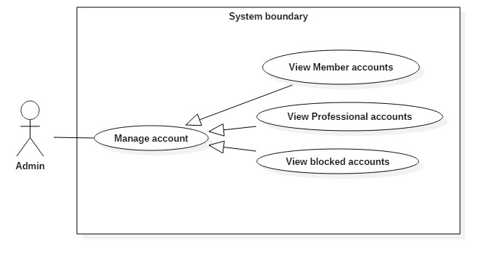

Figure 35: <Admin> View accounts

|  |  |  |  |
| --- | --- | --- | --- |
| **USE CASE – 4.1** | | | |
| **Use Case No.** | 4.1 | **Use Case Version** | 1.1 |
| **Use Case Name** | View accounts | | |
| **Author** | Le Dai An | | |
| **Date** | June 18, 2017 | **Priority** | Normal |
| **Actor:**   * Admin   **Summary:**   * This use case allows Admin to view accounts list include member, professional and blocked accounts.   **Goal:**   * A list member/professional/blocked accounts in system are displayed.   **Triggers:** Admin clicks on “Member” or ”Professional” or ”Danh sách bị chặn” button in “Quản lý tài khoản” tab.  **Preconditions:**   * Actor logged in system with role Admin.   **Post Conditions:**   * **Success:** List of accounts based on member/professional/blocked account is showed. * **Fail:**   **Main Success Scenario:**   |  |  |  | | --- | --- | --- | | Step | Actor Action | System Response | | 1 | - Admin clicks on “Tài khoản” tab.  - Then clicks on “Member” or” Professional” or ”Danh sách bị chặn” button. | System loads the result. Information for each account:   * Full name * Phone number * Email * Register date   [Alternative 1]: There is no account in system.  [Exception 1]: Internet connection is lost. |   **Alternative Scenario:**   |  |  |  | | --- | --- | --- | | Step | Cause | System Response | | 1 | System doesn’t have any account or no account in chosen status. | Web page has a table without content. |   **Exceptions:**   |  |  |  | | --- | --- | --- | | No | Cause | System Response | | 1 | Internet is disconnect. | Page with error code 404. |   **Relationships:** View accounts successfully so Admin can click to view account’s detail, deactivate account.  **Business Rules:** N/A | | | |

##### < Admin > Search accounts

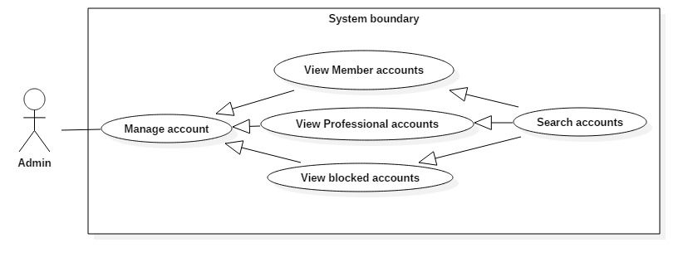

Figure 36: <Admin> Search accounts

|  |  |  |  |
| --- | --- | --- | --- |
| **USE CASE – 4.2** | | | |
| **Use Case No.** | 4.2 | **Use Case Version** | 1.1 |
| **Use Case Name** | Search accounts | | |
| **Author** | Le Dai An | | |
| **Date** | June 18, 2017 | **Priority** | Normal |
| **Actor:**   * Admin   **Summary:**   * This use case allows Admin to search account in list.   **Goal:**   * A list accounts that match input account’s name, phone, email or register date is displayed.   **Triggers:** Admin type in Search Command.  **Preconditions:**   * Actor logged in system with role Admin.   **Post Conditions:**   * **Success:** List of matching accounts based on search term is showed. * **Fail:**   **Main Success Scenario:**   |  |  |  | | --- | --- | --- | | Step | Actor Action | System Response | | 1 | - Types in Search command. | - System compare data in table with the input in Search command.  - Show results.  [Alternative 1]: There is no accounts matched with input text. |   **Alternative Scenario:**   |  |  |  | | --- | --- | --- | | Step | Cause | System Response | | 1 | - No accounts matched. | - Table without result. |   **Exceptions:** N/A  **Relationships:** N/A  **Business Rules:** N/A | | | |

##### < Admin > View account’s detail

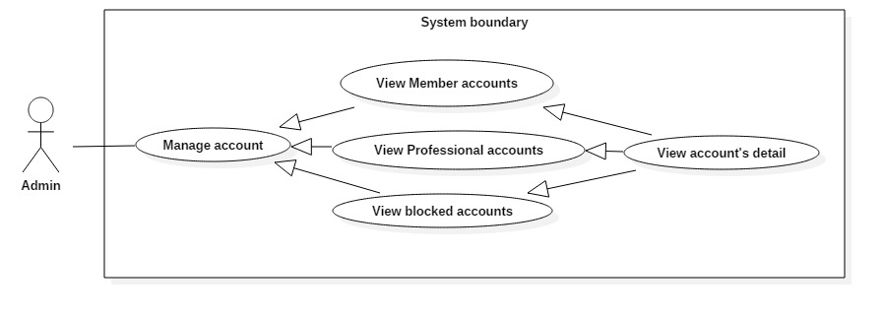

Figure 37: <Admin> View account’s detail

|  |  |  |  |
| --- | --- | --- | --- |
| **USE CASE – 4.3** | | | |
| **Use Case No.** | 4.3 | **Use Case Version** | 1.1 |
| **Use Case Name** | View account’s detail | | |
| **Author** | Le Dai An | | |
| **Date** | June 18, 2017 | **Priority** | Normal |
| **Actor:**   * Admin   **Summary:**   * This use case allows Admin view an account’s detail.   **Goal:**   * Display all information of an account.   **Triggers:** Clicks on “Chi tiết” button.  **Preconditions:**   * Actor logged in system with role Admin. * Actor can do this after use case View accounts   **Post Conditions:**   * **Success:** A page with all information of account is displayed * **Fail:** N/A   **Main Success Scenario:**   |  |  |  | | --- | --- | --- | | Step | Actor Action | System Response | | 1 | - At account list page, Admin clicks on “Chi tiết” button. | - System loads result and displays all information of account.  [Exception 1] Lost Internet Connection. |   **Alternative Scenario:** N/A  **Exceptions:**   |  |  |  | | --- | --- | --- | | No | Cause | System Response | | 1 | Internet is disconnect. | Page with error code 404. |   **Relationships:** N/A  **Business Rules:** N/A | | | |

##### < Admin > Deactivate accounts

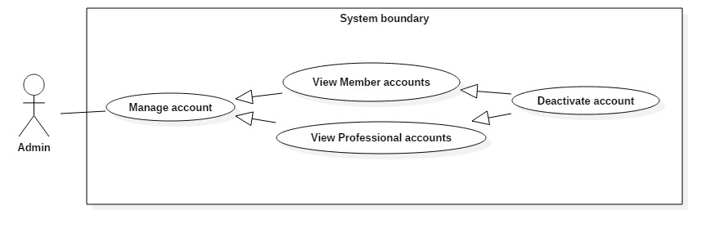

Figure 38: <Admin> Deactivate accounts

|  |  |  |  |
| --- | --- | --- | --- |
| **USE CASE – 4.4** | | | |
| **Use Case No.** | 4.4 | **Use Case Version** | 1.1 |
| **Use Case Name** | Deactivate accounts | | |
| **Author** | Le Dai An | | |
| **Date** | June 18, 2017 | **Priority** | Normal |
| **Actor:**   * Admin.   **Summary:**   * Admin can deactivate an account.   **Goal:**   * Deactivated account can’t login to system.   **Triggers:** Clicks on “Khoá tài khoản” button.  **Preconditions:**   * Actor logged in system with role Admin. * Actor can do this use case after View accounts (tabs “Member” or “Professional”) or View account’s detail (account is active).   **Post Conditions:**   * **Success:** The account is deactivated can’t login to system. * **Fail:** N/A   **Main Success Scenario:**   |  |  |  | | --- | --- | --- | | Step | Actor Action | System Response | | 1 | - Admin clicks on “Khóa tài khoản” button or go to views detail, then clicks on “Khóa tài khoản” button. | - System updates status of the account.  - Returns to account list page.  [Exception 1] Lost Internet Connection. |   **Alternative Scenario:** N/A  **Exceptions:**   |  |  |  | | --- | --- | --- | | No | Cause | System Response | | 1 | Internet is disconnect. | Page with error code 404. |   **Relationships:** N/A  **Business Rules:** N/A | | | |

##### < Admin > Activate account

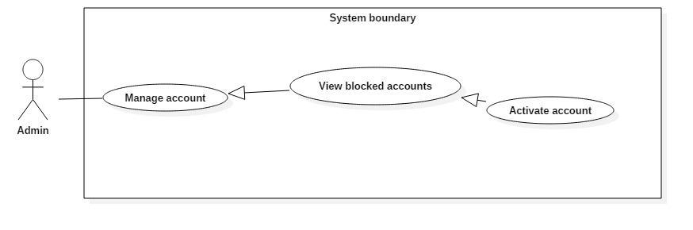

Figure 39: <Admin> Activate account

|  |  |  |  |
| --- | --- | --- | --- |
| **USE CASE – 4.5** | | | |
| **Use Case No.** | 4.5 | **Use Case Version** | 1.1 |
| **Use Case Name** | Activate account | | |
| **Author** | Le Dai An | | |
| **Date** | June 18, 2017 | **Priority** | Normal |
| **Actor:**   * Admin   **Summary:**   * Admin can activate a deactivated account.   **Goal:**   * Activate an account and the account can login to system.   **Triggers:** Clicks on “Mở tài khoản” button.  **Preconditions:**   * Actor logged in system with role Admin. * Actor can do this use case after View accounts (tab “Danh sách bị chặn) or View account’s detail (account is deactive).   **Post Conditions:**   * **Success:** Activated account can log in system * **Fail:** N/A   **Main Success Scenario:**   |  |  |  | | --- | --- | --- | | Step | Actor Action | System Response | | 1 | - Admin clicks on “Mở tài khoản” button or go to views detail, then clicks on “Mở tài khoản” button. | - System updates status of the account.  - Returns to account list page.  [Exception 1] Lost Internet Connection. |   **Alternative Scenario:** N/A  **Exceptions:**   |  |  |  | | --- | --- | --- | | No | Cause | System Response | | 1 | Internet is disconnect. | Page with error code 404. |   **Relationships:** N/A  **Business Rules:** N/A | | | |

##### < Admin > View products

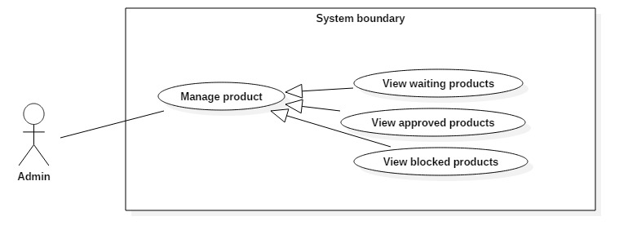

Figure 40: <Admin> View products

|  |  |  |  |
| --- | --- | --- | --- |
| **USE CASE – 4.6** | | | |
| **Use Case No.** | 4.6 | **Use Case Version** | 1.1 |
| **Use Case Name** | View products | | |
| **Author** | Le Dai An | | |
| **Date** | June 18, 2017 | **Priority** | Normal |
| **Actor:**   * Admin   **Summary:**   * This use case allows Admin to view products list include waiting, approved, blocked products.   **Goal:**   * A list waiting or approved or blocked products are displayed.   **Triggers:** Admin clicks on “Danh sách chờ duyệt” or ”Danh sách đã duyệt” or ”Danh sách bị chặn” button in “Sản phẩm” tab.  **Preconditions:**   * Actor logged in system with role Admin.   **Post Conditions:**   * **Success:** List of products based on waiting, accepted, blocked product is showed. * **Fail:**   **Main Success Scenario:**   |  |  |  | | --- | --- | --- | | Step | Actor Action | System Response | | 1 | Admin clicks on “Sản phẩm” tab.  Then clicks on “Danh sách chờ duyệt”/”Danh sách đã duyệt”/”Danh sách bị chặn” button | System loads the result. Information for each product:   * Tax number of Seller * Product’s name * Category * Style   [Alternative 1]: There is no product in system.  [Exception 1]: Internet connection is lost. |   **Alternative Scenario:**   |  |  |  | | --- | --- | --- | | Step | Cause | System Response | | 1 | System doesn’t have any product or no product in chosen status. | Web page has a table without content. |   **Exceptions:**   |  |  |  | | --- | --- | --- | | No | Cause | System Response | | 1 | Internet is disconnect. | Page with error code 404. |   **Relationships:** View products successfully so Admin can click to view product’s detail, accept or block product.  **Business Rules:** N/A | | | |

##### < Admin > Search products

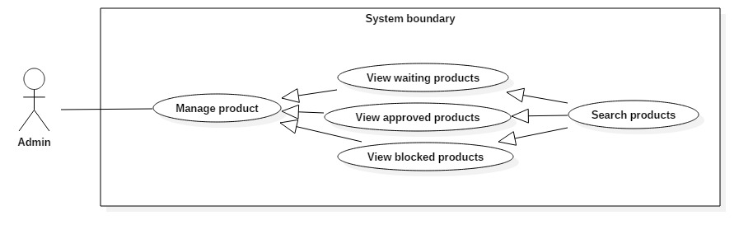

Figure 41: <Admin> Search products

|  |  |  |  |
| --- | --- | --- | --- |
| **USE CASE – 4.7** | | | |
| **Use Case No.** | 4.7 | **Use Case Version** | 1.1 |
| **Use Case Name** | Search products | | |
| **Author** | Le Dai An | | |
| **Date** | June 18, 2017 | **Priority** | Normal |
| **Actor:**   * Admin.   **Summary:**   * This use case allows Admin to search product.   **Goal:**   * A list accounts that match input tax number, product’s name, category or style is displayed.   **Triggers:**  **Preconditions:**   * Actor logged in system with role Admin.   **Post Conditions:**   * **Success:** List of matching products based on search term is showed. * **Fail:** N/A.   **Main Success Scenario:**   |  |  |  | | --- | --- | --- | | Step | Actor Action | System Response | | 1 | - Types in Search command. | - System compare data in table with the input in Search command.  - Show results.  [Alternative 1]: There is no products matched with input text. |   **Alternative Scenario:**   |  |  |  | | --- | --- | --- | | Step | Cause | System Response | | 1 | - No products matched. | - Table without result. |   **Exceptions:** N/A  **Relationships:** N/A  **Business Rules:** N/A | | | |

##### < Admin > View product’s detail

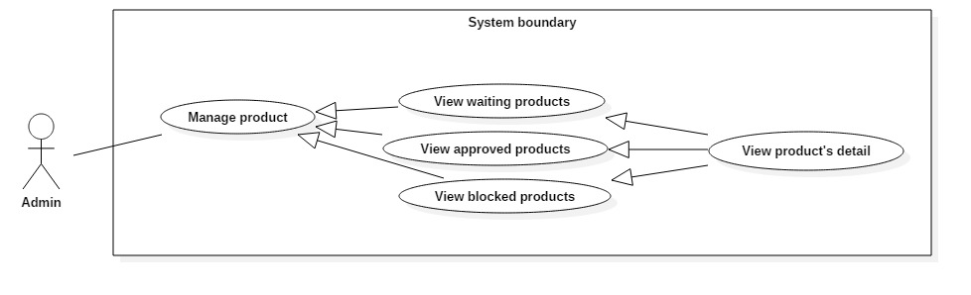

Figure 42: <Admin> View product’s detail

|  |  |  |  |
| --- | --- | --- | --- |
| **USE CASE – 4.8** | | | |
| **Use Case No.** | 4.8 | **Use Case Version** | 1.1 |
| **Use Case Name** | View product’s detail | | |
| **Author** | Le Dai An | | |
| **Date** | June 18, 2017 | **Priority** | High |
| **Actor:**   * Admin   **Summary:**   * This use case allows Admin view a product’s detail and view product’s photos list.   **Goal:**   * Display product’s detail and product’s photos list.   **Triggers:**  **Preconditions:**   * Actor logged in system with role Admin.   **Post Conditions:**   * **Success:** Product’s detail and photos list are displayed. * **Fail:**   **Main Success Scenario:**   |  |  |  | | --- | --- | --- | | Step | Actor Action | System Response | | 1 | Admin click on “Chi tiết” button. | System displays product’s detail and product’s photos.  [Exception 1] Lost Internet Connection. |   **Alternative Scenario:** N/A  **Exceptions:**   |  |  |  | | --- | --- | --- | | No | Cause | System Response | | 1 | Internet is disconnect. | Page with error code 404. |   **Relationships:** N/A  **Business Rules:** N/A | | | |

##### < Admin > Accept product

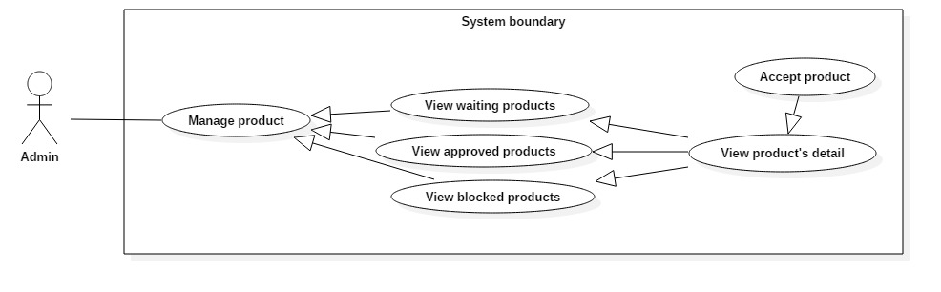

Figure 43: <Admin> Accept product

|  |  |  |  |
| --- | --- | --- | --- |
| **USE CASE – 4.9** | | | |
| **Use Case No.** | 4.9 | **Use Case Version** | 1.1 |
| **Use Case Name** | Accept product | | |
| **Author** | Le Dai An | | |
| **Date** | June 18, 2017 | **Priority** | High |
| **Actor:**   * Admin.   **Summary:**   * This use case allows Admin accept a product.   **Goal:**   * The product’s status is changed to “accepted” and system shows the product.   **Triggers:**  **Preconditions:**   * Actor logged in system with role Admin.   **Post Conditions:**   * **Success:** Product’s status is changed to “accepted”. * **Fail:**   **Main Success Scenario:**   |  |  |  | | --- | --- | --- | | Step | Actor Action | System Response | | 1 | Admin click on “Chấp nhận” button. | System redirects to before page.  [Exception 1] Lost Internet Connection. |   **Alternative Scenario:** N/A  **Exceptions:**   |  |  |  | | --- | --- | --- | | No | Cause | System Response | | 1 | Internet is disconnect. | Page with error code 404. |   **Relationships:** N/A  **Business Rules:** N/A | | | |

##### < Admin > Block product

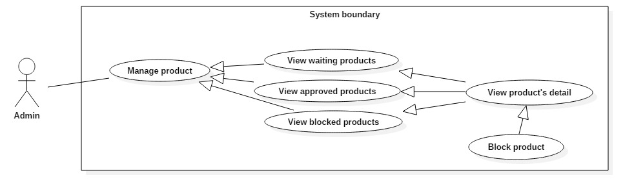

Figure 44: <Admin> Block product

|  |  |  |  |
| --- | --- | --- | --- |
| **USE CASE – 4.10** | | | |
| **Use Case No.** | 4.10 | **Use Case Version** | 1.1 |
| **Use Case Name** | Block product | | |
| **Author** | Le Dai An | | |
| **Date** | June 18, 2017 | **Priority** | High |
| **Actor:**   * Admin.   **Summary:**   * This use case allows Admin block a product.   **Goal:**   * The product’s status is changed to “blocked” and system hires the product.   **Triggers:**  **Preconditions:**   * Actor logged in system with role Admin.   **Post Conditions:**   * **Success:** Product’s status is changed to “blocked”. * **Fail:**   **Main Success Scenario:**   |  |  |  | | --- | --- | --- | | Step | Actor Action | System Response | | 1 | Admin click on “Chặn” button. | System redirects to before page.  [Exception 1] Lost Internet Connection. |   **Alternative Scenario:** N/A  **Exceptions:**   |  |  |  | | --- | --- | --- | | No | Cause | System Response | | 1 | Internet is disconnect. | Page with error code 404. |   **Relationships:** N/A  **Business Rules:** N/A | | | |

##### < Admin > View idea books

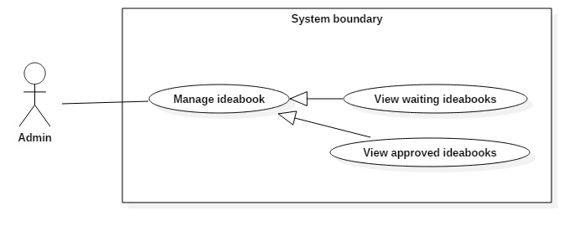

Figure 45: <Admin> View idea books

|  |  |  |  |
| --- | --- | --- | --- |
| **USE CASE – 4.11** | | | |
| **Use Case No.** | 4.11 | **Use Case Version** | 1.1 |
| **Use Case Name** | View products | | |
| **Author** | Le Dai An | | |
| **Date** | June 18, 2017 | **Priority** | Normal |
| **Actor:**   * Admin   **Summary:**   * This use case allows Admin to view idea books list include waiting and approved idea books.   **Goal:**   * A list waiting or approved idea books are displayed.   **Triggers:** Admin clicks on “Danh sách chờ duyệt”/”Danh sách đã duyệt” button in “Quản lý ideabooks” tab.  **Preconditions:**   * Actor logged in system with role Admin.   **Post Conditions:**   * **Success:** List of idea books based on waiting or approved idea book is showed. * **Fail:**   **Main Success Scenario:**   |  |  |  | | --- | --- | --- | | Step | Actor Action | System Response | | 1 | Admin clicks on “Ideabooks” tab.  Then clicks on “Danh sách chờ duyệt”/”Danh sách đã duyệt” button | System loads the result. Information for each idea book:   * A Photo * Email * Title * Category * Style   [Alternative 1]: There is no ideabook in system.  [Exception 1]: Internet connection is lost. |   **Alternative Scenario:**   |  |  |  | | --- | --- | --- | | Step | Cause | System Response | | 1 | System doesn’t have any idea book or no idea book in chosen status. | Web page has a table without content. |   **Exceptions:**   |  |  |  | | --- | --- | --- | | No | Cause | System Response | | 1 | Internet is disconnect. | Page with error code 404. |   **Relationships:** View idea books successfully so Admin can view idea book’s detail, approve idea book.  **Business Rules:** N/A | | | |

##### < Admin > Search idea books

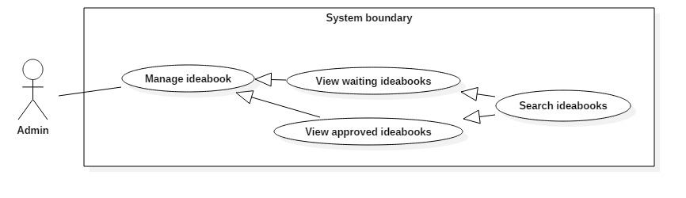

Figure 46: <Admin> Search idea books

|  |  |  |  |
| --- | --- | --- | --- |
| **USE CASE – 4.12** | | | |
| **Use Case No.** | 4.12 | **Use Case Version** | 1.1 |
| **Use Case Name** | Search idea books | | |
| **Author** | Le Dai An | | |
| **Date** | June 18, 2017 | **Priority** | Normal |
| **Actor:**   * Admin   **Summary:**   * This use case allows Admin to search idea book. So that admin can view idea book’s detail.   **Goal:**   * A list idea books that match input idea book’s name or email is displayed.   **Triggers:** Admin type in Search Command.  **Preconditions:**   * Actor logged in system with role Admin.   **Post Conditions:**   * **Success:** List of matching idea books based on search term is showed. * **Fail:**   **Main Success Scenario:**   |  |  |  | | --- | --- | --- | | Step | Actor Action | System Response | | 1 | - Types in Search command. | - System compare data in table with the input in Search command.  - Show results.  [Alternative 1]: There is no idea books matched with input text. |   **Alternative Scenario:**   |  |  |  | | --- | --- | --- | | Step | Cause | System Response | | 1 | - No idea books matched. | - Table without result. |   **Exceptions:** N/A  **Relationships:** N/A  **Business Rules:** N/A | | | |

##### < Admin > View idea book’s detail

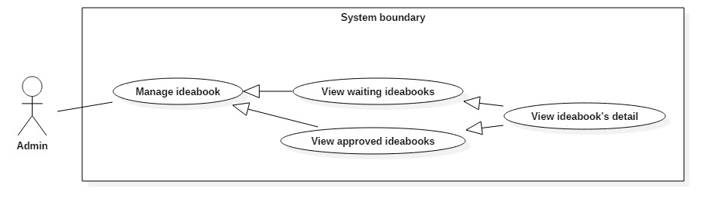

Figure 47: <Admin> View idea book’s detail

|  |  |  |  |
| --- | --- | --- | --- |
| **USE CASE – 4.13** | | | |
| **Use Case No.** | 4.13 | **Use Case Version** | 1.1 |
| **Use Case Name** | View idea book’s detail | | |
| **Author** | Le Dai An | | |
| **Date** | June 18, 2017 | **Priority** | Normal |
| **Actor:**   * Admin   **Summary:**   * This use case allows Admin view an idea book’s detail and view idea book’s photos list.   **Goal:**   * Display idea book’s detail and idea book’s photos list.   **Triggers:**  **Preconditions:**   * Actor logged in system with role Admin.   **Post Conditions:**   * **Success:** Project’s detail and photos list are displayed. * **Fail:**   **Main Success Scenario:**   |  |  |  | | --- | --- | --- | | Step | Actor Action | System Response | | 1 | Admin click on “Chi tiết” button. | System displays idea book’s detail and idea book’s photos list.  [Exception 1] Lost Internet Connection. |   **Alternative Scenario:** N/A  **Exceptions:**   |  |  |  | | --- | --- | --- | | No | Cause | System Response | | 1 | Internet is disconnect. | Page with error code 404. |   **Relationships:**  **Business Rules:** | | | |

##### < Admin > View projects

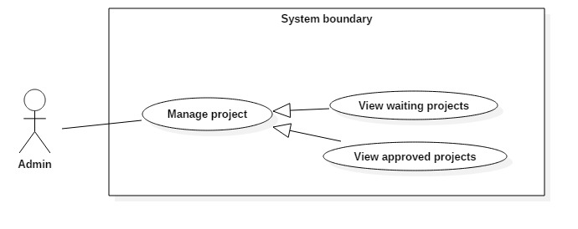

Figure 48: <Admin> View project

|  |  |  |  |
| --- | --- | --- | --- |
| **USE CASE – 4.14** | | | |
| **Use Case No.** | 4.14 | **Use Case Version** | 1.1 |
| **Use Case Name** | View projects | | |
| **Author** | Le Dai An | | |
| **Date** | June 18, 2017 | **Priority** | Normal |
| **Actor:**   * Borrower   **Summary:**   * This use case allows Borrowers to search book. So that borrowers can view status of book, add book to wish list.   **Goal:**   * A list books that match input book’s name is displayed.   **Triggers:** Borrower send Search Command.  **Preconditions:**   * Actor logged in system with role Borrower.   **Post Conditions:**   * **Success:** List of matching books based on search term is showed. * **Fail:** A Dialog will be showed and display message: “Search fail. Please check your internet connection”.   **Main Success Scenario:**   |  |  |  | | --- | --- | --- | | Step | Actor Action | System Response | | 1 | Admin clicks on “Projects” tab.  Then clicks on “Danh sách chờ duyệt”/”Danh sách đã duyệt” button | System loads the result. Information for each idea book:   * Email * Project’s name * Address * Cost * Year * Category * Style   [Alternative 1]: There is no project in system.  [Exception 1]: Internet connection is lost. |   **Alternative Scenario:**   |  |  |  | | --- | --- | --- | | Step | Cause | System Response | | 1 | System doesn’t have any project or no project in chosen status. | Web page has a table without content. |   **Exceptions:**   |  |  |  | | --- | --- | --- | | No | Cause | System Response | | 1 | Internet is disconnect. | Page with error code 404. |   **Relationships:** Search successfully so Borrower can add book to wish list if Book is not available at that time.  **Business Rules:**   * Search return the most matched book with the search term. * Book Title: free text * Position: free text, get floor, shelf from position table. * Author: free text, get author name from author table. * Is available: Available if total book copies is more than number of borrowing books. If not, it’s not available. | | | |

##### < Admin > Search projects

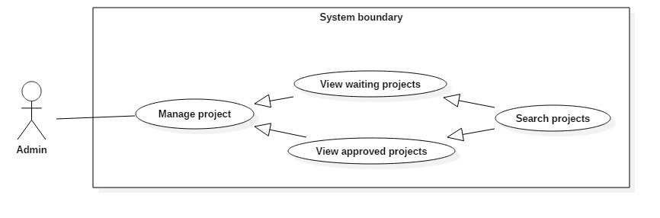

Figure 49: <Admin> Search project

|  |  |  |  |
| --- | --- | --- | --- |
| **USE CASE – 4.15** | | | |
| **Use Case No.** | 4.15 | **Use Case Version** | 1.1 |
| **Use Case Name** | Search projects | | |
| **Author** | Le Dai An | | |
| **Date** | June 18, 2017 | **Priority** | Normal |
| **Actor:**   * Admin   **Summary:**   * This use case allows Admin to search project. So that admin can view project’s detail.   **Goal:**   * A list projects that match input project’s name or email is displayed.   **Triggers:** Admin type in Search Command.  **Preconditions:**   * Actor logged in system with role Admin.   **Post Conditions:**   * **Success:** List of matching projects based on search term is showed. * **Fail:**   **Main Success Scenario:**   |  |  |  | | --- | --- | --- | | Step | Actor Action | System Response | | 1 | - Types in Search command. | - System compare data in table with the input in Search command.  - Show results.  [Alternative 1]: There is no projects matched with input text. |   **Alternative Scenario:**   |  |  |  | | --- | --- | --- | | Step | Cause | System Response | | 1 | - No projects matched. | - Table without result. |   **Exceptions:** N/A  **Relationships:** N/A  **Business Rules:** N/A | | | |

##### < Admin > View project’s detail

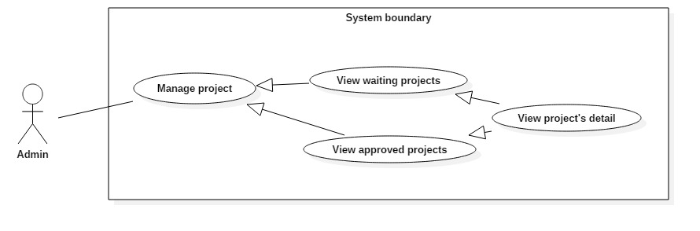

Figure 50: <Admin> View project

|  |  |  |  |
| --- | --- | --- | --- |
| **USE CASE – 4.16** | | | |
| **Use Case No.** | 4.16 | **Use Case Version** | 1.1 |
| **Use Case Name** | View project’s detail | | |
| **Author** | Le Dai An | | |
| **Date** | June 18, 2017 | **Priority** | Normal |
| **Actor:**   * Admin   **Summary:**   * This use case allows Admin view a project’s detail and view project’s photos list.   **Goal:**   * Display project’s detail and project’s photos list.   **Triggers:** Clicks on “Chi tiết” button.  **Preconditions:**   * Actor logged in system with role Admin.   **Post Conditions:**   * **Success:** Project’s detail and photos list are displayed. * **Fail:**   **Main Success Scenario:**   |  |  |  | | --- | --- | --- | | Step | Actor Action | System Response | | 1 | Admin clicks on “Chi tiết” button. | System displays project’s detail and project’s photos list.  [Exception 1] Lost Internet Connection. |   **Alternative Scenario:** N/A  **Exceptions:**   |  |  |  | | --- | --- | --- | | No | Cause | System Response | | 1 | Internet is disconnect. | Page with error code 404. |   **Relationships:**  **Business Rules:** | | | |

##### < Admin > View photo’s detail

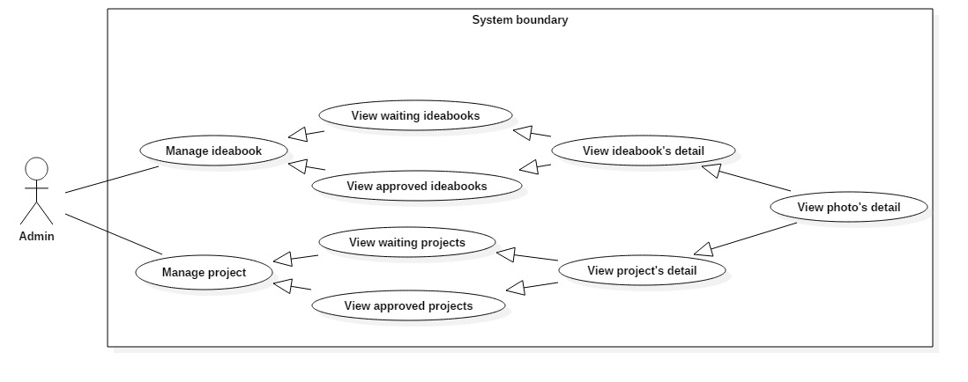

Figure 51: <Admin> View photo’s detail

|  |  |  |  |
| --- | --- | --- | --- |
| **USE CASE – 4.17** | | | |
| **Use Case No.** | 4.17 | **Use Case Version** | 1.1 |
| **Use Case Name** | View photo’s detail | | |
| **Author** | Le Dai An | | |
| **Date** | June 18, 2017 | **Priority** | Normal |
| **Actor:**   * Admin   **Summary:**   * This use case allows Admin view photo’s detail.   **Goal:**   * Display photo’s detail.   **Triggers:** Select a photo from in list.  **Preconditions:**   * Actor logged in system with role Admin.   **Post Conditions:**   * **Success:** Photo’s detail is displayed. * **Fail:**   **Main Success Scenario:**   |  |  |  | | --- | --- | --- | | Step | Actor Action | System Response | | 1 | Admin clicks to select a photo from photo list in an idea book or project. | System displays photo’s detail.  [Exception 1] Lost Internet Connection. |   **Alternative Scenario:** N/A  **Exceptions:**   |  |  |  | | --- | --- | --- | | No | Cause | System Response | | 1 | Internet is disconnect. | Page with error code 404. |   **Relationships:** N/A  **Business Rules:** N/A | | | |

##### < Admin > Accept photo

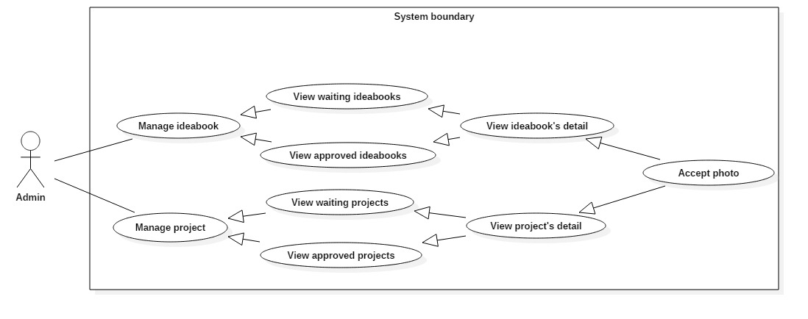

Figure 52: <Admin> Accept photo

|  |  |  |  |
| --- | --- | --- | --- |
| **USE CASE – 4.18** | | | |
| **Use Case No.** | 4.18 | **Use Case Version** | 1.1 |
| **Use Case Name** | Accept photo | | |
| **Author** | Le Dai An | | |
| **Date** | June 18, 2017 | **Priority** | High |
| **Actor:**   * Borrower.   **Summary:**   * This use case allows Admin accept a photo in ideabook or project.   **Goal:**   * The photo’s status is changed to “accepted” and publish photo in system.   **Triggers:** Clicks on “Chấp nhận” button.  **Preconditions:**   * Actor logged in system with role Admin.   **Post Conditions:**   * **Success:** Photo’s status is changed to blocked and display a correct image on the photo. * **Fail:**   **Main Success Scenario:**   |  |  |  | | --- | --- | --- | | Step | Actor Action | System Response | | 1 | Admin clicks on “Chấp nhận” button. | System refresh page and set correct icon on the photo.  [Exception 1] Lost Internet Connection. |   **Alternative Scenario:** N/A  **Exceptions:**   |  |  |  | | --- | --- | --- | | No | Cause | System Response | | 1 | Internet is disconnect. | Page with error code 404. |   **Relationships:** N/A  **Business Rules:** N/A | | | |

##### < Admin > Block photo

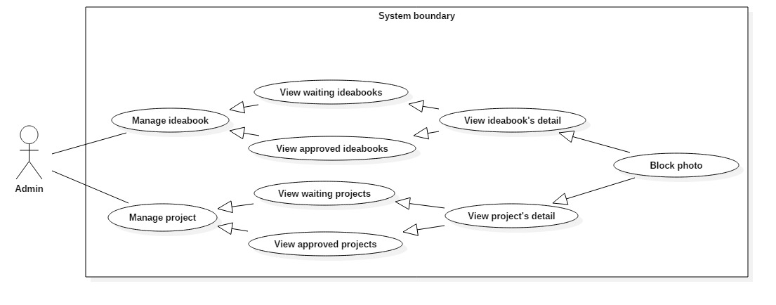

Figure 53: <Admin> Block photo

|  |  |  |  |
| --- | --- | --- | --- |
| **USE CASE – 4.19** | | | |
| **Use Case No.** | 4.19 | **Use Case Version** | 1.1 |
| **Use Case Name** | Block photo | | |
| **Author** | Le Dai An | | |
| **Date** | June 18, 2017 | **Priority** | High |
| **Actor:**   * Admin   **Summary:**   * This use case allows Admin block a photo in ideabook or project.   **Goal:**   * The photo’s status is changed to “blocked” and remove the photo from system.   **Triggers:** Clicks on “Chặn” button.  **Preconditions:**   * Actor logged in system with role Admin.   **Post Conditions:**   * **Success:** Photo’s status is changed to blocked and display a wrong image on the photo. * **Fail:**   **Main Success Scenario:**   |  |  |  | | --- | --- | --- | | Step | Actor Action | System Response | | 1 | Admin clicks on “Chặn” button. | System refresh page and set wrong icon on the photo.  [Exception 1] Lost Internet Connection. |   **Alternative Scenario:** N/A  **Exceptions:**   |  |  |  | | --- | --- | --- | | No | Cause | System Response | | 1 | Internet is disconnect. | Page with error code 404. |   **Relationships:** N/A  **Business Rules:** N/A | | | |

##### < Admin > Approve

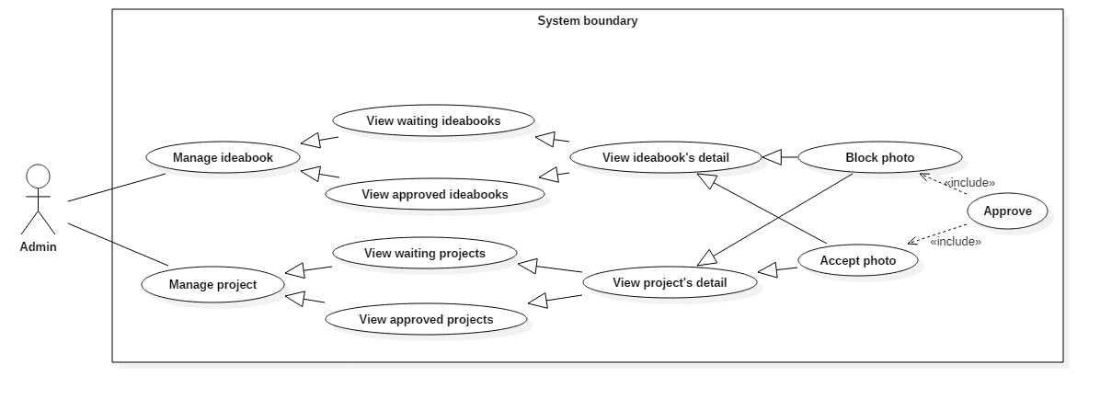

Figure 54: <Admin> Approve

|  |  |  |  |
| --- | --- | --- | --- |
| **USE CASE – 4.20** | | | |
| **Use Case No.** | 4.20 | **Use Case Version** | 1.1 |
| **Use Case Name** | Approve | | |
| **Author** | Le Dai An | | |
| **Date** | June 18, 2017 | **Priority** | Normal |
| **Actor:**   * Admin   **Summary:**   * This use case allows Admin approve an ideabook or project.   **Goal:**   * Set ideabook’s status or project’s status to accepted or blocked.   **Triggers:** Clicks on “Hoàn thành” button.  **Preconditions:**   * Actor logged in system with role Admin.   **Post Conditions:**   * **Success:** Ideabook’s status or project’s status is change and system redirects back to list page. * **Fail:** show message “Vui lòng duyệt hết tất cả hình ảnh!!”   **Main Success Scenario:**   |  |  |  | | --- | --- | --- | | Step | Actor Action | System Response | | 1 | Admin clicks on “Hoàn thành” button. | System redirects to before page.  [Alternative 1]: Idea book or project has photo is not approved yet.  [Exception 1] Lost Internet Connection. |   **Alternative Scenario:**   |  |  |  | | --- | --- | --- | | Step | Cause | System Response | | 1 | Photos in idea book or project are not approved completely. | Shows message “Vui lòng duyệt hết tất cả hình ảnh!!” |   **Exceptions:**   |  |  |  | | --- | --- | --- | | No | Cause | System Response | | 1 | Internet is disconnect. | Page with error code 404. |   **Relationships:** N/A  **Business Rules:** N/A | | | |

##### < Admin > Logout

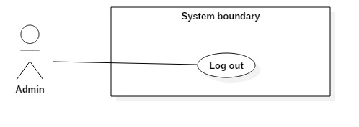

Figure 55: <Admin> Logout

|  |  |  |  |
| --- | --- | --- | --- |
| **USE CASE – 4.21** | | | |
| **Use Case No.** | 4.21 | **Use Case Version** | 1.0 |
| **Use Case Name** | Logout | | |
| **Author** | Le Dai An | | |
| **Date** | June 18, 2017 | **Priority** | Normal |
| **Actor:**   * Admin.   **Summary:**   * This use case allows Admin to logout of the system.   **Goal:**   * Invalidate the Admin, redirect to login view   **Triggers:** Clicks on log out icon or “Đăng xuất” button.  **Preconditions:** Actor logged in the system as an Admin.  **Post Conditions:**   * **Success:** Admin is logged out of the system. * **Fail:** N/A   **Main Success Scenario:**   |  |  |  | | --- | --- | --- | | Step | Actor Action | System Response | | 1 | - Admin clicks on Setting then clicks on “Đăng xuất” button. | - Clear session.  - System redirects the Admin to login view.  [Exception 1] Lost Internet Connection. |   **Alternative Scenario:** N/A  **Exceptions:**   |  |  |  | | --- | --- | --- | | No | Cause | System Response | | 1 | Internet is disconnect. | Page with error code 404. |   **Relationships:** N/A  **Business Rules:** N/A | | | |

#### System

##### < System > Add tracking

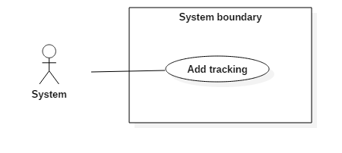

Figure 56: <System > Add tracking

|  |  |  |  |
| --- | --- | --- | --- |
| **USE CASE – 5.1** | | | |
| **Use Case No.** | 5.1 | **Use Case Version** | 1.0 |
| **Use Case Name** | Add tracking | | |
| **Author** | Vo Tran Hoang Long | | |
| **Date** | June 18, 2017 | **Priority** | Normal |
| **Actor:**   * System   **Summary:**   * This use case allows System keep tracking on user behavior   **Goal:**   * Keep tracking when user view photo and product on website   **Triggers:**  **Preconditions:** User view photo or product  **Post Conditions:**   * **Success:** User behavior is tracked * **Fail:** N/A   **Main Success Scenario:**   |  |  |  | | --- | --- | --- | | Step | Actor Action | System Response | | 1 | User view photo or product. | System catch the category of photo which was viewed by user and store in database |   **Alternative Scenario:**   |  |  |  | | --- | --- | --- | | No. | Actor Action | System Response | | 1 | |  |  |   **Exception:** N/A  **Relationships:** N/A  **Business Rules:** N/A | | | |

##### < System > Remove tracking

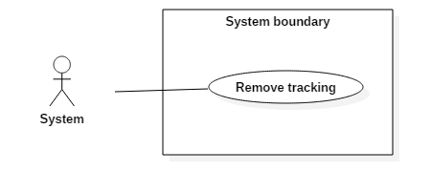

Figure 57: <System > Remove tracking

|  |  |  |  |
| --- | --- | --- | --- |
| **USE CASE – 5.2** | | | |
| **Use Case No.** | 5.2 | **Use Case Version** | 1.0 |
| **Use Case Name** | Remove tracking | | |
| **Author** | Vo Tran Hoang Long | | |
| **Date** | June 18, 2017 | **Priority** | Normal |
| **Actor:**   * System   **Summary:**   * This use case allows System automatically remove outdate tracking   **Goal:**   * This function will be run automatically at a specific time, it remove tracking which out of date base on a predefined period time variable.   **Triggers:**  **Preconditions:**  **Post Conditions:**   * **Success:** Outdate tracking is deleted * **Fail:** N/A   **Main Success Scenario:**   |  |  |  | | --- | --- | --- | | Step | Actor Action | System Response | | 1 | At the specific time, a crontab will run function to remove outdate tracking | System find and remove outdate tracking from database |   **Alternative Scenario:**   |  |  |  | | --- | --- | --- | | No. | Actor Action | System Response | | 1 | |  |  |   **Exception:** N/A  **Relationships:** N/A  **Business Rules:** N/A | | | |

##### < System > Send promotion to Customer

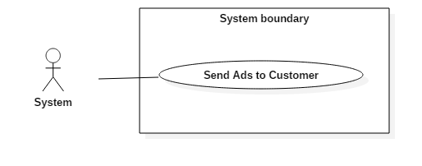

Figure 58: <System> Send Ads to Customer

|  |  |  |  |
| --- | --- | --- | --- |
| **USE CASE – 5.3** | | | |
| **Use Case No.** | 5.3 | **Use Case Version** | 1.0 |
| **Use Case Name** | Send promotion to Customer | | |
| **Author** | Vo Tran Hoang Long | | |
| **Date** | June 18, 2017 | **Priority** | Normal |
| **Actor:**   * System   **Summary:**   * This use case allows System automatically send Ads of promotion to Customer   **Goal:**   * This function will be run automatically at a specific time, it collect promotion and send them to customers who are interested in (base on “Tracking”).   **Triggers:**  **Preconditions:**  **Post Conditions:**   * **Success:** Promotions will be sent to customer * **Fail:** N/A   **Main Success Scenario:**   |  |  |  | | --- | --- | --- | | Step | Actor Action | System Response | | 1 | At the specific time, a crontab will run function to collect promotion and send them to customer via email | System collects promotion and email them to customer |   **Alternative Scenario:**   |  |  |  | | --- | --- | --- | | No. | Actor Action | System Response | | 1 | |  |  |   **Exception:** N/A  **Relationships:** N/A  **Business Rules:** N/A | | | |

##### < System > Send notification to Admin

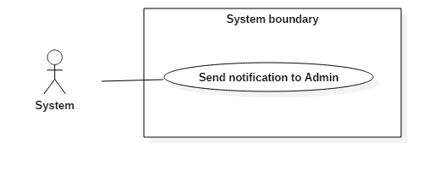

Figure 59: <System > Send notification to Admin

|  |  |  |  |
| --- | --- | --- | --- |
| **USE CASE – 5.4** | | | |
| **Use Case No.** | 5.4 | **Use Case Version** | 1.0 |
| **Use Case Name** | Send notification to Admin | | |
| **Author** | Vo Tran Hoang Long | | |
| **Date** | June 18, 2017 | **Priority** | Normal |
| **Actor:**   * System   **Summary:**   * This use case allows System automatically send notification to admin on admin page   **Goal:**   * This function will be run automatically, it check and notify to admin when:   + Product need approval   + New photo of project and idea book need approval   **Triggers:**  **Preconditions:**   * Product need approval * New photo of project and idea book need approval   **Post Conditions:**   * **Success:** Notification will be shown on admin page * **Fail:** N/A   **Main Success Scenario:**   |  |  |  | | --- | --- | --- | | Step | Actor Action | System Response | | 1 | At the specific time, a crontab will run function to check unapproved product and photo | System check and send notification to admin if it has any unapproved product or photo |   **Alternative Scenario:**   |  |  |  | | --- | --- | --- | | No. | Actor Action | System Response | | 1 | |  |  |   **Exception:** N/A  **Relationships:** N/A  **Business Rules:** N/A | | | |

##### < System > Send notification of product approval

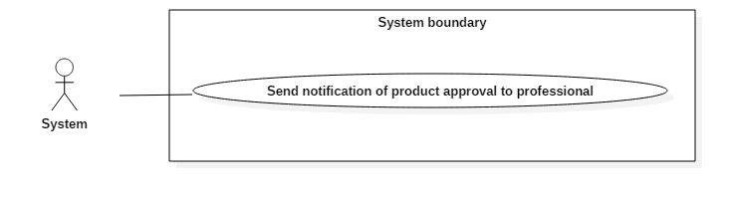

Figure 60: <System > Send notification of product approval

|  |  |  |  |
| --- | --- | --- | --- |
| **USE CASE – 5.5** | | | |
| **Use Case No.** | 5.5 | **Use Case Version** | 1.0 |
| **Use Case Name** | Send notification of product approval | | |
| **Author** | Vo Tran Hoang Long | | |
| **Date** | June 18, 2017 | **Priority** | Normal |
| **Actor:**   * System   **Summary:**   * This use case allows System automatically send notification to Professional when their product is approved (via email)   **Goal:**   * An email will be sent to Professional when Admin approve a Product.   **Triggers:**   * N/A   **Preconditions:**   * N/A   **Post Conditions:**   * **Success:** An email will be sent to Professional when Admin approve a Product. * **Fail:** N/A   **Main Success Scenario:**   |  |  |  | | --- | --- | --- | | Step | Actor Action | System Response | | 1 | Admin approve a Product | System will sent an email to Professional when their Product is approved |   **Alternative Scenario:**   |  |  |  | | --- | --- | --- | | No. | Actor Action | System Response | | 1 | |  |  |   **Exception:** N/A  **Relationships:** N/A  **Business Rules:** N/A | | | |

##### < System > Send notification of banned post



Figure 61: <System > Send notification of banned post

|  |  |  |  |
| --- | --- | --- | --- |
| **USE CASE – 5.6** | | | |
| **Use Case No.** | 5.6 | **Use Case Version** | 1.0 |
| **Use Case Name** | Send notification of banned post | | |
| **Author** | Vo Tran Hoang Long | | |
| **Date** | June 18, 2017 | **Priority** | Normal |
| **Actor:**   * System   **Summary:**   * This use case allows System automatically send notification to Professional or Customer when their post is banned (post is Product or photo in Idea Book, Project) via email   **Goal:**   * An email will be sent to Professional or Customer when Admin banned a post   **Triggers:**   * N/A   **Preconditions:**   * N/A   **Post Conditions:**   * **Success:** An email will be sent to Professional or Customer when Admin banned a post * **Fail:** N/A   **Main Success Scenario:**   |  |  |  | | --- | --- | --- | | Step | Actor Action | System Response | | 1 | Admin ban a post | System will sent an email to Customer or Professional when their post is banned |   **Alternative Scenario:**   |  |  |  | | --- | --- | --- | | No. | Actor Action | System Response | | 1 | |  |  |   **Exception:** N/A  **Relationships:** N/A  **Business Rules:** N/A | | | |

##### < System > Manage order

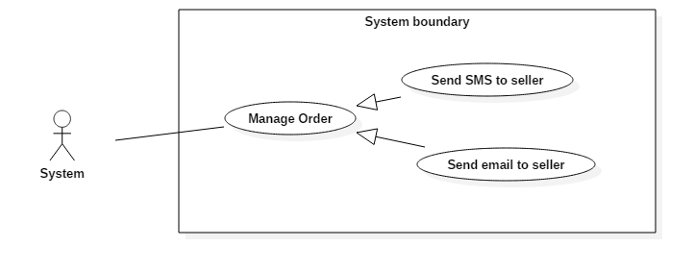

Figure 62: <System > Manage order

|  |  |  |  |
| --- | --- | --- | --- |
| **USE CASE – 5.7** | | | |
| **Use Case No.** | 5.7 | **Use Case Version** | 1.0 |
| **Use Case Name** | Manage order | | |
| **Author** | Vo Tran Hoang Long | | |
| **Date** | June 18, 2017 | **Priority** | Normal |
| **Actor:**   * System.   **Summary:**   * This use case allows System send email to seller when order is created   **Goal:**   * Send email to seller which appears in orders.   **Triggers:**  **Preconditions:** User checkout shopping cart.  **Post Conditions:**   * **Success:** Email will be sent to seller * **Fail:** N/A   **Main Success Scenario:**   |  |  |  | | --- | --- | --- | | Step | Actor Action | System Response | | 1 | User checkout shopping cart. | System send email to seller. |   **Alternative Scenario:**   |  |  |  | | --- | --- | --- | | No. | Actor Action | System Response | | 1 | |  |  |   **Exception:** N/A  **Relationships:** N/A  **Business Rules:** N/A | | | |

## Software System Attribute



### Usability

* The Web application for guest/ member/ professional/ seller will take less than 5 minutes to get used.
* The Web application for admin will take 10-30 minutes to get used to the system completely

### Reliability

* The number of sending notification failure is 1 time per 1000 notifications.
* Timer tasks run at configured time with 100% execution rate.

### Availability

* System is available 24 hours per day and 7 days per week.
* System should take at most 5 hours per month for backup or repairing.

### Security

* Privacy: Each role of user has a specific permission to interact with system.
* System always checks authorization and authenticated before doing anything.
* Only admin can grant permission to other roles.

### Maintenance

* The system is divided into separated modules.
* The code is easy to maintain and upgrade.

### Portability

* The web application is running on Windows Server 2008 or above.

### Performance

* Web appication handles the task within 30 seconds.



# Report 4 - Software Design Description

## Design Overview

* The architectural design describes the overall architecture of the system and the architecture of each main component and subsystem.
* The detailed design describes static and dynamic structure for each component and functions. It includes class diagrams, class explanations and sequence diagrams for each use cases.
* The database design describes the relationships between entities and details of each entity.
* Document overview:
* Section 1: gives an overall description of the system architecture design.
* Section 2: gives component diagrams that describe the connection and integration of the system.
* Section 3: gives the detail design description, which includes class diagram, class explanation, and sequence diagram to details the application functions.
* Section 4: gives the interface design description, which includes component interface, web application interface and mobile application design.
* Section 5: describe a fully attributed Entity Relationship Diagram.
* Section 6: describe the algorithms that apply to the system.

## System Architectural Design

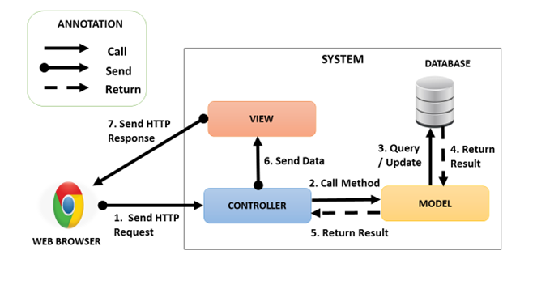

Figure 63: System Architectural Design

### Web Application Architecture Description

In Web Application, we develop the system under MVC architecture style. We choose this architecture for Web application because of following advantages:

* Web application contains Web services with MVC architecture; we can separate business code with Controller and View. In addition, we can use the business code in web service without repeat the code.
* We can organize the code better for maintainability, extensibility, reusability.
* In scope of 4-members team, MVC architecture makes it easier to split the big project into small modules and make it easier to assign each module for members in our team

## Component Diagram

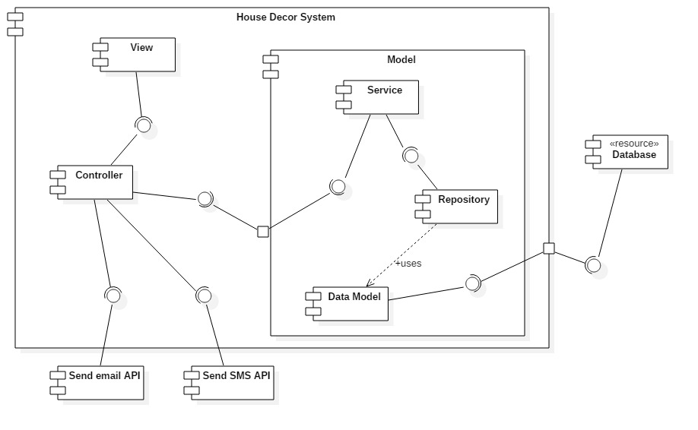

Figure 64: Web Service Architecture

|  |  |
| --- | --- |
| **Name** | **Description** |
| Controller | Common component used to handle request. |
| Service | Common component used to handle system’s business operations. |
| Repository | Component used to handle interaction between the system and database. |
| Data Model | Class entity |
| Database | Support storage and manipulate data. |
| Send email API | Provide API for send email. |
| Send SMS API | Provide API for send SMS. |

Table 12: Component Dictionary

## Detailed Description

### Class Diagram

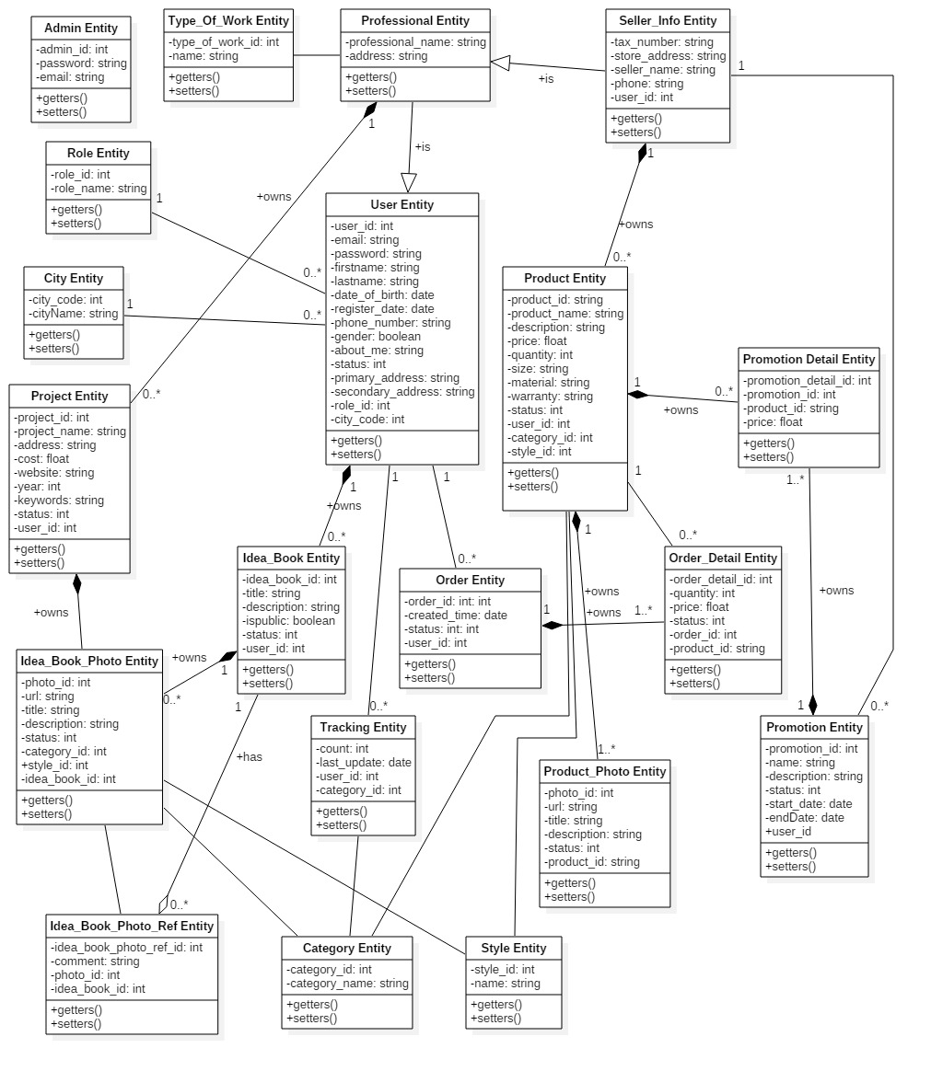

Figure 65: Web Service Architecture

|  |  |  |
| --- | --- | --- |
| **Class name** | **Mapping column with conceptual diagram** | **Description** |
| Admin Entity | Admin | Admin’s accounts in the system. |
| Professional Entity | Account | Professional’s information in the system. |
| User Entity | User | User’s accounts in the system. |
| Role Entity | Role | Roles in the system. |
| Order Entity | Order | Orders in the system. |
| Order Detail Entity | Order Detail | Order’s details in the system. |
| City Entity | City | Cities in the system. |
| Tracking Entity | Tracking | Tracking user’s activities in the system. |
| Category Entity | Category | Categories in the system. Example of category are . |
| Idea_Book_Photo Entity | Idea Book Photo | Idea book and project photos in the system. |
| Idea_Book_Photo_Ref Entity | Idea Book Photo Ref | Photos are saved from other idea books, projects in the system. |
| Project Entity | Project | Projects in the system. |
| Idea_Book Entity | Idea Book | Idea books in the system. |
| Product_Photo Entity | Product Photo | Product’s photos in the system. |
| Type_Of_Work Entity | Type of Work | Types of work in the system. |
| Seller_Info_Entity | Seller Info | Seller’s informations in the system. |
| Promotion Entity | Promotion | Promotions in the system. |
| Promotion_Detail Entity | Promotion Detail | Promotion details in the system. |
| Product Entity | Product | Products in the system. |
| Style Entity | Style | Styles in the system. |

Table 13: Class Diagram Dictionary

### Class Diagram Explanation

#### Admin

**Attributes**

|  |  |  |  |
| --- | --- | --- | --- |
| **Attribute** | **Type** | **Visibility** | **Description** |
| id | Integer | Private | Unique id of an account. |
| password | String | Private | Password of an account. |
| email | String | Private | Email of an account. |
| Table 13: Admin class attributes explanation | | | |

**Methods**

|  |  |  |  |
| --- | --- | --- | --- |
| **Method** | **Return type** | **Visibility** | **Description** |
| Getter | Attribute type | Public | Get attribute value |
| Setter | Void | Public | Set value of attribute |
| Table 14: Admin class methods explanation | | | |

#### Professional

**Attributes**

|  |  |  |  |
| --- | --- | --- | --- |
| **Attribute** | **Type** | **Visibility** | **Description** |
| nameProfessional | String | Private | Unique id of an professional. |
| address | String | Private | Address of an professional. |
| userId | Integer | Private | Id of user. |
| TypeOfWorkId | Integer | Private | Id of TypeOfWork |
| Table 15: Professional class attributes explanation | | | |

**Methods**

|  |  |  |  |
| --- | --- | --- | --- |
| **Method** | **Return type** | **Visibility** | **Description** |
| Getter | Attribute type | Public | Get attribute value |
| Setter | Void | Public | Set value of attribute |
| Table 16: Professional method methods explanation | | | |

#### User

**Attributes**

|  |  |  |  |
| --- | --- | --- | --- |
| **Attribute** | **Type** | **Visibility** | **Description** |
| userId | Integer | Private | Unique id of user role. |
| email | String | Private | Email of an user. |
| Password | String | Private | Password of an user. |
| Firstname | String | Private | Firstname of an user. |
| Lastname | String | Private | Lastname of an user. |
| DateOfBirth | Date | Private | Birthdate of an user. |
| RegisterDate | Date | Private | Register date of an user. |
| PhoneNumber | String | Private | Phone number of an user. |
| RoleId | Integer | Private | Id of role. |
| Gender | Integer | Private | Gender of an user. |
| AboutMe | String | Private | Description about user. |
| Status | Integer | Private | Status of an user. |
| PrimaryAddress | String | Private | Primary address of an user. |
| SecondAddress | String | Private | Second address of an user. |
| cityCode | Integer | Private | Code of city |
| Table 17: User class attributes explanation | | | |

**Methods**

|  |  |  |  |
| --- | --- | --- | --- |
| **Method** | **Return type** | **Visibility** | **Description** |
| Getter | Attribute type | Public | Get attribute value |
| Setter | Void | Public | Set value of attribute |
| Table 18: User class methods explanation | | | |

#### Role

**Attributes**

|  |  |  |  |
| --- | --- | --- | --- |
| **Attribute** | **Type** | **Visibility** | **Description** |
| RoleId | Integer | Private | Unique id of a role. |
| RoleName | String | Private | Name of a role. |
| Table 19: Role class attributes explanation | | | |

**Methods**

|  |  |  |  |
| --- | --- | --- | --- |
| **Method** | **Return type** | **Visibility** | **Description** |
| Getter | Attribute type | Public | Get attribute value |
| Setter | Void | Public | Set value of attribute |
| Table 20: Role class methods explanation | | | |

#### Order

**Attributes**

|  |  |  |  |  |  |  |
| --- | --- | --- | --- | --- | --- | --- |
| **Attribute** | | **Type** | | **Visibility** | | **Description** |
| OrderId | | Integer | | Private | | Unique id of a order. |
| CreatedTime | | Date | | Private | | Created time of an order. |
| Status | Integer | | Private | | Status of an order. | |
| UserId | Integer | | Private | | Id of user. | |
| Table 21: Order class attributes explanation | | | | | | |

**Methods**

|  |  |  |  |
| --- | --- | --- | --- |
| **Method** | **Return type** | **Visibility** | **Description** |
| Getter | Attribute type | Public | Get attribute value |
| Setter | Void | Public | Set value of attribute |
| Table 22: Order class methods description | | | |

#### Order Detail

**Attributes**

|  |  |  |  |
| --- | --- | --- | --- |
| **Attribute** | **Type** | **Visibility** | **Description** |
| OrderDetailId | Integer | Private | Unique id of an OrderDetail. |
| ProductId | Integer | Private | Id of product. |
| Quantity | Integer | Private | Quantity of an product. |
| Price | Float | Private | Price of an product. |
| StoreId | Integer | Private | Id of store. |
| Status | Integer | Private | Status of an OrderDetail. |
| OrderId | Integer | Private | Id of an order. |
| Table 23: Order Detail class attributes explanation | | | |

**Methods**

|  |  |  |  |
| --- | --- | --- | --- |
| **Method** | **Return type** | **Visibility** | **Description** |
| Getter | Attribute type | Public | Get attribute value |
| Setter | Void | Public | Set value of attribute |
| Table 24: Order Detail class methods explanation | | | |

#### City

**Attributes**

|  |  |  |  |
| --- | --- | --- | --- |
| **Attribute** | **Type** | **Visibility** | **Description** |
| CityCode | Integer | Private | Unique id of a City. |
| CityName | String | Private | Name of a city. |
| Table 25: City class attributes explanation | | | |

**Methods**

|  |  |  |  |
| --- | --- | --- | --- |
| **Method** | **Return type** | **Visibility** | **Description** |
| Getter | Attribute type | Public | Get attribute value |
| Setter | Void | Public | Set value of attribute |
| Table 26: City class methods explanation | | | |

#### Tracking

**Attributes**

|  |  |  |  |
| --- | --- | --- | --- |
| **Attribute** | **Type** | **Visibility** | **Description** |
| Count | Integer | Private | Unique id of an author. |
| LastUpdate | Date | Private | Last update date. |
| UserId | Integer | Private | Id of an user. |
| CategoryId | Integer |  | Id of a category |
| Table 27: Tracking class attributes explanation | | | |

**Methods**

|  |  |  |  |
| --- | --- | --- | --- |
| **Method** | **Return type** | **Visibility** | **Description** |
| Getter | Attribute type | Public | Get attribute value |
| Setter | Void | Public | Set value of attribute |
| Table 28: Tracking class methods explanation | | | |

#### Category

**Attributes**

|  |  |  |  |
| --- | --- | --- | --- |
| **Attribute** | **Type** | **Visibility** | **Description** |
| CategoryId | Integer | Private | Unique id of a category. |
| CategoryName | String | Private | Name of a category. |
| Table 29: Category class attributes explanation | | | |

**Methods**

|  |  |  |  |
| --- | --- | --- | --- |
| **Method** | **Return type** | **Visibility** | **Description** |
| Getter | Attribute type | Public | Get attribute value |
| Setter | Void | Public | Set value of attribute |
| Table 30: Category class methods explanation | | | |

#### Idea Book Photo

**Attributes**

|  |  |  |  |
| --- | --- | --- | --- |
| **Attribute** | **Type** | **Visibility** | **Description** |
| PhotoId | Integer | Private | Unique id of a Photo. |
| Url | String | Private | Url of a photo. |
| Title | String | Private | Title of a photo. |
| Description | String | Private | Description of a photo |
| Status | Integer | Private | Status of a photo. |
| ProjectId | Integer | Private | Id of a project. |
| CategoryId | Integer | Private | Id of a categegory. |
| StyleId | Integer | Private | Id of a style. |
| Table 31: Photo class attributes explanation | | | |

**Methods**

|  |  |  |  |
| --- | --- | --- | --- |
| **Method** | **Return type** | **Visibility** | **Description** |
| Getter | Attribute type | Public | Get attribute value |
| Setter | Void | Public | Set value of attribute |
| Table 32: Photo class methods explanation | | | |

#### Project

**Attributes**

|  |  |  |  |
| --- | --- | --- | --- |
| **Attribute** | **Type** | **Visibility** | **Description** |
| ProjectId | Integer | Private | Unique id of a Project. |
| ProjectName | String | Private | Name of a project. |
| Address | String | Private | Address of a project. |
| Cost | Float | Private | Cost of a project. |
| Website | String | Private | Website of a project. |
| Year | Integer | Private | Year of a project |
| Keywords | String | Private | Keywords of a project. |
| Status | Integer | Private | Status of a project. |
| UserId | Integer | Private | Id of an user. |
| Table 33: Project class attributes explanation | | | |

**Methods**

|  |  |  |  |
| --- | --- | --- | --- |
| **Method** | **Return type** | **Visibility** | **Description** |
| Getter | Attribute type | Public | Get attribute value |
| Setter | Void | Public | Set value of attribute |
| Table 34: Project class methods explanation | | | |

#### Idea Book

**Attributes**

|  |  |  |  |
| --- | --- | --- | --- |
| **Attribute** | **Type** | **Visibility** | **Description** |
| IdeabookId | Integer | Private | Unique id of a idea book. |
| Title | String | Private | Title of an idea book. |
| Description | String | Private | Description of an idea book. |
| IsPublic | Integer | Private | Idea book is public or not. |
| Status | Integer | Private | Status of an idea book. |
| UserId | Integer | Private | Id of an user. |

Table 35: Idea book class attributes explanation

**Methods**

|  |  |  |  |
| --- | --- | --- | --- |
| **Method** | **Return type** | **Visibility** | **Description** |
| Getter | Attribute type | Public | Get attribute value |
| Setter | Void | Public | Set value of attribute |

Table 36: Idea book class methods explanation

#### Product Photo

**Attributes**

|  |  |  |  |
| --- | --- | --- | --- |
| **Attribute** | **Type** | **Visibility** | **Description** |
| ProductPhotoId | Integer | Private | Unique id of a product’s photo. |
| Url | String | Private | Url of a product’s photo. |
| Title | String | Private | Title of a product’s photo. |
| Description | String | Private | Description of a product’s photo. |
| Status | Integer | Private | Status of a product’s photo. |
| Product_ProductId | Integer | Private | Id of a product |
| Table 37: Product Photo class attributes explanation | | | |

**Methods**

|  |  |  |  |
| --- | --- | --- | --- |
| **Method** | **Return type** | **Visibility** | **Description** |
| Getter | Attribute type | Public | Get attribute value |
| Setter | Void | Public | Set value of attribute |
| Table 38: Product Photo method methods explanation | | | |

#### Type of Work

**Attributes**

|  |  |  |  |
| --- | --- | --- | --- |
| **Attribute** | **Type** | **Visibility** | **Description** |
| Id | Integer | Private | Unique id of a type of work. |
| Name | String | Private | Name of a type of work. |
| Table 39: Type Of Work class attributes explanation | | | |

**Methods**

|  |  |  |  |
| --- | --- | --- | --- |
| **Method** | **Return type** | **Visibility** | **Description** |
| Getter | Attribute type | Public | Get attribute value |
| Setter | Void | Public | Set value of attribute |
| Table 40: Type Of Work method methods explanation | | | |

#### Seller

**Attributes**

|  |  |  |  |
| --- | --- | --- | --- |
| **Attribute** | **Type** | **Visibility** | **Description** |
| TaxNumber | String | Private | Unique id of a seller. |
| StoreAddress | String | Private | Store address. |
| SellerName | String | Private | Name of a seller. |
| StartDate | Date | Private | Date seller open store on system. |
| DueDate | Date | Private | Date seller close store on system. |
| Phone | String | Private | Phone of a seller. |
| UserId | Integer | Private | Id of an user. |
| Table 41: Seller class attributes explanation | | | |

**Methods**

|  |  |  |  |
| --- | --- | --- | --- |
| **Method** | **Return type** | **Visibility** | **Description** |
| Getter | Attribute type | Public | Get attribute value |
| Setter | Void | Public | Set value of attribute |
| Table 42: Seller method methods explanation | | | |

#### Promotion

**Attributes**

|  |  |  |  |
| --- | --- | --- | --- |
| **Attribute** | **Type** | **Visibility** | **Description** |
| Id | Integer | Private | Unique id of a promotion. |
| Name | String | Private | Name of a promotion. |
| Description | String | Private | Description of a promotion. |
| Status | Integer | Private | Status of a promotion. |
| StartDate | Date | Private | Date promotion start on system. |
| EndDate | Date | Private | Date promotion end on system. |
| userId | Integer | Private | Id of a user. |
| Table 43: Promotion class attributes explanation | | | |

**Methods**

|  |  |  |  |
| --- | --- | --- | --- |
| **Method** | **Return type** | **Visibility** | **Description** |
| Getter | Attribute type | Public | Get attribute value |
| Setter | Void | Public | Set value of attribute |
| Table 44: Promotion method methods explanation | | | |

#### Product

**Attributes**

|  |  |  |  |
| --- | --- | --- | --- |
| **Attribute** | **Type** | **Visibility** | **Description** |
| ProductId | Integer | Private | Unique id of a Product. |
| ProductName | String | Private | Name of a product. |
| Desciption | String | Private | Desciption of a product. |
| Price | Float | Private | Price of a product. |
| Quantity | Integer | Private | Quantity of a product. |
| Size | String | Private | Size of a product. |
| Material | String | Private | Material of a product. |
| Warranty | String | Private | Warranty of a product. |
| Status | Integer | Private | Status of a product. |
| Style_StyleId | Integer | Private | Id of a style. |
| Category_CategoryId | Integer | Private | Id of a category. |
| Seller_UserId | Integer | Private | Id of user is seller. |
| Table 45: Product class attributes explanation | | | |

**Methods**

|  |  |  |  |
| --- | --- | --- | --- |
| **Method** | **Return type** | **Visibility** | **Description** |
| Getter | Attribute type | Public | Get attribute value |
| Setter | Void | Public | Set value of attribute |
| Table 46: Product method methods explanation | | | |

#### Style

**Attributes**

|  |  |  |  |
| --- | --- | --- | --- |
| **Attribute** | **Type** | **Visibility** | **Description** |
| StyleId | Integer | Private | Unique id of a Style. |
| Name | String | Private | Name of a style. |
| Table 47: Style class attributes explanation | | | |

**Methods**

|  |  |  |  |
| --- | --- | --- | --- |
| **Method** | **Return type** | **Visibility** | **Description** |
| Getter | Attribute type | Public | Get attribute value |
| Setter | Void | Public | Set value of attribute |
| Table 48: Style method methods explanation | | | |

#### Promotion Detail

**Attributes**

|  |  |  |  |
| --- | --- | --- | --- |
| **Attribute** | **Type** | **Visibility** | **Description** |
| PromotionDetailId | Integer | Private | Unique id of a Promotion detail. |
| PromotionId | Integr | Private | Id of a promotion. |
| ProductId | String | Private | Id of a product. |
| Price | Float | Private | Discounted price. |
| Table 49: Promotion Detail class attributes explanation | | | |

**Methods**

|  |  |  |  |
| --- | --- | --- | --- |
| **Method** | **Return type** | **Visibility** | **Description** |
| Getter | Attribute type | Public | Get attribute value |
| Setter | Void | Public | Set value of attribute |
| Table 50: Promotion Detail method methods explanation | | | |

#### Idea Book Photo Ref

**Attributes**

|  |  |  |  |
| --- | --- | --- | --- |
| **Attribute** | **Type** | **Visibility** | **Description** |
| IdeabookPhotoRefId | Integer | Private | Unique id of an Idea book photo ref. |
| Comment | String | Private | Comment of a photo. |
| PhotoId | Integer | Private | Id of a photo. |
| IdeabookId | Integer | Private | Id of an idea book. |
| Table 51: Idea Book Photo Ref class attributes explanation | | | |

**Methods**

|  |  |  |  |
| --- | --- | --- | --- |
| **Method** | **Return type** | **Visibility** | **Description** |
| Getter | Attribute type | Public | Get attribute value |
| Setter | Void | Public | Set value of attribute |
| Table 52: Idea Book Photo Ref method methods explanation | | | |

### Interaction Diagram

Web Application

#### Guest

##### < Guest > View Idea Book Detail

Sumary: This diagram shows the process of load idea book return idea book detail.

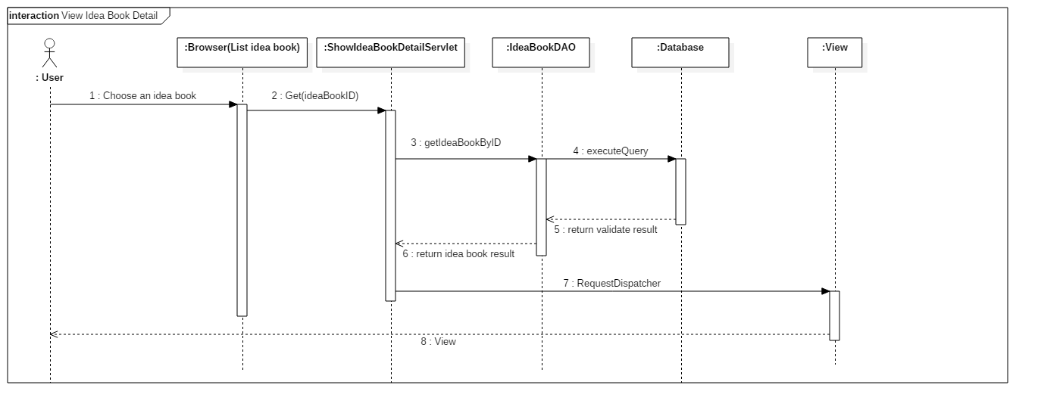

##### < Guest > View Product Detail

Sumary: This diagram shows the process of load product return product detail.

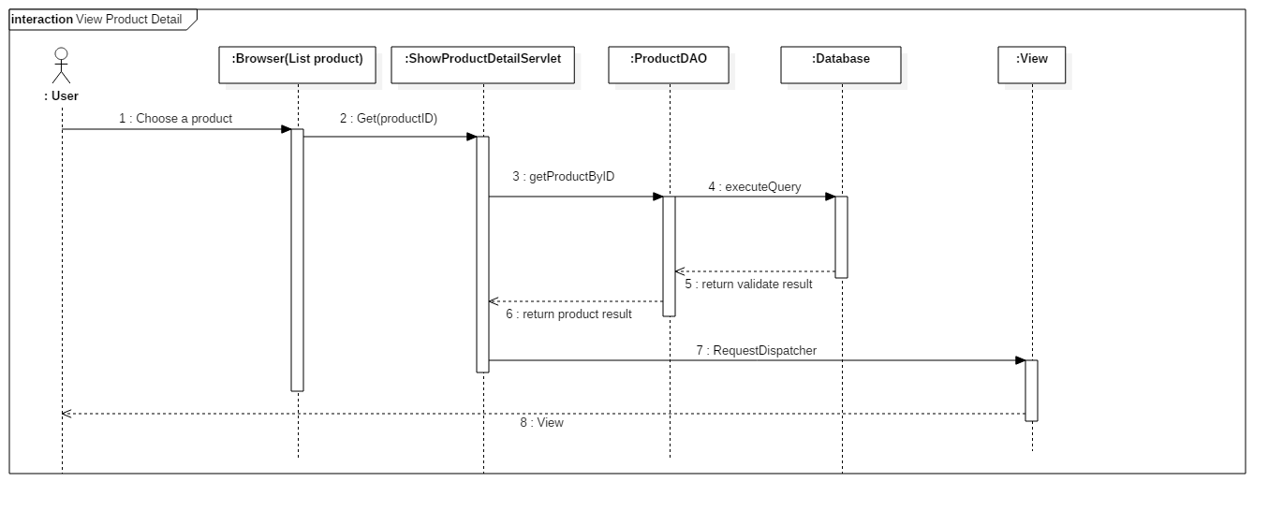

#### Member

##### < Member > Create Idea Book

Sumary: This diagram shows the process of create idea book by user.

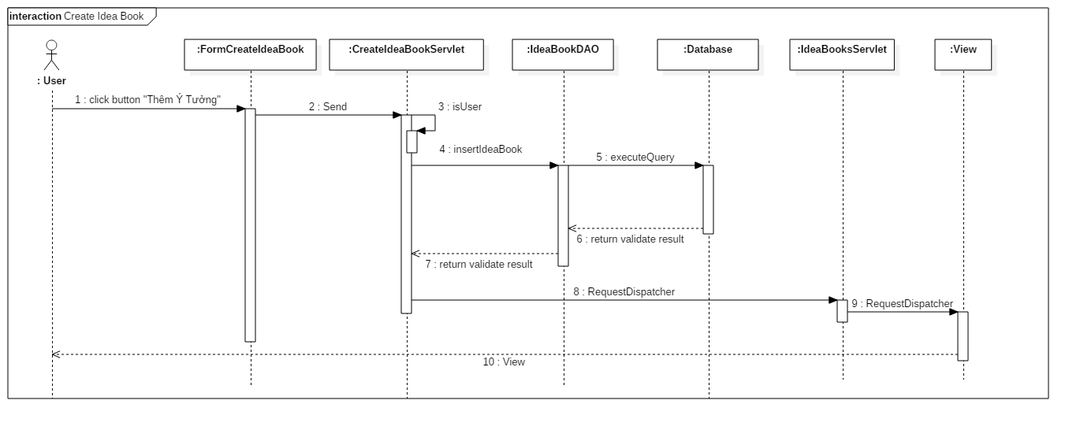

##### < Member > Order Product

Sumary: This diagram shows the process of order product by user.

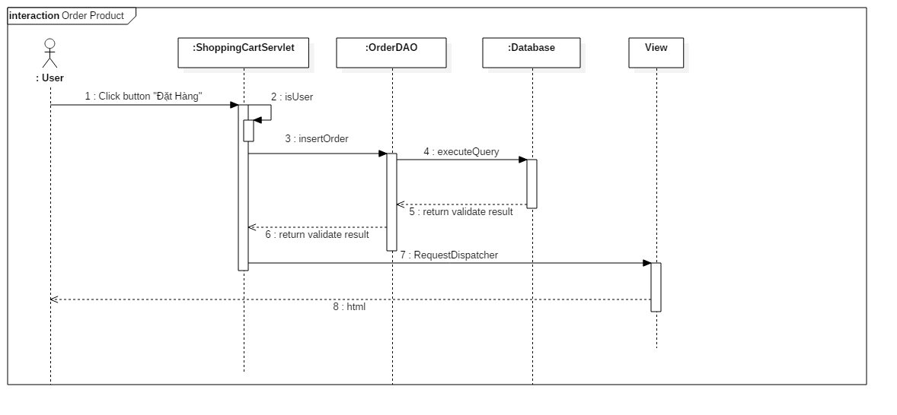

#### Professional

##### < Professional > Create project

Sumary: This diagram shows the process of create project by professional.

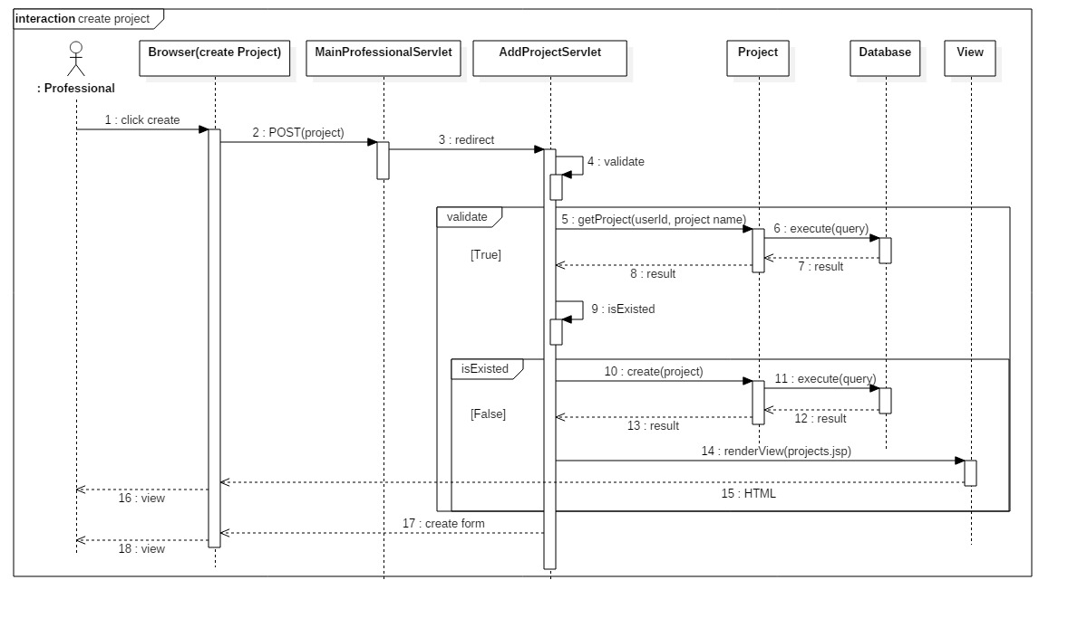

##### < Seller > Add Product

Sumary: This diagram shows the process of add product by seller.

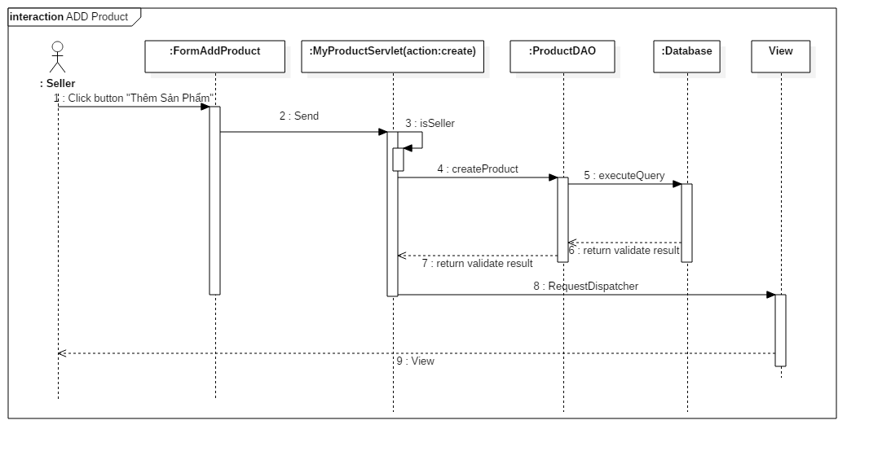

#### Admin

Sumary: The diagrams shows the process of load product list, view details about a product with product’s photos and update product’s status.

##### < Admin > Load Products

Sumary: This diagram shows the process of load product list return product list by product’s status.

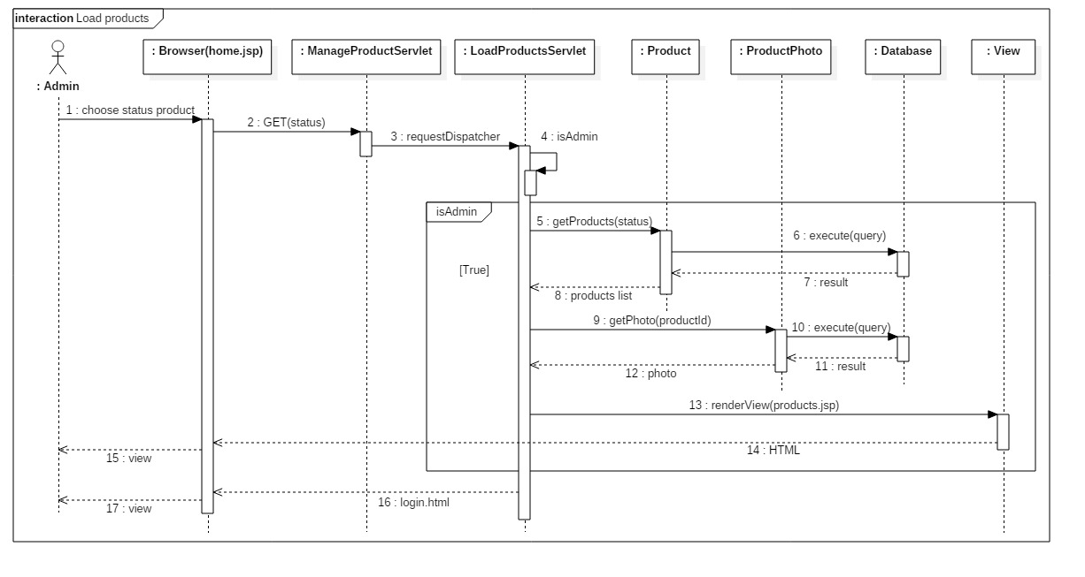

##### < Admin > View Product’s Detail

Sumary: This diagram shows the process of view product’s detail return product’s detail and product’s photos.

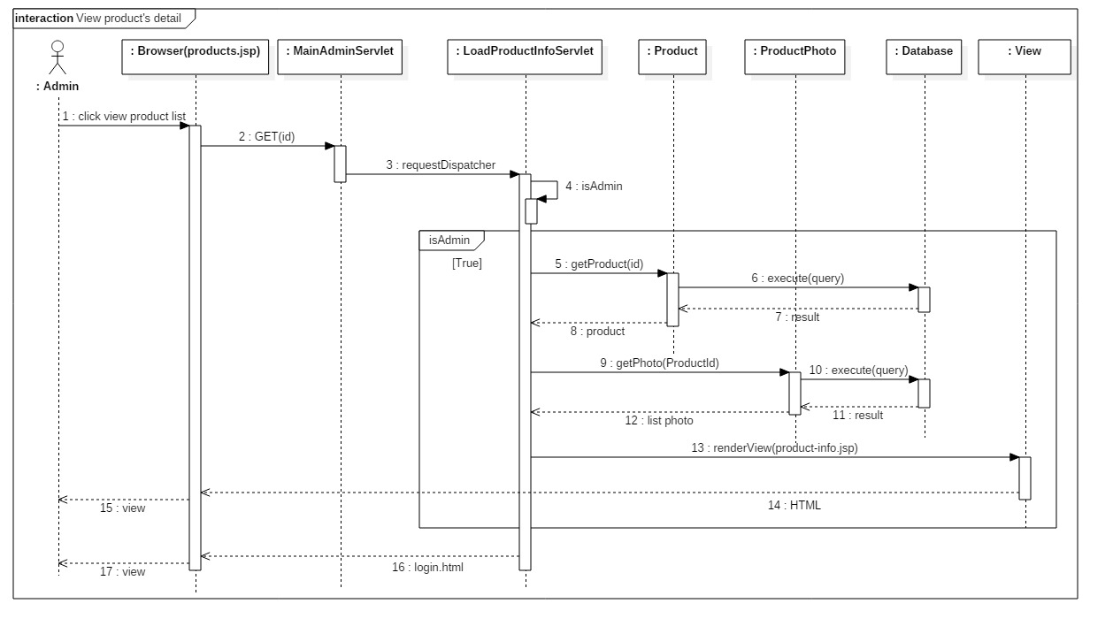

##### < Admin > Update Product’s Status

Sumary: This diagram shows the process of update product’s status.

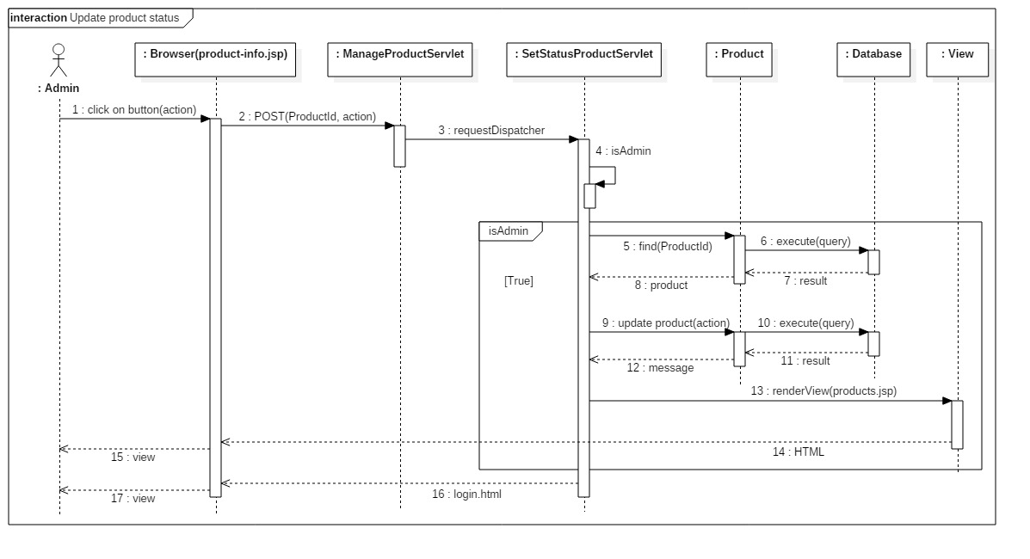

#### System

##### < System > Tracking

Sumary: This diagram shows the process of tracking in system.

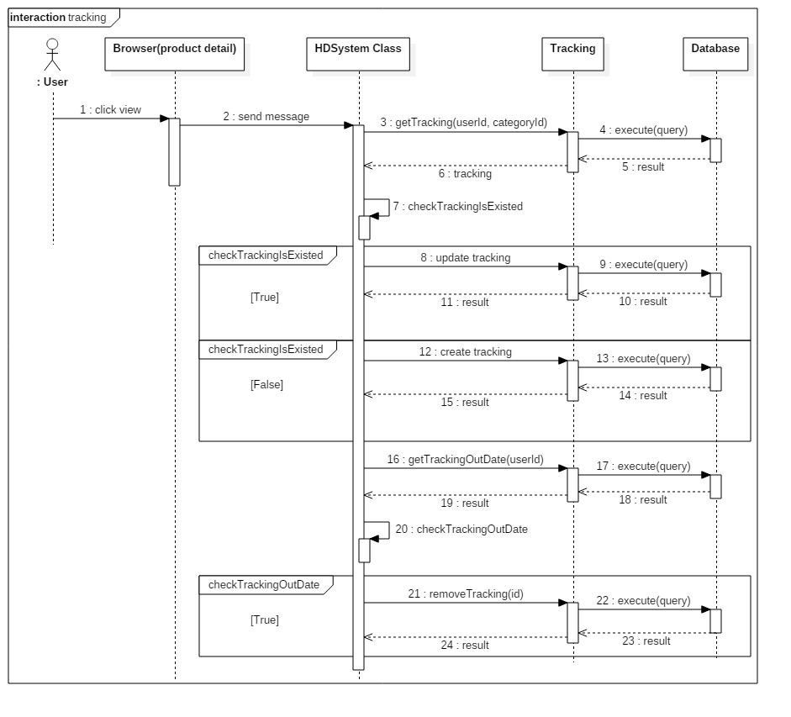

## Interface

### Component interface

### User Interface Design

#### Guest

##### < Guest > View photo

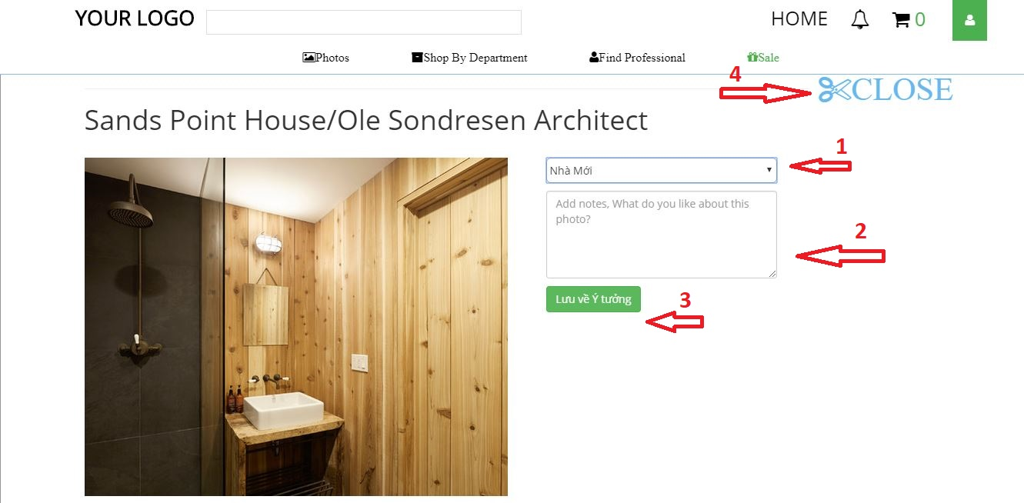

**Fields**

|  |  |  |  |  |  |  |  |
| --- | --- | --- | --- | --- | --- | --- | --- |
| **No** | **Field Name** | **Description** | **Read Only** | **Mandatory** | **Control Type** | **Data Type** | **Length** |
| **1** | Name idea book | Your list idea book | No | Yes | Drop down | String | N/A |
| **2** | Description photo | Description photo to save your idea book | No | No | Text box | String | N/A |

**Buttons/Hyperlinks**

|  |  |  |  |  |
| --- | --- | --- | --- | --- |
| **No** | **Function** | **Description** | **Validation** | **Outcome** |
| **3** | Lưu về Ý tưởng | Save image into your idea book. | N/A | Your idea book you just added photo |
| **4** | Close | Close page photo detail. | N/A | List of photos before |

##### < Guest > Search Professional

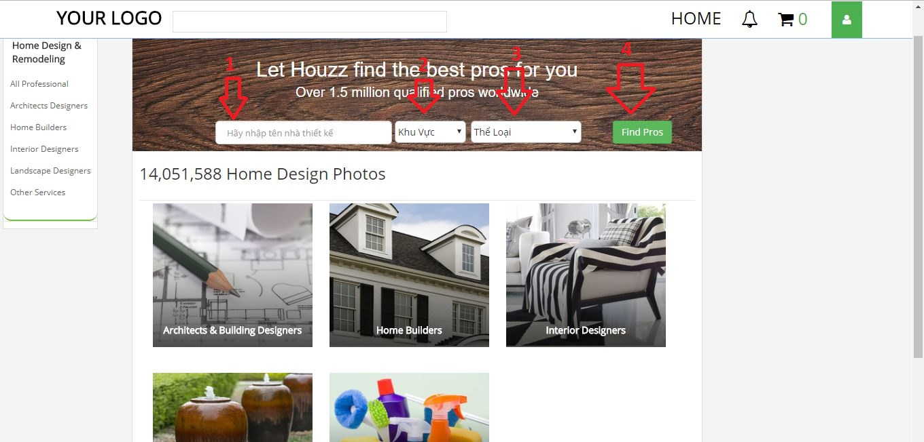

**Fields**

|  |  |  |  |  |  |  |  |
| --- | --- | --- | --- | --- | --- | --- | --- |
| **No** | **Field Name** | **Description** | **Read Only** | **Mandatory** | **Control Type** | **Data Type** | **Length** |
| **1** | Name Professional | Search professional’s name | No | No | Text box | String | N/A |
| **2** | Location | Search location of professional | No | No | Drop down | String | N/A |
| **3** | Type of work | Search professional by type of work | No | No | Drop down | String | N/A |

**Buttons/Hyperlinks**

|  |  |  |  |  |
| --- | --- | --- | --- | --- |
| **No** | **Function** | **Description** | **Validation** | **Outcome** |
| **4** | Find Pros | Search professional | N/A | List of professional. |

#### Member

##### < Member > Member’s idea book

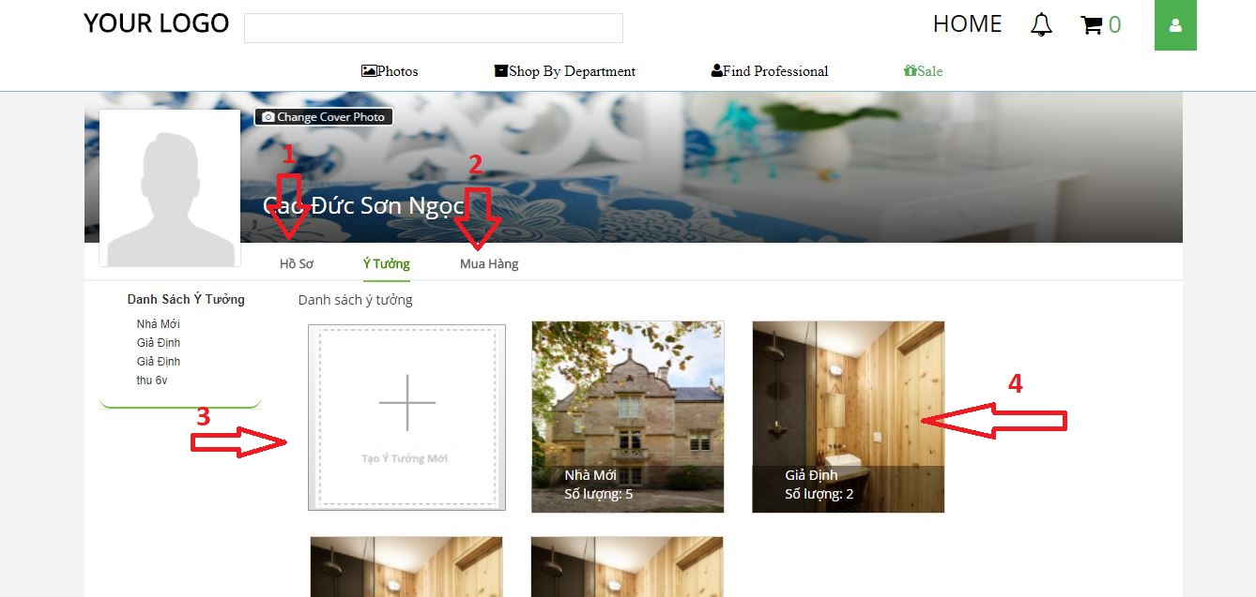

**Buttons/Hyperlinks**

|  |  |  |  |  |
| --- | --- | --- | --- | --- |
| **No** | **Function** | **Description** | **Validation** | **Outcome** |
| **1** | Profile | Edit member’s profile | N/A | Form to edit profile |
| **2** | Purchase | List order of member | N/A | List order page |
| **3** | Add new idea book | Add new idea book | N/A | Form to add idea book |
| **4** | Idea book | View idea book detail | N/A | Show idea book detail |

#### Professional

##### < Seller > Add Product

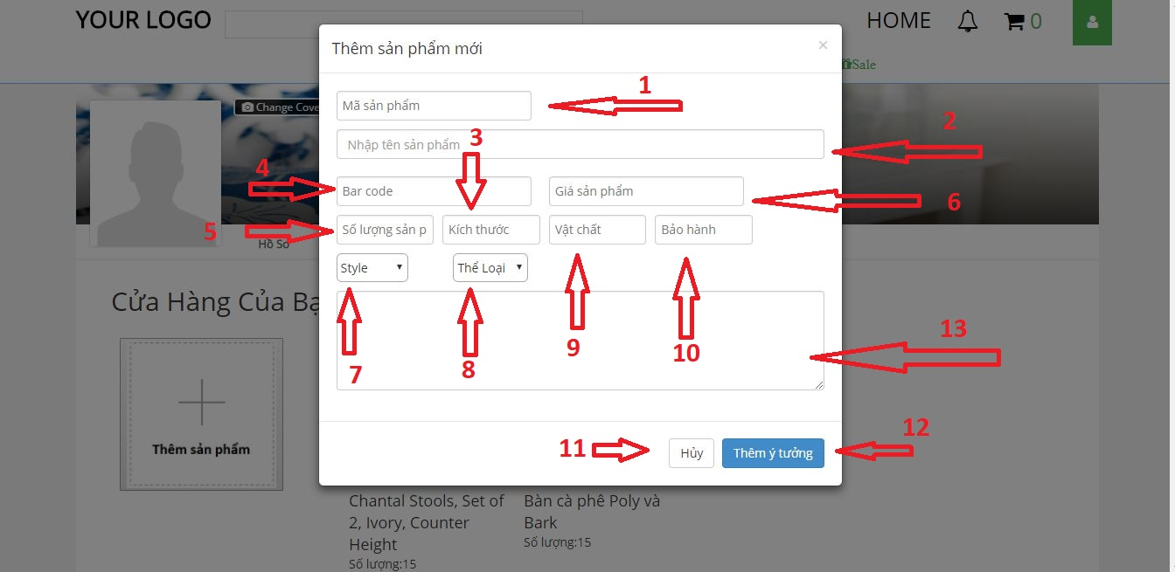

**Fields**

|  |  |  |  |  |  |  |  |
| --- | --- | --- | --- | --- | --- | --- | --- |
| **No** | **Field Name** | **Description** | **Read Only** | **Mandatory** | **Control Type** | **Data Type** | **Length** |
| **1** | Product code | Input product code | No | Yes | Text box | String | N/A |
| **2** | Product’s name | Input product name | No | Yes | Text box | String | N/A |
| **3** | Product’s size | Input product’s size | No | No | Text box | String | N/A |
| **4** | Bar Code | Input bar code | No | No | Text box | String | N/A |
| **5** | Quantity | Quantity of product | No | No | Text box | String | N/A |
| **6** | Product’s price | Input price | No | Yes | Text box | String | N/A |
| **7** | Style | Choose style for product | No | Yes | Text box | String | N/A |
| **8** | Category | Choose category | No | Yes | Text box | String | N/A |
| **9** | Material | Input material | No | No | Text box | String | N/A |
| **10** | Warranty | Input warranty | No | No | Text box | String | N/A |
| **13** | Description | Input description | No | No | Text Box | String | N/A |

**Buttons/Hyperlinks**

|  |  |  |  |  |
| --- | --- | --- | --- | --- |
| **No** | **Function** | **Description** | **Validation** | **Outcome** |
| **11** | Cancel | Cancel add product | N/A | N/A |
| **12** | Add Product | Add product | N/A | Seller’s list product |

#### Admin

##### <Admin> Manage Accounts

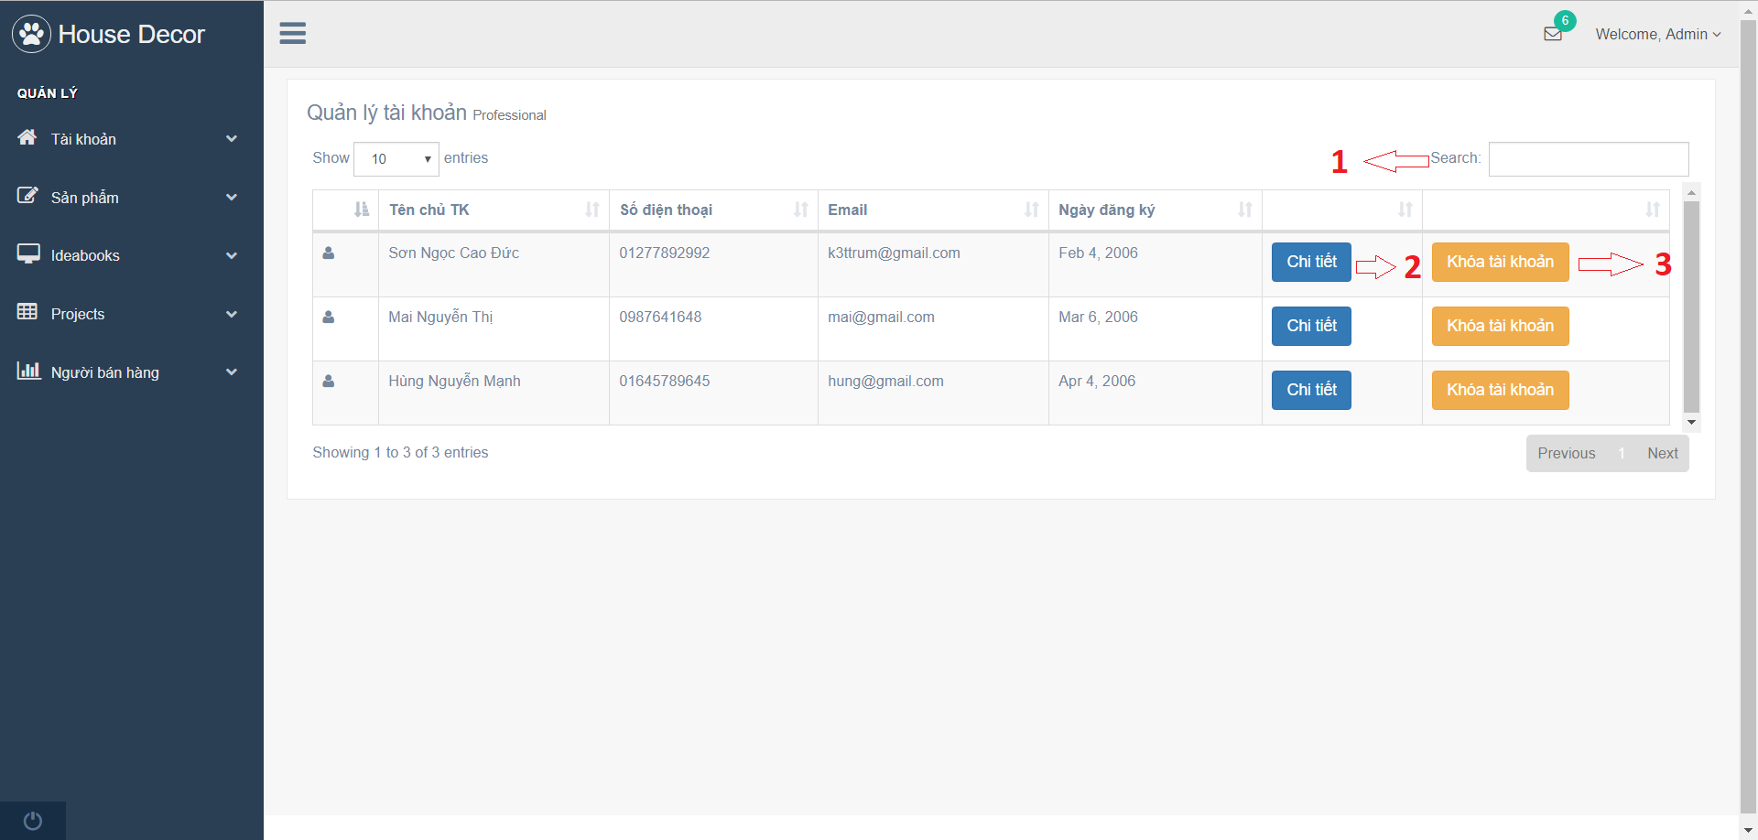

**Fields**

|  |  |  |  |  |  |  |  |
| --- | --- | --- | --- | --- | --- | --- | --- |
| **No** | **Field Name** | **Description** | **Read Only** | **Mandatory** | **Control Type** | **Data Type** | **Length** |
| **1** | Search Input | Search account | No | Yes | Textbox | String | N/A |

**Buttons/Hyperlinks**

|  |  |  |  |  |
| --- | --- | --- | --- | --- |
| **No** | **Function** | **Description** | **Validation** | **Outcome** |
| **2** | loadAccountInfo | Go to account detail view | N/A | Redirect to account detail view. |
| **3** | setStatusAccount | Ban or unban chosen account | N/A | Call SetStatusAccountServlet. |

##### <Admin> Manage Products

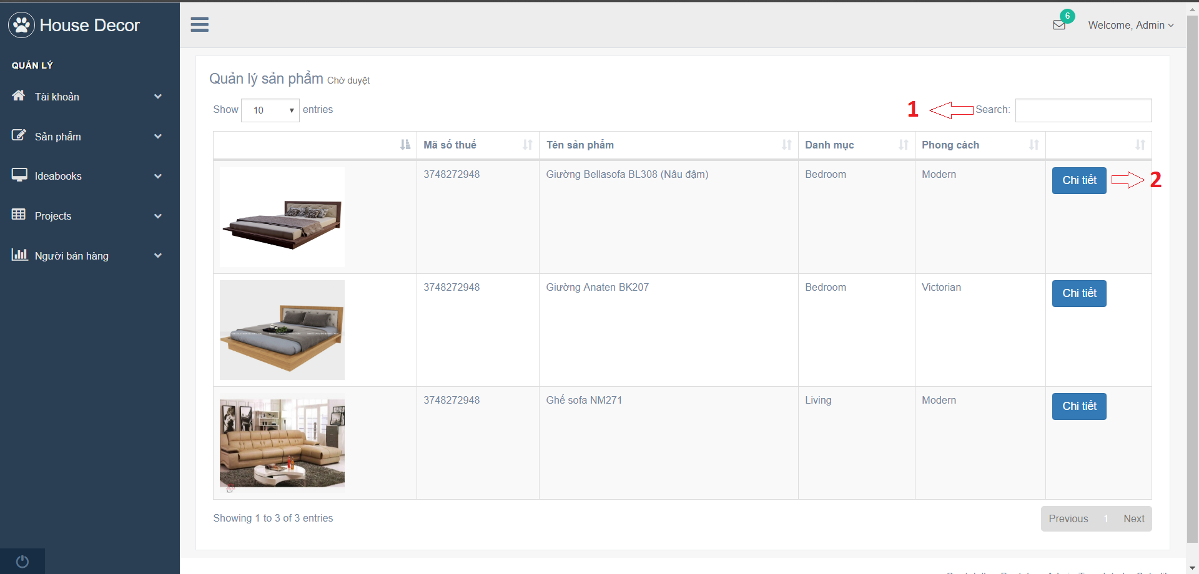

**Fields**

|  |  |  |  |  |  |  |  |
| --- | --- | --- | --- | --- | --- | --- | --- |
| **No** | **Field Name** | **Description** | **Read Only** | **Mandatory** | **Control Type** | **Data Type** | **Length** |
| **1** | Search Input | Search product | No | Yes | Textbox | String | N/A |

**Buttons/Hyperlinks**

|  |  |  |  |  |
| --- | --- | --- | --- | --- |
| **No** | **Function** | **Description** | **Validation** | **Outcome** |
| **2** | loadProductInfo | Go to product detail view | N/A | Redirect to account detail view. |

## Database Design

### Entity Relationship Diagram (ERD)

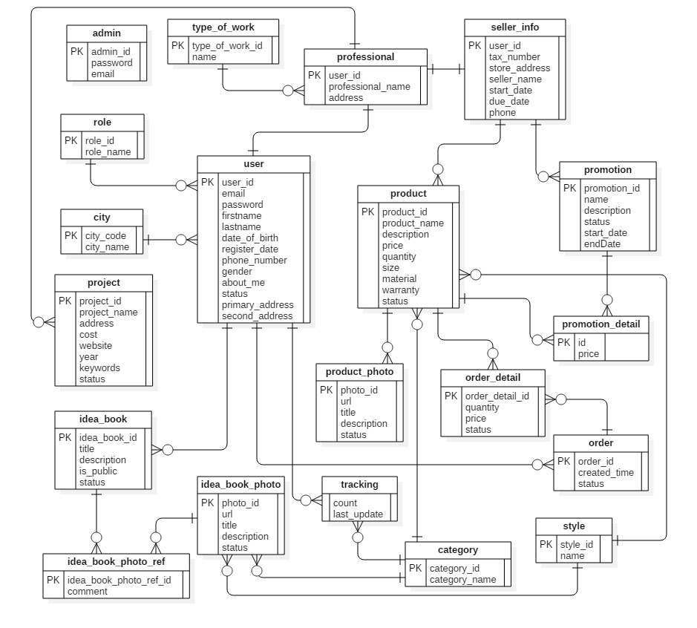

Figure 66: Entity Relationship Diagram (ERD)

### Data Dictionary

|  |  |
| --- | --- |
| **Entity Data Dictionary: describe contents of all entities** | |
| **Entity Name** | **Description** |
| User | All user accounts in the system. |
| Professional | All professional accounts in the system. |
| Admin | All admin accounts in the system. |
| Tracking | All activities of users in the system. |
| Idea_book_photo_ref | All accepted idea book/project’s photos in the system. |
| Idea_book | All idea books in the system. |
| Order_detail | Detail information of all orders in the system. |
| Idea_book_photo | All idea book/project’s photo in the system. |
| Type_of_work | All type of work in the system. |
| Role | All role in the system. |
| Promotion | All promotion of products in the system. |
| City | All city in the system. |
| Seller info | All sellers in the system. |
| Product_photo | All product’s photos in the system. |
| Product | All products in the system. |
| Project | All projects in the system. |
| Order | All orders in the system. |
| Style | All styles in the system. |
| Category | All categories in the system. |
| Promotion_detail | All promotion details in the system. |

## Algorithms

**Approve an idea book: (parameter: Idea book Id)**

Load all photos of the idea book by idea book id in “Idea Book Photo” table

For all photos in photo list

If photo’s status is waiting for approval then

Output: Error message

End for

End if

End for

Load the idea book by idea book id

Update idea book’s status to approved

**Tracking: (parameters: user Id, category Id)**

Load tracking by user Id and category Id

If tracking is existed then

Update this tracking

Else

Create new tracking

Save new tracking to Database

End if

Load tracking is out of date by user Id

If exist tracking is out of date then

Remove tracking out of date

End if

**Send promotion emails: (parameter: product Id)**

Load product by product Id

Load category Id of product

Use category Id to find users matched with in “Tracking” table

If users are not empty then

Load emails of founded users.

Send promotion email to users email

End if

**Send order to seller: (parameter: order Id)**

Load order by order Id

Load products in “Order detail” table by order

For all products in the order

Load sellers provide product by product Id

End for

For all sellers in list loaded above

For all products in the order

Load products, quantity are matched with seller

End for

Send email to seller

End for.

# Report 5 - System Implementation & Test

## Introduction

### Overview

This section describes the approach and methodologies used by group to plan, organize and manage the testing of House Decor system. It provides in the detail all necessary information about the implementation and testing procedure of the system included test plans, test cases, test result, test environments, pass/fail criteria and risks estimations as well as a checklist to cover all possible cases.

### Test Approach

* Goal: Test all features in the whole House Decor system based on the core flow.
* Method: black-box testing
* Technique: check list

The testing for this project will consists of Integration System test level. Testing the program which was integrated and as a complete system to ensure that the software requirements have been met.

* Integration testing would be performed by all member of team and approved by team leader.

System testing is focused on assessing the system’s reliability. This process is concerned with finding errors that result from unanticipated interactions between components and component interface problems.

## Database Relationship Diagram

### Physical Diagram



Figure 67: <Database Relation Diagram> Physical Diagram

### Data Dictionary

|  |  |  |
| --- | --- | --- |
| **Data dictionary: describe content of all tables** | | |
| **Table Name** | **Mapping column with Conceptual diagram** | **Description** |
| **Admin** |  | Admin’s accounts in the system. |
| **Professional** | Type_Of_Work, Project, Seller_Info, Project | Professional’s information in the system. |
| **User** | Role, Professional, Idea_Book, City, Order, Tracking | User’s accounts in the system. |
| **Role** | User | Roles in the system. |
| **Orders** | User, Order_Detail | Orders in the system. |
| **Order_Detail** | Order, Product | Order’s details in the system. |
| **City** | User | Cities in the system. |
| **Tracking** | User, Category | Tracking user’s activities in the system. |
| **Category** | Tracking, Product, Idea_Book_Photo | Categories in the system. Example of category are . |
| **Idea_Book_Photo** | Project, Idea_Book, Idea_Book_Photo_Ref, Category, Style | Idea book and project photos in the system. |
| **Project** | Idea_Book_Photo, Professional | Projects in the system. |
| **Idea_Book** | Idea_Book_Photo, User, Idea_Book_Ref | Idea books in the system. |
| **Product_Photo** | Product | Product’s photos in the system. |
| **Type_Of_Work** | Professional | Types of work in the system. |
| **Seller_Info** | Professional, Product | Seller’s informations in the system. |
| **Promotion** | Promotion_Detail, Product_Has_Promotion | Promotions in the system. |
| **Product** | Product_Photo, Seller_Info, Category, Style | Products in the system. |
| **Style** | Product, Idea_Book_Photo | Styles in the system. |
| **Promotion_Detail** | Product, Promotion | Promotion’s detail in the system. |
| **Idea_Book_Photo_Ref** | Idea_Book, Idea_Book_Photo | Photo save from others in the system. |

|  |  |  |  |  |
| --- | --- | --- | --- | --- |
| **Table Name** | **Attributes** | **Description** | **Domain** | **Null** |
| **Admin** | id | Unique id of an account. | Integer | No |
| password | Password of an account. | String | No |
| email | Email of an account. | String | No |
| **Professional** | nameProfessional | Name of an professional. | String | No |
| address | Address of an professional. | String | No |
| userId | Id of user. | Integer | No |
| TypeOfWorkId | Id of TypeOfWork | Integer | No |
| **User** | userId | Unique id of user role. | Integer | No |
| email | Email of an user. | String | No |
| Password | Password of an user. | String | No |
| Firstname | Firstname of an user. | String | No |
| Lastname | Lastname of an user. | String | No |
| DateOfBirth | Birthdate of an user. | Date | No |
| RegisterDate | Register date of an user. | Date | No |
| PhoneNumber | Phone number of an user. | String | No |
| RoleId | Id of role. | Integer | No |
| Gender | Gender of an user. | Integer | No |
| AboutMe | Description about user. | String | Yes |
| Status | Status of an user. | Integer | No |
| PrimaryAddress | Primary address of an user. | String | Yes |
| SecondAddress | Second address of an user. | String | Yes |
| cityCode | Code of city | Integer | No |
| **Role** | RoleId | Unique id of a role. | Integer | No |
| RoleName | Name of a role. | String | No |
| **Order** | OrderId | Unique id of a order. | Integer | No |
| CreatedTime | Created time of an order. | Date | No |
| Status | Status of an order. | Integer | No |
| UserId | Id of user. | Integer | No |
| **Order Detail** | OrderDetailId | Unique id of an OrderDetail. | Integer | No |
| ProductId | Id of product. | Integer | No |
| Quantity | Quantity of an product. | Integer | No |
| Price | Price of an product. | Float | No |
| StoreId | Id of store. | Integer | No |
| Status | Status of an OrderDetail. | Integer | No |
| OrderId | Id of an order. | Integer | No |
| **City** | CityCode | Unique id of a City. | Integer | No |
| CityName | Name of a city. | String | No |
| **Tracking** | Count | Unique id of an author. | Integer | No |
| LastUpdate | Last update date. | Date | No |
| UserId | Id of an user. | Integer | No |
| CategoryId | Id of a category | Integer | No |
| **Category** | CategoryId | Unique id of a category. | Integer | No |
| CategoryName | Name of a category. | String | No |
| **Idea_Book_Photo** | PhotoId | Unique id of a Photo. | Integer | No |
| Url | Url of a photo. | String | No |
| Title | Title of a photo. | String | No |
| Description | Description of a photo | String | Yes |
| Status | Status of a photo. | Integer | No |
| ProjectId | Id of a project. | Integer | Yes |
| IdeabookId | Id of an idea book | Integer | Yes |
| CategoryId | Id of a categegory. | Integer | No |
| StyleId | Id of a style. | Integer | No |
| **Project** | ProjectId | Unique id of a Project. | Integer | No |
| ProjectName | Name of a project. | String | No |
| Address | Address of a project. | String | No |
| Cost | Cost of a project. | Float | Yes |
| Website | Website of a project. | String | Yes |
| Year | Year of a project | Intger | Yes |
| Keywords | Keywords of a project. | String | Yes |
| Status | Status of a project. | Integer | No |
| UserId | Id of an user. | Integer | No |
| **Idea book** | IdeabookId | Unique id of a idea book. | Integer | No |
| Title | Title of an idea book. | String | No |
| Description | Description of an idea book. | String | Yes |
| IsPublic | Idea book is public or not. | Integer | No |
| Status | Status of an idea book. | Integer | No |
| UserId | Id of an user. | Integer | No |
| **Product Photo** | ProductPhotoId | Unique id of a product’s photo. | Integer | No |
| Url | Url of a product’s photo. | String | No |
| Title | Title of a product’s photo. | String | No |
| Description | Description of a product’s photo. | String | Yes |
| Status | Status of a product’s photo. | Integer | No |
| ProductId | Id of a product | String | No |
| **Type Of Work** | Id | Unique id of a type of work. | Integer | No |
| Name | Name of a type of work. | String | No |
| **Seller** | TaxNumber | Unique id of a seller. | String | No |
| StoreAddress | Store address. | String | No |
| SellerName | Name of a seller. | String | No |
| StartDate | Date seller open store on system. | Date | No |
| DueDate | Date seller close store on system. | Date | No |
| Phone | Phone of a seller. | String | No |
| UserId | Id of an user. | Integer | No |
| **Promotion** | Id | Unique id of a promotion. | Integer | No |
| Name | Name of a promotion. | String | No |
| Description | Description of a promotion. | String | No |
| Status | Status of a promotion. | Integer | No |
| StartDate | Date promotion start on system. | Date | No |
| EndDate | Date promotion end on system. | Date | No |
| **Product** | ProductId | Unique id of a Product. | String | No |
| ProductName | Name of a product. | String | No |
| Desciption | Desciption of a product. | String | No |
| Price | Price of a product. | Float | No |
| Quantity | Quantity of a product. | Integer | No |
| Size | Size of a product. | String | Yes |
| Material | Material of a product. | String | Yes |
| Warranty | Warranty of a product. | String | Yes |
| Status | Status of a product. | Integer | No |
| CategoryId | Id of category | Integer | No |
| StyleId | Id of style | Integer | No |
|  | Seller_UserId | Id of user is seller. | Integer | No |
| **Style** | StyleId | Unique id of a Style. | Integer | No |
| Name | Name of a style. | String | No |
| **Promotion Detail** | PromotionDetailId | Unique id of a Promotion detail. | Integer | No |
| PromotionId | Id of promotion | Integer | No |
| Productid | Id of product | String | No |
| Price | Price of product | Float | Yes |
| **Idea_Book_Photo_Ref** | IdeaBookId | Id of idea book | Integer | No |
| PhotoId | Id of photo | Integer | No |
| Comment | Comment | String | Yes |

Table 53: Data dictionary: Describe content of all tables

## Performance Measures

This section measure the speed of the system on certain task, and the average time it took to assign a new request

### 3.1 Test environment

### 3.2 Test cases

* Using browser to perform certain task
* List of function to be tested

|  |  |  |
| --- | --- | --- |
| **No** | **Function Name** | **Description** |
| 1 |  |  |
| 2 |  |  |

Table 2: Test case

### 3.3 Test result

|  |  |  |  |  |  |  |
| --- | --- | --- | --- | --- | --- | --- |
| **Test case** | **Time (unit: second)** | | | | | |
| **1** | **2** | **3** | **4** | **5** | **Average** |
| **1** |  |  |  |  |  |  |
| **2** |  |  |  |  |  |  |

Table 3: Test result

## Test Plans

### Features to be tested

* 1. **Guest**:
     + Login
     + Add product to shopping cart
  2. **Member**:
     + Check out order
     + Create an idea book
     + Add photo to idea book
  3. **Professional**:
     + Create a project
     + Add photo to project
  4. **Seller**:
     + Create a product
  5. **Admin**:
     + Activate/ Deactivate an account
     + Approve a photo in an idea book
     + Approve an idea book
     + Approve a product
  6. **System**:
     + Send notification to seller
     + Send promotion to customer

### Features not to be tested

1. **Guest:**
   * + **Edit shopping cart**
2. **User:**
3. **Professional:**
4. **Admin:**
5. **System****:**

## 

## System Testing Test Case

### Web Application Test Cases

#### <Guest> Login

|  |  |  |  |  |  |  |
| --- | --- | --- | --- | --- | --- | --- |
| **ID** | **Test Case Description** | **Test case procedure** | **Expected output** | **Inter-test case dependence** | **Result** | **Test Date** |
| **101** | Login with valid email and password | 1. Go to login page  2. Input valid email and password  3. Press “đăng nhập” button | Show target main page |  | PASS | 06/08/2017 |
| **102** | Login with invalid password | 1. Go to login page  2. Input valid email and invalid password  3. Press “đăng nhập” button | Show message “Email hoặc Password không đúng !!” |  | PASS | 06/08/2017 |
| **103** | Login with invalid email | 1. Go to login page  2. Input invalid email and valid password  3. Press “đăng nhập” button | Show message “Email hoặc Password không đúng !!” |  | PASS | 06/08/2017 |
| **104** | Login with blocked account | 1. Go to login page  2. Input blocked account: email and password  3. Press “đăng nhập” button | Show message “Tài khoản đang bị khóa” |  | PASS | 06/08/2017 |

Table 54: <Guest> Login

#### <Guest> Add product to shopping cart

|  |  |  |  |  |  |  |
| --- | --- | --- | --- | --- | --- | --- |
| **ID** | **Test Case Description** | **Test case procedure** | **Expected output** | **Inter-test case dependence** | **Result** | **Test Date** |
| **201** | Add a product to empty cart | 1. Go to “Mua sắm” page  2. Choose product  3. Press “Thêm vào giỏ hang” button | Show message “Sản phẩm đã được them vào giỏ hàng” |  | PASS | 06/08/2017 |
| **202** | Add product with quantity >= 2 to empty cart | 1. Go to “Mua sắm” page  2. Choose product  3. Choose quantity: 2  3. Press “Thêm vào giỏ hang” button | Show message “Sản phẩm đã được them vào giỏ hàng” |  | PASS | 06/08/2017 |
| **203** | Add a product to existed cart | 1. Go to “Mua sắm” page  2. Choose product  3. Press “Thêm vào giỏ hàng” button  4. Choose “Tiếp tục mua sắm” button  5. Choose another product  6. Press “Thêm vào giỏ hàng” | Show message “Sản phẩm đã được them vào giỏ hàng” |  | PASS | 06/08/2017 |
| **204** | Add product with quantity >= 2 to existed cart | 1. Go to “Mua sắm” page  2. Choose product  3. Press “Thêm vào giỏ hàng” button  4. Choose “Tiếp tục mua sắm” button  5. Choose another product  6. Choose quantity: 2  7. Press “Thêm vào giỏ hàng” | Show message “Sản phẩm đã được them vào giỏ hàng” |  | PASS | 06/08/2017 |
| **205** | Add product and the product is existed in cart | 1. Go to “Mua sắm” page  2. Choose product  3. Press “Thêm vào giỏ hàng” button  4. Choose “Tiếp tục mua sắm” button  5. Choose the product again  6. Choose quantity: 1  7. Press “Thêm vào giỏ hàng” | Show message “Sản phẩm đã được them vào giỏ hàng” |  | PASS | 06/08/2017 |

Table 55: <Guest> Add product to shopping cart

#### <Member> Check out order

|  |  |  |  |  |  |  |
| --- | --- | --- | --- | --- | --- | --- |
| **ID** | **Test Case Description** | **Test case procedure** | **Expected output** | **Inter-test case dependence** | **Result** | **Test Date** |
| **301** | Check out an empty cart | 1. Go to shopping cart page  2. Press “Hoàn thành” button | Show message “Giỏ hàng trống” |  | PASS | 06/08/2017 |
| **302** | Check out cart with products as Guest | 1. Go to shopping cart page  2. Press “Hoàn thành” button | Show login page |  | PASS | 06/08/2017 |
| **303** | Check out cart with products as Member | 1. Add product to shopping cart  2. Go to shopping cart page  3. Press “Hoàn thành” button | Show message “Đặt hàng thành công” |  | PASS | 06/08/2017 |

Table 56: <Member> Check out order

#### <Member> Create an idea book

|  |  |  |  |  |  |  |
| --- | --- | --- | --- | --- | --- | --- |
| **ID** | **Test Case Description** | **Test case procedure** | **Expected output** | **Inter-test case dependence** | **Result** | **Test Date** |
| **401** | Create a valid idea book | 1. Go to create idea book form  2. Type in title (Ex: Ngôi nhà mơ ước)  3. Type in description (Ex: Mơ ước đạt được)  4. Press “Thêm ý tưởng” button |  |  | PASS | 06/08/2017 |
| **402** | Cancel create idea book form | 1. Go to create idea book form  2. Press “Hủy” button |  |  | PASS | 06/08/2017 |
| **403** | Create an idea book without idea book’s title | 1. Go to create idea book form  2. Type in description (Ex: Mơ ước đạt được)  3. Press “Thêm ý tưởng” button |  |  | PASS | 06/08/2017 |
| **404** | Create an idea book with title is existed | 1. Go to create idea book form  2. Type existed title in title field (Ex: Ngôi nhà mơ ước)  3. Type in description (Ex: Mơ ước đạt được)  4. Press “Thêm ý tưởng” button |  |  | PASS | 06/08/2017 |
| **405** | Create an idea book without description | 1. Go to create idea book form  2. Type in title (Ex: Ngôi nhà mơ ước)  3. Press “Thêm ý tưởng” button |  |  | PASS | 06/08/2017 |

Table 57: <Member> Create an idea book

#### <Member> Add photo to idea book

|  |  |  |  |  |  |  |
| --- | --- | --- | --- | --- | --- | --- |
| **ID** | **Test Case Description** | **Test case procedure** | **Expected output** | **Inter-test case dependence** | **Result** | **Test Date** |
| **501** | Add a valid photo to idea book | 1. Go to idea book detail page  2. Press “Thêm hình ảnh” button  3. Type in title (Ex: abc)  4. Press “Chọn tệp” button and choose a photo  5. Type in description  6. Press “Thêm hình ảnh” button |  |  | PASS | 06/08/2017 |
| **502** | Add a photo without title | 1. Go to idea book detail page  2. Press “Thêm hình ảnh” button  3. Press “Chọn tệp” button and choose a photo  4. Type in description  5. Press “Thêm hình ảnh” button |  |  | PASS | 06/08/2017 |
| **503** | Add a photo without upload file | 1. Go to idea book detail page  2. Press “Thêm hình ảnh” button  3. Type in title (Ex: abc)  4. Type in description  5. Press “Thêm hình ảnh” button |  |  | PASS | 06/08/2017 |
| **504** | Add a photo without description | 1. Go to idea book detail page  2. Press “Thêm hình ảnh” button  3. Type in title (Ex: abc)  4. Press “Chọn tệp” button and choose a photo  5. Press “Thêm hình ảnh” button |  |  | PASS | 06/08/2017 |
| **505** | Add a photo from other idea book |  |  |  | PASS | 06/08/2017 |

Table 58: <Member> Add photo to idea book

#### <Professional> Create a project

|  |  |  |  |  |  |  |
| --- | --- | --- | --- | --- | --- | --- |
| **ID** | **Test Case Description** | **Test case procedure** | **Expected output** | **Inter-test case dependence** | **Result** | **Test Date** |
| **601** | Create a valid project | 1. Go to create project form  2. Type in name (Ex: Nhà cao tầng)  3. Type in address (Ex: 123 Phạm Ngũ Lão)  4. Type in cost (Ex: 123000)  5. Type in website (Ex: <http://www.abc.com>)  6. Type in year (Ex: 2000)  7. Press “Tạo dự án” button | New project is added to list |  | PASS | 06/08/2017 |
| **602** | Cancel create project form | 1. Go to create project form  2. Press “Hủy” button | Close create project form |  |  |  |
| **603** | Create a project without project’s name | 1. Go to create project form  2. Type in address (Ex: 123 Phạm Ngũ Lão)  3. Type in cost (Ex: 123000)  4. Type in website (Ex: <http://www.abc.com>)  5. Type in year (Ex: 2017)  6. Press “Tạo dự án” button | Show message “Vui lòng điền vào trường này” |  | PASS | 06/08/2017 |
| **604** | Create a project with name is existed | 1. Go to create project form  2. Type in name (Ex: Nhà cao tầng)  3. Type in address (Ex: 123 Phạm Ngũ Lão)  4. Type in cost (Ex: 123000)  5. Type in website (Ex: <http://www.abc.com>)  6. Type in year (Ex: 2010)  7. Press “Tạo dự án” button | Show message “Trùng tên dự án” |  | PASS | 06/08/2017 |
| **605** | Create a project without address | 1. Go to create project form  2. Type in name (Ex: Nhà cao tầng)  3. Type in cost (Ex: 123000)  4. Type in website (Ex: <http://www.abc.com>)  5. Type in year (Ex: 2016)  6. Press “Tạo dự án” button | Show message “Vui lòng điền vào trường này” |  | PASS | 06/08/2017 |
| **606** | Create a project without cost | 1. Go to create project form  2. Type in name (Ex: Nhà cao tầng)  3. Type in address (Ex: 123 Phạm Ngũ Lão)  4. Type in website (Ex: <http://www.abc.com>)  5. Type in year (Ex: 2016)  6. Press “Tạo dự án” button | New project is added to list |  | PASS | 06/08/2017 |
| **607** | Create a project without website | 1. Go to create project form  2. Type in name (Ex: Nhà cao tầng)  3. Type in address (Ex: 123 Phạm Ngũ Lão)  4. Type in cost (Ex: 123000)  5. Type in year (Ex: 2016)  6. Press “Tạo dự án” button | New project is added to list |  | PASS | 06/08/2017 |
| **608** | Create a project with invalid website format | 1. Go to create project form  2. Type in name (Ex: Nhà cao tầng)  3. Type in address (Ex: 123 Phạm Ngũ Lão)  4. Type in cost (Ex: 123000)  5. Type in website (Ex: [abc.com](http://www.abc.com))  6. Type in year (Ex: 2010)  7. Press “Tạo dự án” button | Show message “Vui lòng nhập URL” |  | PASS | 06/08/2017 |
| **609** | Create a project without year | 1. Go to create project form  2. Type in name (Ex: Nhà cao tầng)  3. Type in address (Ex: 123 Phạm Ngũ Lão)  4. Type in cost (Ex: 123000)  5. Type in website (Ex: <http://www.abc.com>)  6. Press “Tạo dự án” button | Show message “Vui lòng điền vào trường này” |  | PASS | 06/08/2017 |
| **610** | Create a project with year < 2000 | 1. Go to create project form  2. Type in name (Ex: Nhà cao tầng)  3. Type in address (Ex: 123 Phạm Ngũ Lão)  4. Type in cost (Ex: 123000)  5. Type in website (Ex: <http://www.abc.com>)  6. Type in year (Ex: 1999)  7. Press “Tạo dự án” button | Show message “Giá trị phải lớn hơn hoặc bằng 2000” |  | PASS | 06/08/2017 |
| **611** | Create a project with year > 2017 | 1. Go to create project form  2. Type in name (Ex: Nhà cao tầng)  3. Type in address (Ex: 123 Phạm Ngũ Lão)  4. Type in cost (Ex: 123000)  5. Type in website (Ex: http://www.abc.com)  6. Type in year (Ex: 2018)  7. Press “Tạo dự án” button | Show message “Giá trị phải nhỏ hơn hoặc bằng 2017” |  | PASS | 06/08/2017 |

Table 59: <Professional> Create a project

#### <Professional> Add photo to project

|  |  |  |  |  |  |  |
| --- | --- | --- | --- | --- | --- | --- |
| **ID** | **Test Case Description** | **Test case procedure** | **Expected output** | **Inter-test case dependence** | **Result** | **Test Date** |
| **701** | Add a valid photo to project | 1. Go to product detail page  2. Press “Thêm hình ảnh” button  3. Type in title (Ex: abc)  4. Press “Chọn tệp” button and choose a photo  5. Type in description  6. Press “Thêm hình ảnh” button |  |  | PASS | 06/08/2017 |
| **702** | Add a photo without title | 1. Go to product detail page  2. Press “Thêm hình ảnh” button  3. Press “Chọn tệp” button and choose a photo  4. Type in description  5. Press “Thêm hình ảnh” button |  |  | PASS | 06/08/2017 |
| **703** | Add a photo without upload file | 1. Go to product detail page  2. Press “Thêm hình ảnh” button  3. Type in title (Ex: abc)  4. Type in description  5. Press “Thêm hình ảnh” button |  |  | PASS | 06/08/2017 |
| **705** | Add a photo without description | 1. Go to product detail page  2. Press “Thêm hình ảnh” button  3. Type in title (Ex: abc)  4. Press “Chọn tệp” button and choose a photo  5. Press “Thêm hình ảnh” button |  |  | PASS | 06/08/2017 |

Table 60: <Professional> Add photo to project

#### <Seller> Create product

|  |  |  |  |  |  |  |
| --- | --- | --- | --- | --- | --- | --- |
| **ID** | **Test Case Description** | **Test case procedure** | **Expected output** | **Inter-test case dependence** | **Result** | **Test Date** |
| **801** | Create a valid product | 1. Go to create project form  2. Type in Code (Ex: AAB)  3. Type in name (Ex: Giường)  4. Type in cost (Ex: 123000)  5. Type in quantity (Ex: 15)  6. Type in style (Ex: Asian)  7. Press “Tạo Sản Phẩm” button | New product is added to list |  | PASS | 06/08/2017 |
| **802** | Create a product without product’s name | 1. Go to create project form  2. Type in Code (Ex: AAB)  3. Type in cost (Ex: 123000)  4. Type in quantity (Ex: 15)  5. Type in style (Ex: Asian)  6. Press “Tạo Sản Phẩm” button | Show message “Vui lòng điền vào trường này” |  | PASS | 06/08/2017 |
| **803** | Create a product with name is existed | 1. Go to create project form  2. Type in Code (Ex: AAB)  3. Type in name (Ex: Giường)  4. Type in cost (Ex: 123000)  5. Type in quantity (Ex: 15)  6. Type in style (Ex: Asian)  7. Press “Tạo Sản Phẩm” button | Show message “Sản phẩm đã Có trong cửa hàng” |  | PASS | 06/08/2017 |
| **804** | Create a product without barcode | 1. Go to create project form  2. Type in Code (Ex: AAB)  3. Type in name (Ex: Giường)  4. Type in cost (Ex: )  5. Type in quantity (Ex: 15)  6. Type in style (Ex: Asian)  7. Press “Tạo Sản Phẩm” button | Show message “Vui lòng nhập giá” |  | PASS | 06/08/2017 |
| **805** | Create a product without description | 1. Go to create project form  2. Type in Code (Ex: AAB)  3. Type in name (Ex: Giường)  4. Type in cost (Ex: )  5. Type in quantity (Ex: 15)  6. Type in style (Ex: Asian)  7. Press “Tạo Sản Phẩm” button | New product is added to list |  | PASS | 06/08/2017 |
| **806** | Create a product without price | 1. Go to create project form  2. Type in Code (Ex: AAB)  3. Type in name (Ex: Giường)  4. Type in cost (Ex: 121414 )  5. Type in quantity (Ex: 15)  6. Type in style (Ex: Asian)  7. Press “Tạo Sản Phẩm” button | New product is added to list |  | PASS | 06/08/2017 |
| **807** | Create a product with price is characters | 1. Go to create project form  2. Type in Code (Ex: AAB)  3. Type in name (Ex: Giường)  4. Type in cost (Ex: aaaaa )  5. Type in quantity (Ex: 15)  6. Type in style (Ex: Asian)  7. Press “Tạo Sản Phẩm” button | Show message “Vui lòng nhập lại giá” |  | PASS | 06/08/2017 |
| **808** | Create a product without quantity | 1. Go to create project form  2. Type in Code (Ex: AAB)  3. Type in name (Ex: Giường)  4. Type in cost (Ex: 121414 )  5. Type in quantity (Ex: 15)  6. Type in style (Ex: Asian)  7. Press “Tạo Sản Phẩm” button | New product is added to list |  | PASS | 06/08/2017 |
| **809** | Create a product with quantity is characters | 1. Go to create project form  2. Type in Code (Ex: AAB)  3. Type in name (Ex: Giường)  4. Type in cost (Ex: 121414 )  5. Type in quantity (Ex: Asian)  6. Press “Tạo Sản Phẩm” button | Show message “Vui lòng nhập lại số lượng” |  | PASS | 06/08/2017 |
| **810** | Create a product with quantity <0 | 1. Go to create project form  2. Type in Code (Ex: AAB)  3. Type in name (Ex: Giường)  4. Type in cost (Ex: 121414 )  5. Type in quantity (Ex: -2)  6. Press “Tạo Sản Phẩm” button | Show message “Vui lòng nhập lại số lượng” |  | PASS | 06/08/2017 |
| **811** | Create a product without size | 1. Go to create project form  2. Type in Code (Ex: AAB)  3. Type in name (Ex: Giường)  4. Type in cost (Ex: 121414 )  5. Type in size (Ex: )  6. Type in quantity (Ex: -2)  7. Press “Tạo Sản Phẩm” button | Show message “Vui lòng điền vào trường này” |  | PASS | 06/08/2017 |
| **812** | Create a product without warranty | 1. Go to create project form  2. Type in Code (Ex: AAB)  3. Type in name (Ex: Giường)  4. Type in cost (Ex: 121414 )  5. Type in size (Ex: )  6. Type in quantity (Ex: -2)  7. Type in warranty  8. Press “Tạo Sản Phẩm” button | New product is added to list |  | PASS | 06/08/2017 |

Table 61: <Seller> Create product

#### <Admin> Activate/ Deactivate an account

|  |  |  |  |  |  |  |
| --- | --- | --- | --- | --- | --- | --- |
| **ID** | **Test Case Description** | **Test case procedure** | **Expected output** | **Inter-test case dependence** | **Result** | **Test Date** |
| **901** | Active account from list manage page | 1. Go to blocked list account page  2. Press “Mở tài khoản” button | Show list account page without the activated account |  | PASS | 06/08/2017 |
| **902** | Active account from account detail page | 1. Go to blocked account detail page  2. Press “Mở tài khoản” button |  |  | PASS | 06/08/2017 |

Table 62: <Admin> Admin activate/ deactivate an account

#### <Admin> Accept/ Block a photo in an idea book

|  |  |  |  |  |  |  |
| --- | --- | --- | --- | --- | --- | --- |
| **ID** | **Test Case Description** | **Test case procedure** | **Expected output** | **Inter-test case dependence** | **Result** | **Test Date** |
| **1001** | Accept a photo in an idea book | 1. Go to idea book detail page  2. Choose photo  3. Press “Chấp nhận” button | Occurs checked right icon on the photo |  | PASS | 06/08/2017 |
| **1002** | Accept a blocked photo in an idea book | 1. Go to idea book detail page  2. Choose blocked photo  3. Press “Chấp nhận” button | Occurs checked right icon on the photo |  | PASS | 06/08/2017 |
| **1003** | Block a photo in an idea book | 1. Go to idea book detail page  2. Choose photo  3. Press “Chặn” button | Occurs checked wrong icon on the photo |  | PASS | 06/08/2017 |
| **1004** | Block a accepted photo in an idea book | 1. Go to idea book detail page  2. Choose accepted photo  3. Press “Chặn” button | Occurs checked wrong icon on the photo |  | PASS | 06/08/2017 |

Table 63: <Admin> Accept/ Block a photo in an idea book

#### <Admin> Approve an idea book

|  |  |  |  |  |  |  |
| --- | --- | --- | --- | --- | --- | --- |
| **ID** | **Test Case Description** | **Test case procedure** | **Expected output** | **Inter-test case dependence** | **Result** | **Test Date** |
| **1101** | Approve an idea book whose photos have been approved | 1. Go to idea book detail page  2. Approve all photo in this  3. Press “Hoàn thành” button | Show idea book list manage page. |  | PASS | 06/08/2017 |
| **1102** | Approve an idea book that has unapproved photo | 1. Go to idea book detail page  2. Press “Hoàn thành” button | Show message |  | PASS | 06/08/2017 |

Table 64: <Admin> Approve an idea book

#### <Admin> Approve/ Block a product

|  |  |  |  |  |  |  |
| --- | --- | --- | --- | --- | --- | --- |
| **ID** | **Test Case Description** | **Test case procedure** | **Expected output** | **Inter-test case dependence** | **Result** | **Test Date** |
| **1201** | Approve a product | 1. Go to product detail page  2. Press “Chấp nhận” button | The product is approved and show “Chặn” button |  | PASS | 06/08/2017 |
| **1202** | Approve a blocked product | 1. Go to blocked product detail page  2. Press “Chấp nhận” button | The product is approved and show “Chặn” button |  | PASS | 06/08/2017 |
| **1203** | Block a product | 1. Go to blocked product detail page  2. Press “Chặn” button | The product is blocked and show “Chấp nhận” button |  | PASS | 06/08/2017 |
| **1204** | Block an approved product | 1. Go to approved product detail page  2. Press “Chặn” button | The product is blocked and show “Chấp nhận” button |  | PASS | 06/08/2017 |

Table 65: <Admin> Approve a product

#### <System> Send notification to seller

|  |  |  |  |  |  |  |
| --- | --- | --- | --- | --- | --- | --- |
| **ID** | **Test Case Description** | **Test case procedure** | **Expected output** | **Inter-test case dependence** | **Result** | **Test Date** |
| **1301** | Customer check out order successfully | 1. Add products to shopping cart  2. Press “” button | Seller receives email that notify the order |  | PASS | 06/08/2017 |

Table 66: <System> Send notification to seller

#### <System> Send promotion to customer

|  |  |  |  |  |  |  |
| --- | --- | --- | --- | --- | --- | --- |
| **ID** | **Test Case Description** | **Test case procedure** | **Expected output** | **Inter-test case dependence** | **Result** | **Test Date** |
| **1401** | Seller create new promotion | 1. Create a new promotion  2. Add product to promotion | Customer receives email that advertises promotions |  | PASS | 06/08/2017 |
| **1402** | Seller add product to existed promotion | 1. Go to promotion detail page  2. Add product to promotion | Customer receives email that advertises promotions |  | PASS | 06/07/2017 |

Table 67: <System> Send promotion to customer

# Report 6 - Software User’s Manual

1. **Installation Guide**
   1. **Setting up environment at server side**

The following software must be installed into the server machine:

* + 1. **Hardware requirements**

|  |  |  |
| --- | --- | --- |
| **Windows** | **Minimum Requirements** | **Recommended** |
| **Internet Connection** | Cable, Wi-Fi (4 Mbps) | Cable, Wi-Fi (8 Mbps) |
| **Operating System** | Window Server 2008 R2 | Window Server 2012 R2 |
| **Computer Processor** | Intel® Xeon ® 1.4GHz | Intel® Xeon ® Quad Core |
| **Computer Memory** | 2GB of RAM | 4GB of RAM or more |

Table 68: Hardware requirements

* + 1. **Software requirements**

|  |  |  |
| --- | --- | --- |
| **Software** | **Name / Version** | **Description** |
| **Operating system** | Window 10 Professional | Operating system and platform for development |
| **Environment** | JDK version 1.8.0 update 101 | Specification for developing web application |
| **IDE** | NetBeans IDE 8.2 | Use to implement website. |
| **Design Model tool** | StartUML v2.5.1 | Use to create modal and diagrams. |
| **DBMS** | MySQL | Use to create & manage the database for system |
| **Document storage** | GitHub | Use to store document |
| **Store and manage source code** | GitHub | Use to store all source code |
| **Web browser** | Chrome 42 or above | Testing browser |

Table 69: Software requirements

* 1. **Deployment at server side**
     1. **Prepare deployment package**
  + Build web application.
  + Step by step:

1. Click right into web package. Click to “Build”

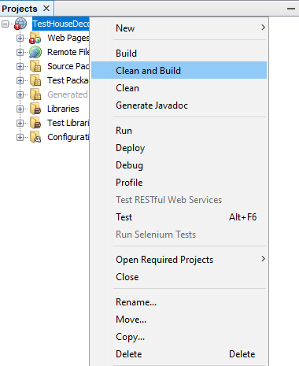

* + 1. **Configure Server before deploy**
    2. **Deploy web application on server**
* Step 1 : Go to Plesk Control Panel and login
* Step 2 : Server setup

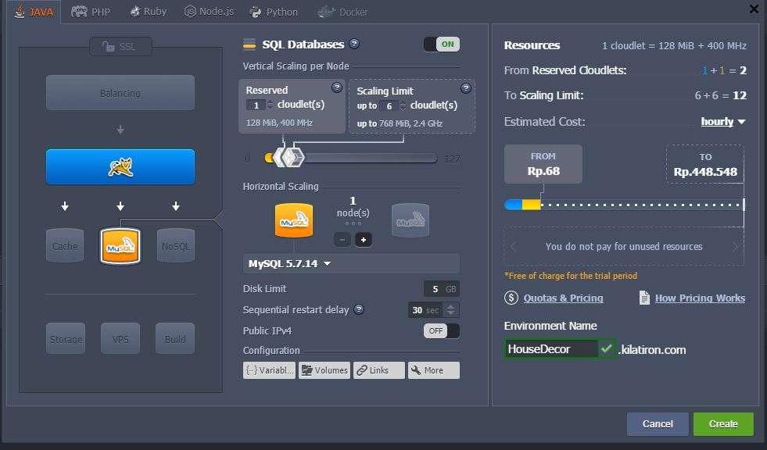

* Step 3: create database

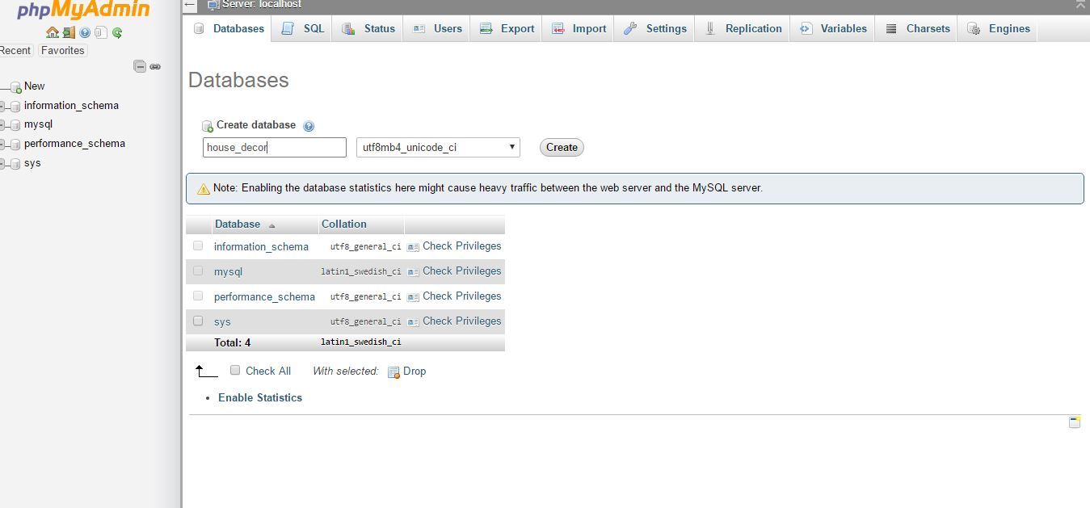

* Step 4: Upload file war

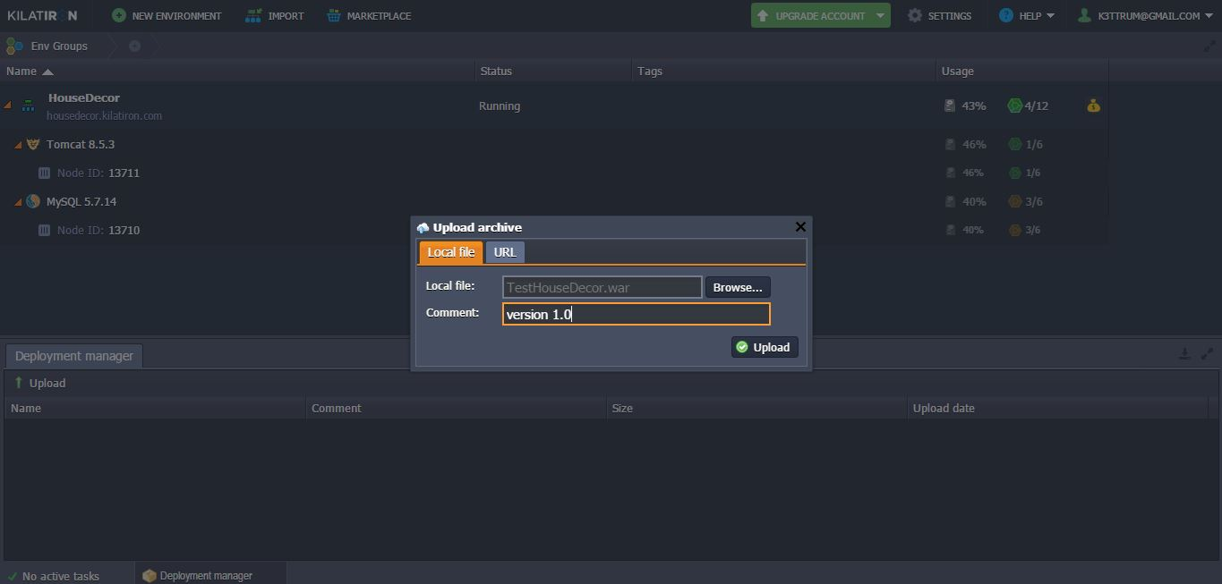

* Step 5: Deploy file war on server

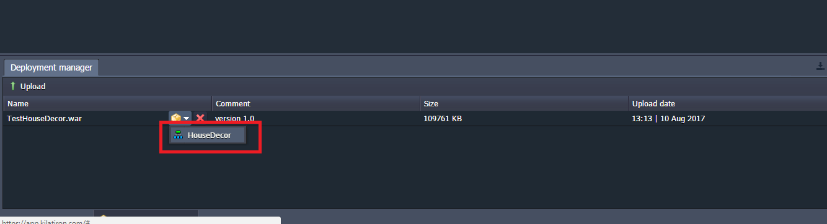

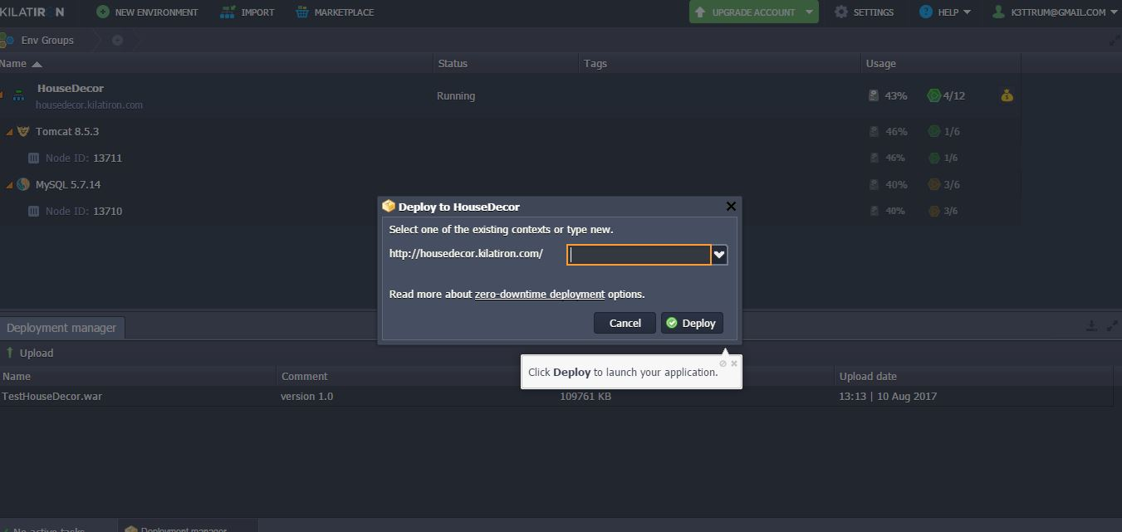

* 1. **Setting up the environment at client side**
     1. **Setting up for computer**

1. **User Guide**
   1. <User> Login

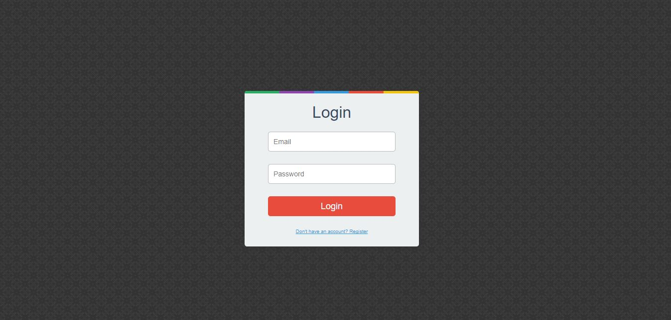

|  |  |
| --- | --- |
| **Step** | **Description** |
| **1** | Click “Login” button |

* 1. <User> View Photo

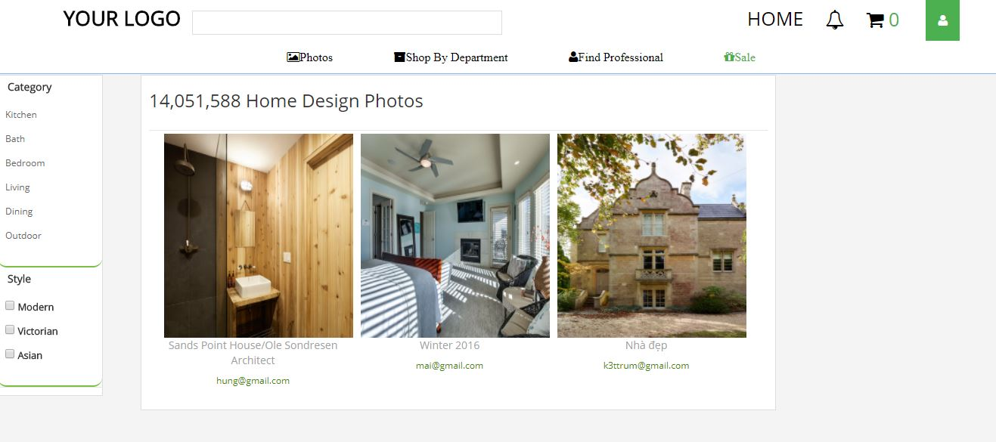

|  |  |
| --- | --- |
| Step | Description |
| 1 | Click “Photo” hyperlink |

* 1. <User> View Product

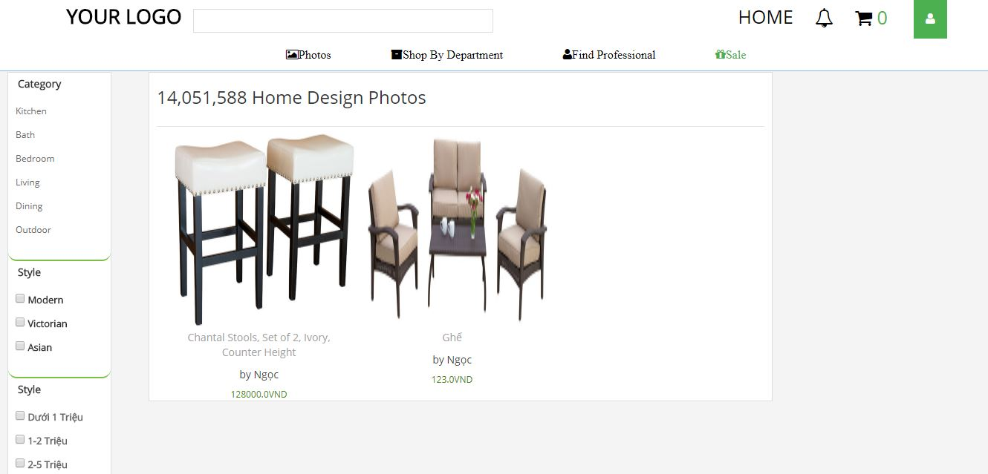

* 1. <User> Find Professional

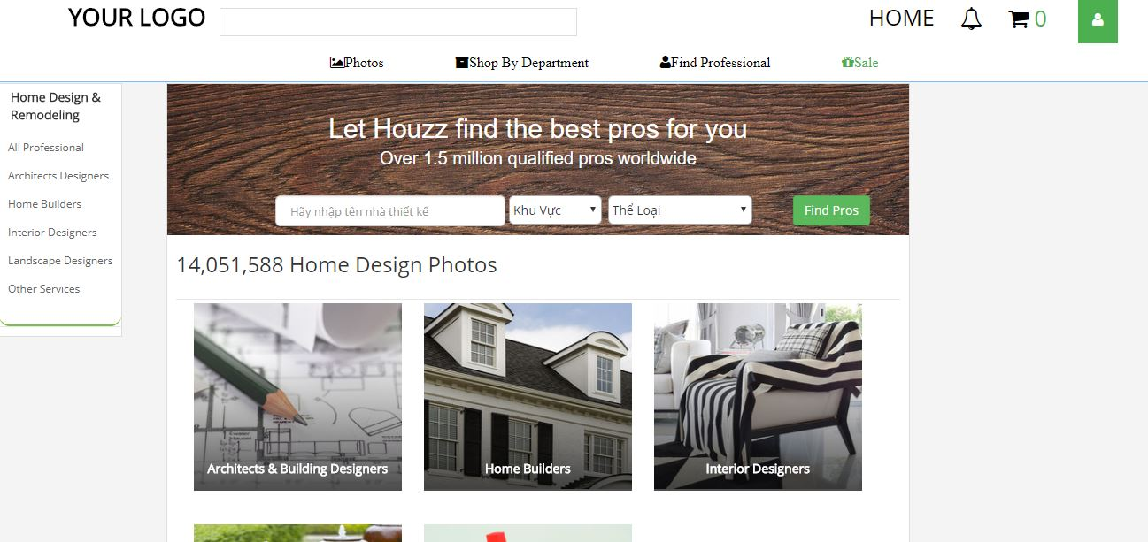

|  |  |
| --- | --- |
| **Step** | **Description** |
| **1** | Click “Find Professional” hyperlink |
| **2** | Input Professional’s name |
| **3** | Choose Location |
| **4** | Choose type of work |
| **5** | Click “Find Pros” button |

* 1. <User> Create Idea Book

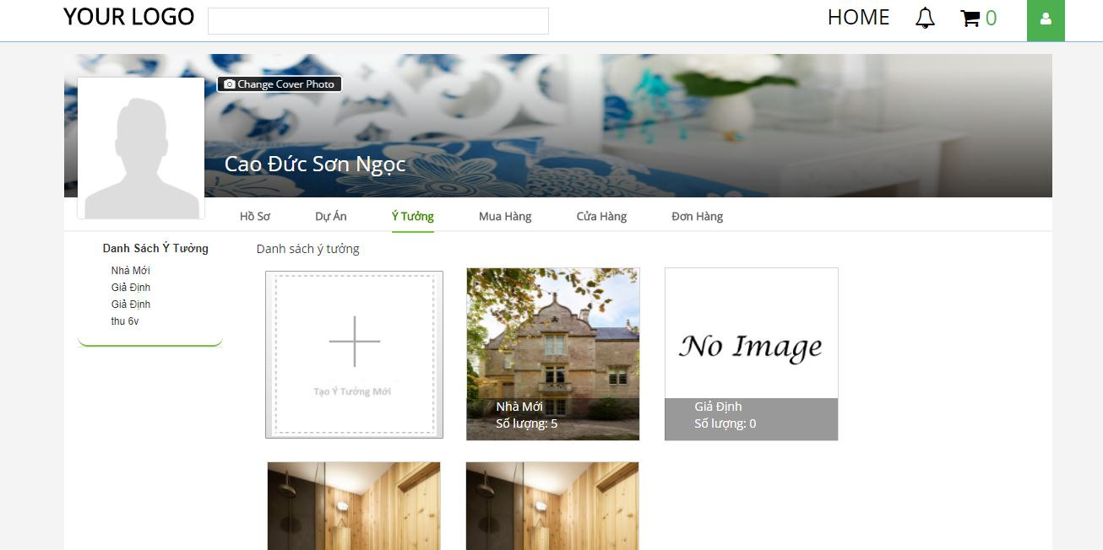

|  |  |
| --- | --- |
| **Step** | **Description** |
| **1** | Click “Thêm Ý Tưởng Mới” button |

* 1. <Seller> Add Product

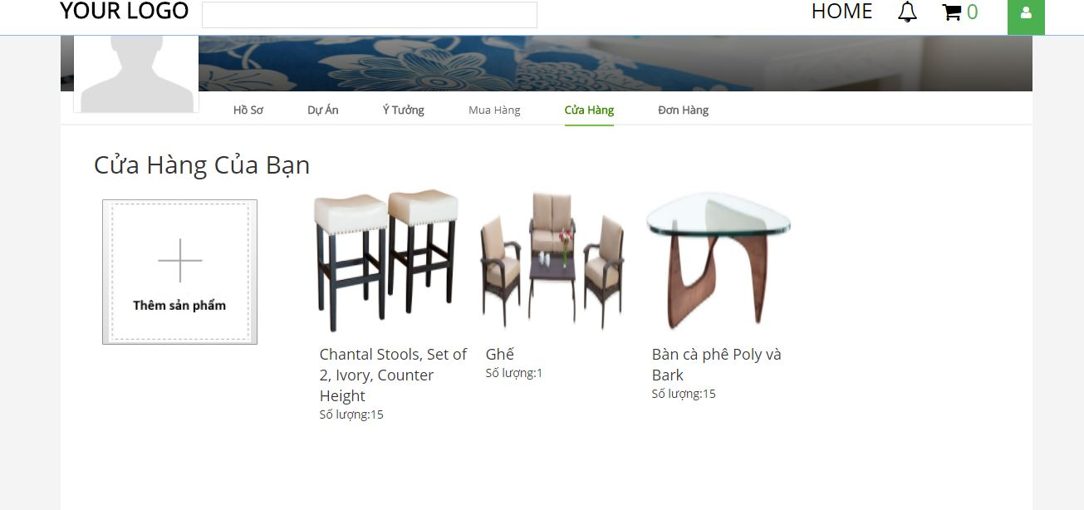

|  |  |
| --- | --- |
| **Step** | **Description** |
| **1** | Click “Thêm sản phẩm” button |

* 1. <Admin> Accept Idea Book

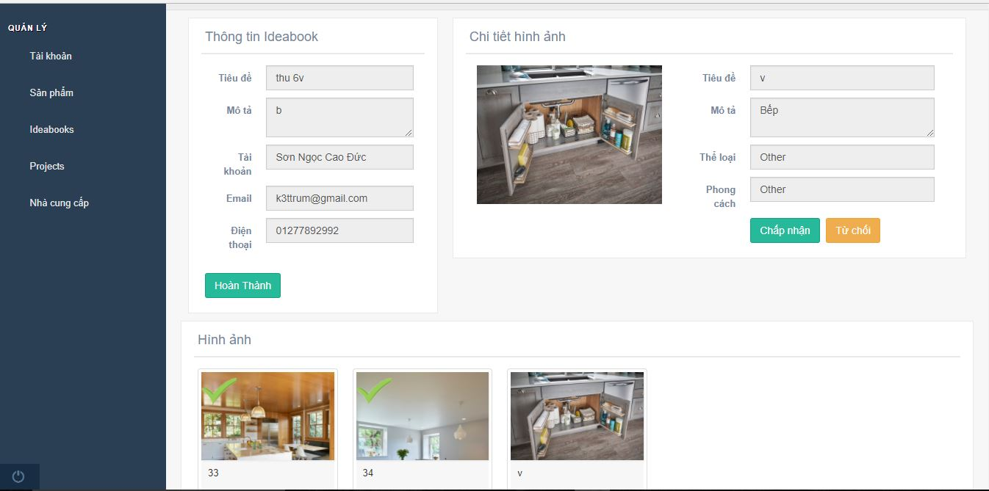

|  |  |
| --- | --- |
| **Step** | **Description** |
| **1** | Click “Ideabooks” hyperlink |
| **2** | Click “Danh sách chờ duyệt” tab |
| **3** | Click “Chi tiết” button |
| **4** | Choose “Chấp nhận” or “Từ chối” button |
| **5** | Click “Hoàn Thành” button |